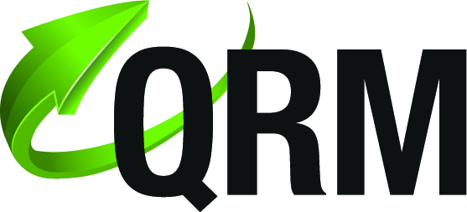
QRM – a Product of the Year award finalist!
Quality Result Management (QRM) has been selected as a 2015 LabVIEW Tools Network Product of the Year award finalist. This award recognizes achievements in innovation and is designated for outstanding software apps and add-ons on the LabVIEW Tools Network.

- ”We are very proud of this nomination that recognizes QRM as one of the top quality tools for managing test results. There have been many years of hard work to reach here.” says Petter Salomonsson, CEO at AddQ Consulting
QRM is a web based result management system that stores and analyzes test results. It is a flexible system using web servers, databases and ATML XML data which can be setup on a single computer, servers or cloud solutions. ATML (Automated Test Markup Language) is an XML standard to exchange test data.
QRM has a powerful web interface for easy access to view and analyze the test results. It is also possible to generate pdf-reports and export data to both Excel and Minitab.
QRM data consists not only by the measurement data, but also a lot of additional information such as traceability of the station and equipment used, configuration version and additional UUT (Unit Under Test) information. It is also possible to attach any kind of file with the reports (graphs, log files etc).

Sites can be connected by the distributed architecture of QRM. By using the QRM Web application, test results can be viewed and analyzed as they are produced.
See all the QRM videos for more information
Download the plugin here.
The winners will be announced during the Alliance Partner and LabVIEW Tools Network awards luncheon on Alliance Day 2015 (Monday, August 3th), in Austin, Texas and we are keeping all our fingers crossed.

Want to know more about QRM please visit
http://www.addq.se/
http://www.addq.se/qrm

For purchasing information, please contact:
Mats Backlund, Sales Manager at AddQ Consulting, +46 (735) 142 190

