200 YEARS AFTER THE BATTLE OF WATERLOO THE SOLDIERS OF THE ALLIED FORCES ARE ON TRACK TO GET THEIR MEMORIAL AT LAST – AT WATERLOO STATION
In the week before the bicentenary of the Battle of Waterloo, the soldiers of the Allied forces who fought and died on that historic day will be commemorated for the first time with a new war memorial at Waterloo Station. It is estimated that there were 24,000 casualties and losses amongst the Allied armies at the Battle: 4,700 killed, 14,600 wounded and 4,700 missing. Until this moment, there has been no memorial to honour the brave Waterloo Men whose great sacrifice helped achieve an extraordinary turning point in the course of European history.
The unveiling ceremony will take place at Midday on 10th June at Waterloo Station, when the 9th Duke of Wellington will reveal the memorial to the nation.
The memorial is being created, funded and installed by The London Mint Office Limited on behalf of Waterloo 200, the government-backed organisation overseeing the commemorations of the 200th anniversary of the Battle of Waterloo. As its centrepiece, the memorial will feature a supersized replica of the obverse to the Waterloo Campaign medal, struck in bronze and 65cm in diameter, which depicts Nike, the Greek Goddess of Victory.
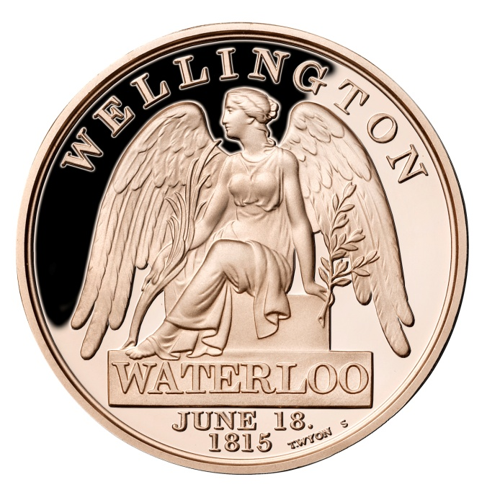James Deeny, Managing Director of The London Mint Office, says, “It is only fitting for the Waterloo Campaign Medal to be the focus of a memorial to the soldiers who fought at Waterloo. This was the first medal commissioned to be given to all the soldiers present at a battle, regardless of rank. Before this, medals presented to participants maintained a sense of the army hierarchy, with gold medals being struck for the senior generals.”
Sir Evelyn Webb-Carter, co-Chairman of Waterloo 200, comments, “With the 200th anniversary of the Battle this year, it seems only right that these brave soldiers should be commemorated with a plaque in the form of a giant medal that reflects the huge sacrifice that they made. Not only that, it is at a place that will forever be linked in people’s minds to the Battle – Waterloo Station – to ensure that they will never be forgotten.”
Tim Shoveller, Chief Executive of the South West Trains-Network Rail Alliance, adds: “We are both honoured and privileged to be taking part in the memorial at London Waterloo station. Thousands of men lost their lives at the Battle of Waterloo and the station is a fitting place for their ultimate sacrifice to be remembered."
The memorial will also feature tribute to the fallen soldiers carved in granite, along with the Iron Duke’s famous quotation: “My heart is broken by the terrible loss I have sustained in my old friends and companions and my poor soldiers. Believe me, nothing except a battle lost can be half so melancholy as a battle won.”
The London Mint Office will also be working with Waterloo 200 to invite a number of descendants of the soldiers to attend the unveiling. Deeny adds, “It will be important for the descendants’ families to also be represented at this event as many of the families of the soldiers who died at Waterloo never received their loved-ones’ medals. The Campaign Medal plaque is also in honour of their loss.”
In addition, Waterloo 200, The London Mint Office and Worcestershire Medal Service are giving away 500,000 free bronze Waterloo Campaign medals to the UK as part of the bicentenary commemorations. The medals are available here and limited to one per household.
Phil McDermott, Managing Director of Worcestershire Medal Service said “We are delighted to have been part of this project and see what is arguably the most important campaign medal in the history of the UK become part of this most fitting tribute to the Allied Armies who took part in the battle 200 years ago”

- ENDS –
Media contact:
Susan Perolls at Loudmouth PR, T 020 7981 9858, E susanp@loudmouthpr.co.uk

Journalists: For more information and access to visuals please visit: http://www.mynewsdesk.com/uk/london-mint-office

About The London Mint Office Limited: The London Mint Office is a trusted and respected partner for a large number of British coin collectors. Gold, silver and other precious metals have fascinated mankind for many centuries, making coin collecting a popular hobby the world over. The London Mint Office is at the centre of British numismatics, bringing the fascinating world of coin collecting to both existing and new collectors. Together with our sister organisations across Europe, The London Mint Office provides a wide range of coins from ancient to modern, originating from virtually every country in the world. Visit www.londonmintoffice.org for more information.

About Waterloo200: Waterloo 200 Ltd is an organisation approved and supported by Government to oversee the celebration of the 200th anniversary of the Battle of Waterloo. In 2009 Waterloo 200 Ltd was granted charitable status. For more information visit: http://www.nam.ac.uk/waterloo200/
About Worcestershire Medal Service: Worcestershire Medal Service is one of the largest suppliers of State Honours in the UK. Granted a Royal Warrant as Medallists to Her Majesty The Queen in 2008, they are best known for the Diamond Jubilee Medal issued in 2012 and its sister organisation Gladman & Norman who designed and produce the Elizabeth Cross. They currently supply UK insignia ranging from the GCB to the BEM as well as awards to countries in Asia, Middle East and the Caribbean. It is this production heritage that lead Waterloo 200 to choose Worcestershire Medal Service as their production partner. Visit www.worcmedals.com for more information.

