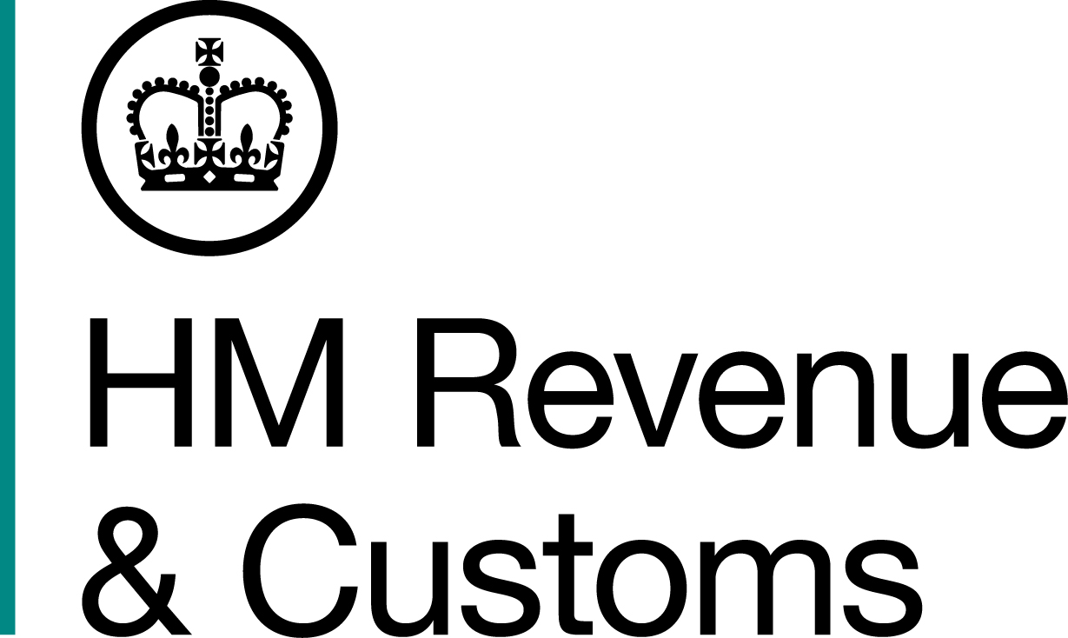
News Release

 | For the attention of News Desks |  | No. of pages: 2
 | Date: | 13 July 2016 | Ref: | WM 08/2016

Twelve arrested in tax fraud and money laundering raids
Ten men and two women have been arrested as part of an ongoing investigation by HM Revenue and Customs (HMRC) into a suspected multi-million pound tax and money laundering fraud.
Two hundred officers from HMRC, alongside local police, searched 13 private and 17 business addresses in Birmingham, Leicester, London and Milton Keynes on Monday.
Stuart Taylor, Assistant Director, Fraud Investigation Service, HMRC, said:
“Tax fraud is often thought victimless but it isn’t; the public lose out on vital funds for essential services. We will continue to work with our partners to tackle this crime and ask anyone with information about this kind of activity to contact our 24-hour hotline on 0800 59 5000.”
Computers, business records and cash were seized during the operation. Those arrested were interviewed by HMRC and have been released on bail. Investigations are continuing.
Notes for editors
- Details of those arrested are as follows:
Eight men from Birmingham: one aged 52, two aged 47, two aged 43, one aged 37, one aged 33 and one aged 32
Two women from Birmingham aged 39 and 29
One man from Milton Keynes aged 39
One man from London aged 45
2. Anyone with information regarding tax fraud is encouraged to contact our 24-hour hotline on 0800 59 5000 or report it online at: http://www.hmrc.gov.uk/reportingfraud/online.htm
3. Follow HMRC Press Office on Twitter @HMRCpressoffice

Issued by HM Revenue & Customs Press Office

Press enquiries only please contact:

Natalie Brown
Press Officer for Wales and West Midlands
Tel: 03000 519123
Email: Natalie.brown@hmrc.gsi.gov.uk

Or

Stevie Roden
Tel: 03000 566399
Email: stevie.roden@hmrc.gsi.gov.uk

Out of hours
Tel: 07860 359544

Website: www.hmrc.gov.uk

