PRESS RELEASE

Swedish startup company and global life science company Bayer initiate partnership

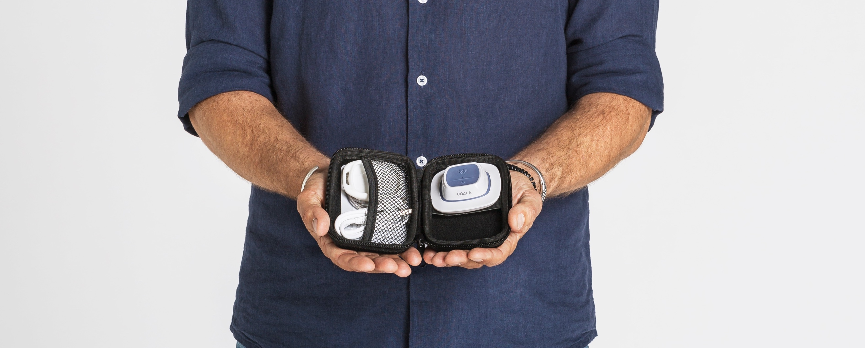

STOCKHOLM, 26 OCT, 2017. The Swedish medical technology company Coala Life AB and the life science company Bayer AB initiate partnership in the field of cardiac care. The partnership aims to find the many patients with undiagnosed heart disease, treat and help avoid myocardial infarction and stroke. By introducing new digital cardiac monitoring in the care chain, patients with undiscovered cardiovascular disease can be treated early.

Coala Life is a Swedish fast-growing startup company in the field of digital health. The company was founded based on more than 10 years of R&D, and has recently launched unique digital solutions for monitoring and diagnosing the heart. The company has developed the Coala Heart Monitor, a hardware and cloud based solution that enables effective arrhythmia investigations, early detection of heart disease and an easier way to follow the heart over time. Efficient monitoring enables for earlier treatment and improved outcomes. Coala Life has received numerous awards for its service and internationally praised for its potential to both improve heart disease and save patients’ lives.

- This is a unique collaboration where the combination of innovative medical technology and world-leading pharmaceuticals will help to digitize, streamline and relieve heart care. Together with Bayer, one of the world's largest pharmaceutical companies in cardiovascular care, we now create common prerequisites for finding and treating cardiac patients earlier, thus helping to win the battle against the world's leading health disease, said Philip Siberg, CEO of Coala Life.

Today, the lack of proper diagnosis is estimated to be around 25 percent among cardiovascular diseases. Only in Sweden, some doctors believe that there are 300,000 people who have not yet been diagnosed. There are evident opportunities to save lives as cardiovascular disease is the most common cause of death in the world.

For more information contact:
Titti Lundgren, CMO Coala Life, +46 70-835 33 28, titti.lundgren@coalalife.com

For questions to Bayer:
Joseffa Moritz, Communication Manager Bayer Sweden, 073-301 75 52, joseffa.moritz@bayer.com

About Coala Life
Coala Life is a Swedish medical technology company focused on cardiac diagnostics and mobile health. The company has developed a portfolio of patented products and services for digital remote monitoring and screening of the heart. All products are developed and manufactured in Sweden. www.coalalife.com

About Bayer
Bayer is a global enterprise with core competencies in the life science fields of health care and agriculture. Its products and services are designed to benefit people and improve their quality of life. Bayer is committed to the principles of sustainable development and to its social and ethical responsibilities as a corporate citizen. . In 2016, Bayer had approximately 115,000 employees and a turnover of 46.8 billion euros. Capital expenses amounted to EUR 2.6 billion and R&D investments to EUR 4.7 billion. www.bayer.se and www.bayer.com.

