Press Release
Düsseldorf, 19/03/2024
Used machines: Auction of high-quality industrial robots
16 high-quality industrial robots from an automotive manufacturer will be auctioned off on 27th March via the industrial auction house Surplex.
Nowadays, industrial robots are an important part of production for many companies in the automotive industry. But other sectors also benefit from their use, such as the metal industry, the plastics and chemicals sector and food production. However, the automotive industry remains the leader among all sectors. However, the purchase of such a machine is associated with high costs.
The current €1 auction for industrial robots organised by the industrial auction house Surplex therefore offers a good opportunity for interested parties. Here, high-quality yet inexpensive industrial robots and various matching accessories can be purchased at auction.
Until 27th March, interested parties have the opportunity to bid for 16 high-quality industrial robots as well as accessories such as water cooling systems and spot welding machines via Surplex.com. Amongst others, these highlights can be found in the auction:
- FANUC M-900iA/260L industrial robot
- KUKA KR240 R2700 prime industrial robot
- KUKA KR 210 L150-2 2000 industrial robot
- KOPR SK258 projection welding machine
- 3x RIEDEL PC251.1L4WE.I water cooling system

A viewing appointment on site is only available by prior arrangement. The machines are all located at the Hodonín site in the Czech Republic.
Both the seller and the customer make the best choice with Surplex. The industrial auction house clearly stands out from the competition with its various services, such as support with customs documents or dismantling and loading, and thus shows that with Surplex you have a reliable partner at your side.
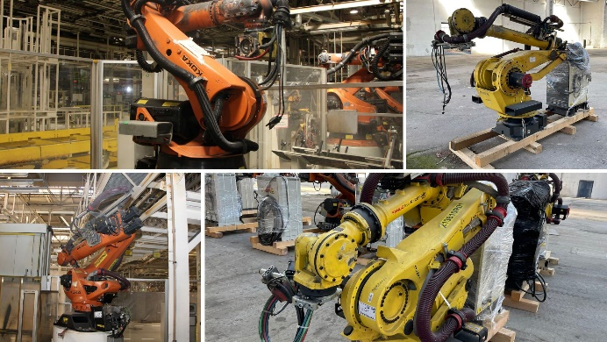 | Picture 1  High-quality machines from a Czech car manufacturer can be purchased at Surplex.com.  (© Surplex.com)
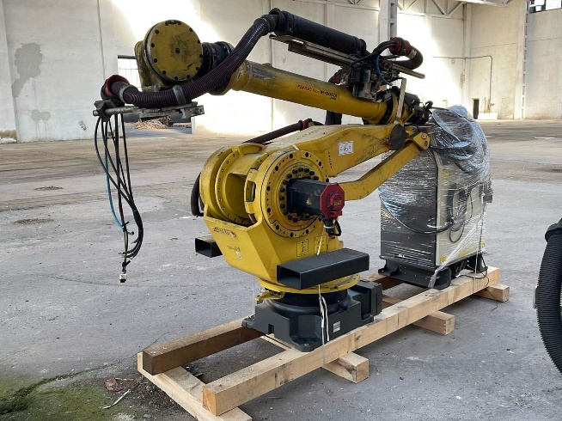 | Picture 2  One of the items up for auction is a FANUC M-900iA_260L industrial robot. (© Surplex.com)

