
News Release
Allison Transmission Europe
Communications
Sliedrecht, The Netherlands

COBUS 3000 and Allison Transmission: smooth and safe transport to the aeroplane
Most travellers requiring airside bus transportation enjoy the smooth combination of a COBUS airport bus and an Allison fully automatic transmission

MAINZ, GERMANY – Singapore, London, Beijing, Barcelona, Moscow, Dresden…. the COBUS airport bus by Wiesbaden-based Contrac GmbH provides safe and comfortable passenger transportation at around 345 airports in 92 countries. Last year, 286 COBUS 3000 model buses – exclusively equipped with the Allison 2000 Series fully automatic transmission since 2005 – were delivered all over the world. With more than 2,700 COBUS buses sold in total, the company enjoys a dominant 90 percent share of the global airport bus market.

To keep aircraft turnarounds as quick as possible for optimum operational efficiency, time on the ground – for example taxiing to and from a terminal building – must be kept to a minimum. This has resulted in airlines parking planes closer to the runway and choosing to transport passengers by bus instead. Nowadays, between 40 and 50 percent of passengers are taken to the plane by bus which has resulted in the constant growth of airport bus fleets over recent years.

Comfort for passengers and drivers
The three metre-wide COBUS 3000 is specially developed for the transportation of as many passengers as possible between the airport terminal buildings and planes.

With mostly short distances covered, the COBUS has standing places for up to 112 passengers – double the capacity of a normal city bus. Thanks to Allison’s 4th Generation close-loop adaptive transmission controls passengers are promised a safe and comfortable standing journey because the transmission shifts are smooth. The torque converter and the helical cut planetary gear sets deliver engine power to the wheels quietly and without jolting. The bus is easy to manoeuvre around aircraft and other support vehicles and drivers can concentrate on driving with both hands on the steering wheel. This enhances safety and driving comfort for all.

The COBUS 3000 is built on a special low floor chassis by Mercedes-Benz and has just one step from the ground to the bus floor, ideal for passengers of all ages. The doorsill can be lowered with a pneumatic ‘kneeling system’ that allows easy and safe boarding and exiting through three extra wide doors located on both sides of the bus. So that the passengers do not have to walk through the path of the bus’s exhaust, the ‘two way’ system automatically directs the exhaust gases away from the side being used.

Low fuel consumption and efficient performance
To help airports meet environmental standards, Contrac has offered a CNG-powered version of the COBUS series since 2007. However, the diesel engine of the regular COBUS is particularly eco-friendly and efficient with only 4-5 litres of fuel per operating hour required. This is achieved thanks to a range of fuel efficiency features such as Allison’s early lock-up clutch insertion at the airfield’s relatively low operating speed limit of 30 km/h. The transmission’s electronic controls allow for its shifting calibrations to be optimised for these specific conditions to offer the best combination between vehicle performance and low fuel consumption.

Perfect temperature thanks to a perfect conditioning
Particularly in hot climates such as in Spain, Portugal, Saudi Arabia and Singapore, the bus ride must not only to be smooth; it must provide a comfortable temperature.
As part of the latest version of the COBUS 3000, which meets the Euro 5 emission standard, the air conditioning system is connected to the PTO provision of the Allison 2000 Series. The power take off direct from the converter housing ensures the best performance of the air conditioner and the perfect comfort inside the bus.

The torque converter with integrated torsional damper reduces shocks on the vehicle driveline enabling operation at lowest engine speed. The electronic controls of the Allison fully automatic transmissions prevent mistakes during gear changes and the integrated diagnostic highlights any system faults to the driver immediately.

Lower maintenance costs
Allison transmissions play an important part in reducing vehicle downtime and ensuring minimum maintenance stops at airports and in many other commercial vehicle applications. The impact for operators running vehicles such as the COBUS 3000 is a reduction in bus fleet operating costs.
”Efficiency is a key factor in every service, even more when it involves transporting people who travel for business, to go back home or to spend their precious free time,” says Manlio Alvaro, Marketing Manager for the European region. “Allison transmissions are dependable and robust with an efficient design. They ensure the shortest transport time with minimum maintenance cost.”

About Contrac GmbH
Contrac GmbH has its head office in Wiesbaden, Germany, where it employs around 65 employees. 350 employees work at the manufacturing plants in Spain and Portugal. The COBUS airport bus is offered in three versions: the best-selling COBUS 3000 with a capacity of 112 passengers, the COBUS 2700 which provides space for 77 passengers and the COBUS 2400 which is the smallest model. In the 3000 and 2700 models, the Allison fully automatic transmission 2000 Series is used. The COBUS 2400 uses the Allison Transmission 1000 Series.

About Allison Transmission, Inc.
Allison Transmission, Inc. (Allison) is the premier global provider of commercial duty automatic transmissions and hybrid propulsion systems. Allison products are specified by over 250 of the world’s leading vehicle manufacturers and are used in many market sectors including bus, refuse, fire, construction, distribution, military and specialty applications. Founded in 1915, the Allison business is headquartered in Indianapolis, Indiana, U.S.A. and employs approximately 2,900 people. Regional headquarters with dedicated support staff are located in China, The Netherlands, Brazil, India and Japan. With a global presence in 80 countries, Allison has over 1,500 distributor and dealer locations. More information about Allison is available at www.allisontransmission.com.

Press enquiries
Claire Dumbreck Miranda Jansen
Market Engineering Allison Transmission Europe B.V.
North Bar House, North Bar Marketing Communications
Banbury Baanhoek 188
Oxfordshire OX16 0TH 3361 GN Sliedrecht, The Netherlands
Tel: +44 (0) 1295 277050 Tel: +31 (0) 78 642 2174
claire.dumbreck@m-eng.com miranda.jansen@allisontransmission.com
Photographs
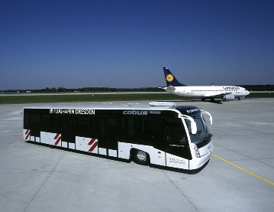  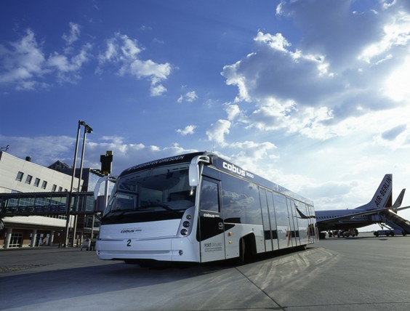  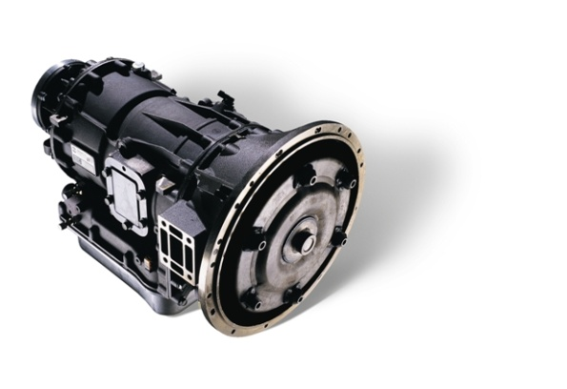 | The COBUS 3000 is exclusively equipped with an Allison fully automatic transmission and is in service at 345 airports in 92 countries.  Passengers always have a safe stand during the journey, owing to Allison transmissions which provide smooth shifts and uninterrupted power without jolting.  The Allison Transmission 2000 Series makes the ride between the airport and plane smooth and comfortable.

ALL6243 Cobus 3000 with Allison Transmission app 1/12/09

