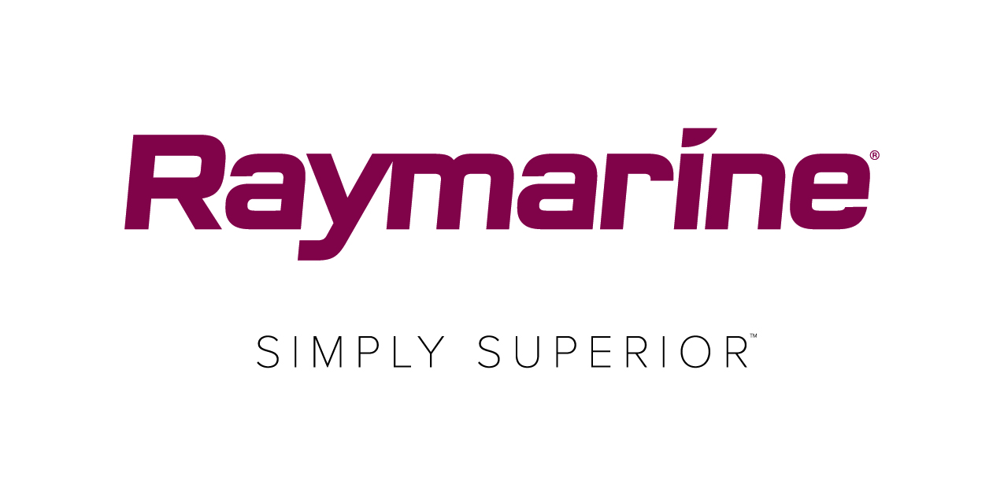

**Raymarine to Present its Latest Product Innovations at Seawork 2018**

*New Radar, Thermal, and Navigation Products Designed to help Professional Mariners Make Smart Decisions*

**FAREHAM, UK - 24 May 2018** – Raymarine, a brand of FLIR Systems, will be showing a range of its new and award-winning product innovations and technology at Seawork International. Its new line of Axiom Pro multifunction displays with FLIR ClearCruise™ thermal technology, which brings users an entirely new level of awareness on the water, will be of particular interest to professional mariners. Raymarine’s latest radar technology, Quantum 2 and new high-performance open array radar, Magnum™ will also be making their show debuts.

**FLIR ClearCruise™**

Available exclusively on Raymarine Axiom and the FLIR M132 and M232 thermal cameras, FLIR ClearCruise™ is intelligent thermal analytics technology, which effectively becomes another pair of eyes for both day and night crews, crucial for the safe operation of commercial vessels. The new technology provides audible and visual alerts of “non-water” objects such as boats, obstacles, or navigation markers providing an even safer experience for operations crew.

**Magnum™ and Quantum 2 Radars**

Raymarine will be debuting two new radar products at Seawork, Quantum 2 and Magnum™. Both

models offer professional mariners, reliable performance and advanced features to help them make

intelligent navigation decisions.

The high-performance open array radar, Magnum™ features superior bird mode, which could be the difference between a good catch and a great catch, and beam sharpening technology for enhanced image clarity. Offering users much of the same radar technology trusted by the United States Coast Guard, Magnum™ includes enhanced target tracking, reliable performance, and superior image detail. It is packaged in a sleek open array pedestal built to withstand any marine environment.

Raymarine’s most advanced, solid-state marine radar, Quantum 2 provides superior target awareness using advanced doppler processing. Quantum 2 instantly highlights moving radar contacts and colour codes them to indicate whether they are inbound or outbound. Quantum 2 with doppler helps captains discern potentially dangerous targets when navigating in high-traffic areas.

**Axiom® Pro**

Bringing together FLIR thermal, Raymarine radar, and GPS navigation into single powerful display is Raymarine’s high performance Axiom Pro. Available in 9-, 12- and 16-inch display sizes, Axiom Pro is designed for serious offshore mariners and professional captains. With a 1kW, high-powered CHIRP sonar and Raymarine’s built-in RealVision 3D sonar, Axiom Pro is a powerful, all-in-one MFD and sonar solution. Axiom Pro is powered by the intuitive LightHouse 3 OS and features Raymarine’s HybridTouch™ user experience, combining multi-touchscreen controls with an ergonomic keypad for additional confidence in rough seas.

Raymarine experts will be at Seawork Stand Q28 to answer your questions or demo products within the Raymarine range.

###

**About FLIR Systems**

*Founded in 1978 and headquartered in Wilsonville, Oregon, FLIR Systems is a world-leading maker of sensor systems that enhance perception and heighten awareness, helping to save lives, improve productivity, and protect the environment. Through its nearly 3,500 employees, FLIR's vision is to be "The World's Sixth Sense" by leveraging thermal imaging and adjacent technologies to provide innovative, intelligent solutions for security and surveillance, environmental and condition monitoring, outdoor recreation, machine vision, navigation, and advanced threat detection. For more information, please visit* [*www.flir.com*](http://www.flir.com/) *and follow* [*@flir*](http://www.twitter.com/flir)*.*

**Media contacts:**

**Karen Bartlett**

**Saltwater Stone**

+44 (0) 1202 669 244

k.bartlett@saltwater-stone.com