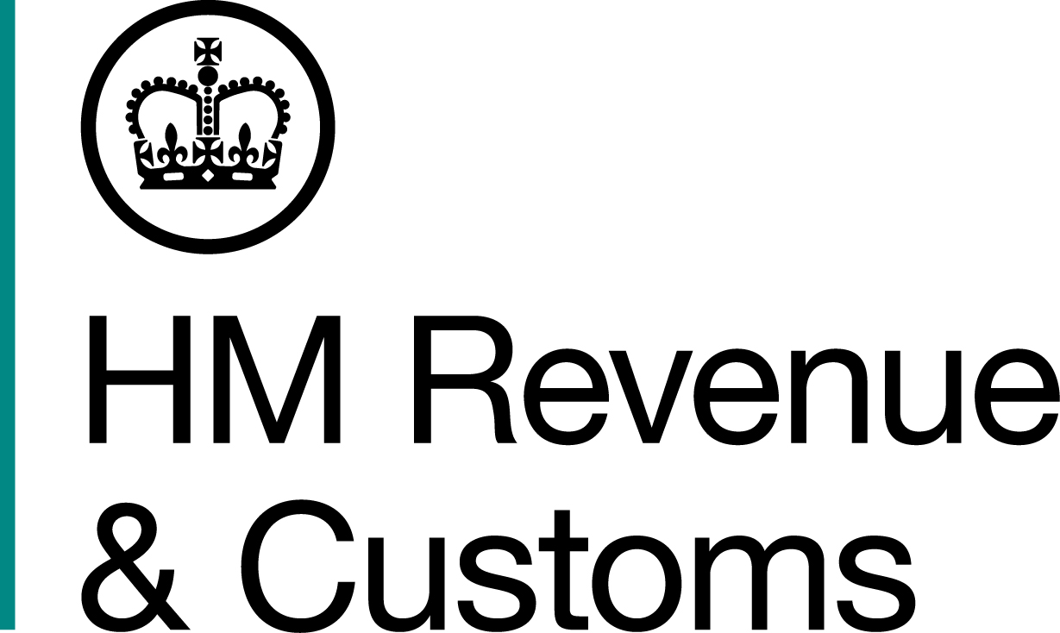
News Release

 | For the attention of News Desks |  | No of pages: 3
 | Date: | 26 October 2015 | Ref: | NTH.19.15

Fugitive cigarette smuggling kingpin jailed

A former County Durham milkman, who masterminded a plot to smuggle ten million illicit cigarettes into the UK, has been jailed after being extradited from Thailand by HM Revenue and Customs (HMRC) to face justice.

Paul Joyce, 41, originally from Consett, fled to the Far East in 2008, only hours before the other members of his gang answered bail for the £1.7m excise duty evasion.

With his criminal empire in tatters, the one-time crime boss began building a new life in Asia. Months later, his six associates began serving jail sentences totalling 12 years. But, in April 2015, after more than six years on the run, Joyce was captured at a luxury hotel in the coastal resort of Hua Hin in a joint operation between HMRC and Thai police.

Cheryl Burr, Assistant Director, Fraud Investigation Service, HMRC, said:

"Paul Joyce thought he could dodge justice by running away to Thailand, leaving his accomplices to serve their time while he soaked up the sunshine. Joyce has now swapped the exotic beaches of Thailand for a prison cell.

"We will always seek to track down, detain and escort criminals like Joyce back to this country to have their day in court. Disrupting criminal trade is at the heart of our strategy to clamp down on the illicit tobacco market, which costs the UK around £2.1 billion a year.”

Evidence against Joyce began to mount following his disappearance. In their search to find him, HMRC investigators turned to airline records, revealing that he had jetted to Bangkok. With the net closing in, HMRC secured a warrant for his extradition and, on 22 April 2015, he was arrested by the Royal Thai Police in the car park of the plush Sea-Cret hotel.

After serving ten weeks in a Thai jail, Joyce was escorted back to Newcastle by HMRC officers.

Newcastle Crown Court heard today how, during the fraud, Joyce had presided over a gang that was caught red-handed, on six occasions, with a total of ten million non-duty paid cigarettes – passing off their illicit cargo on import paperwork as everything from clothing to dog food.

In May 2008, three of Joyce’s associates were caught unloading a shipment of almost six million cigarettes at a Warehouse in Billingham, Teesside. But, unruffled by the seizure, the men continued to operate, moving further large quantities of contraband across the North East.

Joyce’s status as the gang’s kingpin was confirmed by mobile phone evidence linking him to his co-conspirators, proving he was in charge and pinpointing his whereabouts to key geographical locations.

After pleading guilty to the fraudulent evasion of excise duty, Joyce was jailed for two years and eleven months by Recorder Euan Duff at Newcastle Crown Court today, 26 October 2015.

Notes to Editors
- Paul Joyce, HMP Durham. DOB: 21/11/1974
- Joyce’s assets, including a house in Stocksfield, Northumberland, were frozen by HMRC and are the subject of confiscation proceedings under the Proceeds of Crime Act
- Anyone with information about the illegal sale of tobacco can contact the Customs Hotline on 0800 59 5000
- Follow HMRC Press Office on Twitter @HMRCpressoffice
- HMRC's Flickr channel: www.flickr.com/hmrcgovuk
- Images 1 to 4, showing the moment Paul Joyce was arrested by Thai police, must be credited ‘HMRC/Bangkok Post’.

Issued by HM Revenue & Customs Press Office

Press enquiries only please contact:

Joshua Shrimpton Dean
Tel: 03000 554556 / 07469 023445
Email: joshua.shrimpton-dean@hmrc.gsi.gov.uk
Or
Nikki Sanders
Tel: 03000 524936 / 07867 970437
Email: nikki.sanders@hmrc.gsi.gov.uk

Out of hours
Tel: 07860 359544

Website www.hmrc.gov.uk

