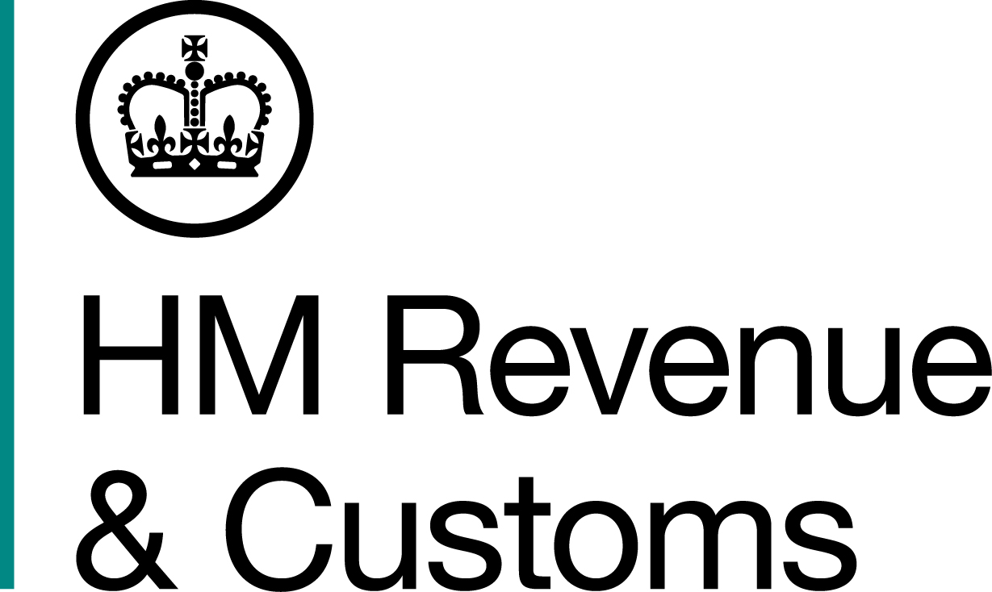
News Release

 | For the attention of News Desks |  | No of pages: 2
 | Date: | 9 February 2015 | Ref: | NAT 09/15

Online tax summaries available now

More than eight million taxpayers who filed their 2013-14 tax return electronically by the 31 January deadline can now access their online tax summary.

The summaries set out how much tax and National Insurance each person has paid in the tax year, and how it contributed to public expenditure.

The online summaries can be viewed by logging onto HMRC online services and selecting the ‘View your 2013 to 2014 tax summary’ option.

Millions of taxpayers who are in the PAYE system and don’t file tax returns have already received paper summaries in the post. Others will receive a paper version in the future, once their 2013-14 tax affairs have been finalised. Online filers who missed the deadline will have access to an online summary once they send their overdue return online.

Financial Secretary to the Treasury, David Gauke, said:

“Taxpayers have a right to know how the Government is spending their tax and National Insurance contributions. The Government promised to provide transparent information about its expenditure and these summaries deliver on that promise.”

Any taxpayer who does not receive a tax summary can use HMRC’s tax calculator to estimate their tax bill and see how it contributes to public spending. The ‘HMRC App’ containing the calculator can be downloaded free of charge from the Apple App Store or the Google Play Store by searching for ‘HMRC’.

Notes for editors

- The summaries were first announced by the Chancellor of the Exchequer, George Osborne, at Budget 2012, in a move to make tax more transparent and easier to understand.

- HMRC received 8.76 million online 2013-14 tax returns by 31 January 2015. Tax summaries will be available for all returns where there is an actual tax liability.

- Follow HMRC Press Office on Twitter @HMRCpressoffice

- HMRC's Flickr channel www.flickr.com/hmrc.gov.uk

Issued by HM Revenue & Customs Press Office

Press enquiries only please contact:

Patrick O’Brien
Tel: 03000 585024
Email: patrick.o’brien@hmrc.gsi.gov.uk

Out of hours
Tel: 07860 359544

Website www.gov.uk/hmrc

