Press release June 2020

New Kiel zero-euro-note for the 125th anniversary of the Kiel Canal
Luminous special edition with the “Kaiseryacht” (imperial yacht)

It is one of the best-selling memorabilia and has established itself as a cult object: the zero-euro souvenir note has been met with great enthusiasm by tourists and locals since 2017. A newly designed, limited edition of the collector’s item was produced by Kiel-Marketing on the occasion of the 125th anniversary of the Kiel Canal.

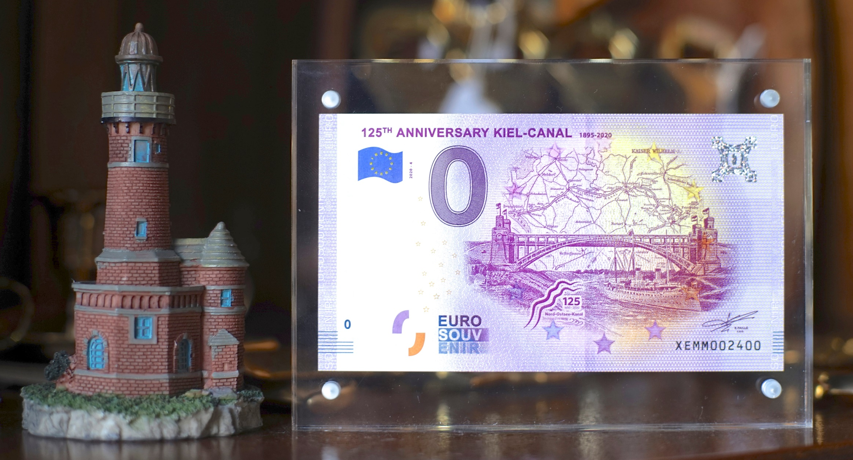
This year’s zero-euro-note commemorates the 125-year history Kiel-Canal 1895-2020 of the world’s most frequented artificial waterway and also celebrates its own anniversary. The Kiel souvenir note with four individual motifs of tourist events has already been available for five years.

In Kiel.Sailing.City the success began with the image of the naval sailing training ship Gorch Fock and was continued with the €0 note on the occasion of the sailors’ revolt in Kiel and the 125th anniversary of Kiel Week. This year, the Kiel Canal and the imperial “Kaiseryacht” adorn the front of the souvenir note.

The €0 note with the international title „125 Anniversary Kiel-Canal 1895-2020” is available as a collector’s item for €3,50 per note. Collectors can also look forward to a special edition, in which some Kiel Canal banknotes were additionally designed with a two-colour fluorescence printing ink. This colour is only recognizable under UV light and servers the protection and identification of counterfeits. The special edition is exclusively available in a four-pack with all Kiel souvenir notes with the motifs of the Gorch Fock, the sailors’ revolt, the Kiel Week and the Kiel Canal for €10 at the Tourist Information Kiel and is limited to 2.000 pieces.

The €0 souvenir note for the Kiel Canal anniversary is available at the €0 note vending at the counter in the Tourist-Information Kiel or at the machine in front of the Tourist Information Monday to Friday available from 7 am to 5 pm (not on public holidays). You can also order in the online shop at www.kiel-souvenirs.de, shipping is possible on request.

You can’t pay for purchase with the note. Nevertheless, the banknote is even officially recognised by the European Central Bank (ECB) and produced in the utmost secrecy by a specially licensed money printer. The €0 note, which is always kept in purple, is printed on the real European paper and measures 125mm x 74mm. In addition, the note has the usual security features such as watermark, hologram, transparent window, copper strips and an individual serial number.

Pressekontakt: Eva-Maria Zeiske, Tel.: 0431 – 679 10 26, E-mail: e.zeiske@kiel-marketing.de
Kiel-Marketing e.V., Andreas-Gayk-Str. 31, 24103 Kiel, www.kiel-marketing.de

