Permateek Appoints Danish Dealer and Installer
Horsens Yachtværft ApS is located on Denmark’s east coast, the home of the extensive Danish boat-building industry
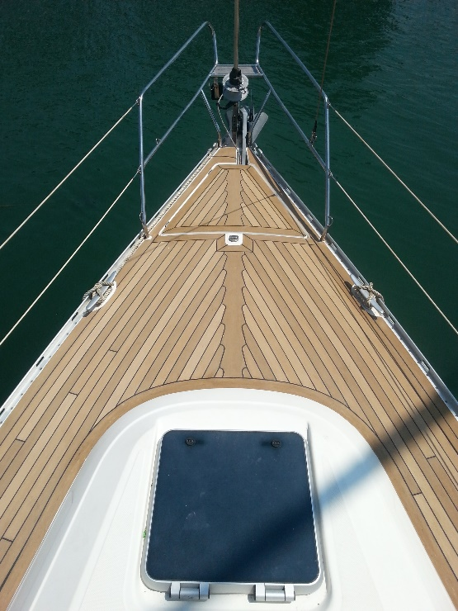

Continuing its comprehensive European development, Permateek, the UK manufacturer of high-quality decking for both power and sailing yachts, has appointed a second specialist dealer and installer for Denmark. Horsens Yachtværft ApS is located on Denmark’s east coast, the home of the extensive Danish boat-building industry. The company is well known in the region as one of the most modern repair and service yards in Denmark, with customers from Holland, Germany and Denmark itself providing an extensive market for the Permateek products.
The Horsens Yachtværft installation team have recently attended Permateek’s dealer/installer course at its Bournemouth factory to learn about the various Permateek style options and technical installation processes which create the very best and most long-lasting teak-style decking. Boats fitted with Permateek 10 years ago are still boasting a stylish, non-slip and simple-to-maintain synthetic teak deck that looks like new.
The installation team were shown the benefits of Permateek, which has been engineered in the UK with specialist materials that perform even better than natural teak. The decking is stain-resistant, impact-resistant, mould-resistant and, an important factor in maintaining Permateek’s fresh looks, resistant to UV fade. The unique design of the product’s underside allows fitters to achieve an air bubble free adhesion to the deck, ensuring its longevity beyond other types of decking.
Vince Corda, MD of Permateek, said: “We were delighted to welcome Horsens Yachtværft to our training course and were impressed by the extensive skills they’ve accrued at the yard in Demark, where they have worked on a vast range of vessels. It is clear they will be able to offer the high standards of product installation that we are keen to provide for our Permateek customers”.
For more information, visit www.permateek.com.

