Wantr.com reinvents online window-shopping

Keeping up with the latest trends and arrivals can be pretty time-consuming, but now social shopping startup Wantr is introducing a fast and fun way for people to get all the latest arrivals from their favorite online stores, in a single place.

Follow your favorite stores
Online stores add exciting new arrivals all the time, and now with Wantr, you can collect them all in one place. Simply add the stores you want to follow, and Wantr will notify you every time they update.

Co-founder Toke Grøfte explains: “Before Wantr, I used to visit the same five or six online stores every day to see if they had any cool new sneakers, oftentimes to no avail. We really felt there had to be a better way to stay on top of your favorite shopping sites. What we wanted to create was a fun and simple way for new product arrivals to find you, rather than you trying to find them.”

Any online store, every new arrival
On Wantr, people can add any given category page from stores they want to follow, like “Women’s New Arrivals” from Asos.com or “Kids’ Shoes” from Nike.com. Wantr then keeps a watch on these pages, and immediately lets you know when new products arrive. This makes Wantr the first shopping tool where people can aggregate all the latest arrivals from any online store, in a single place.

Discover amazing stores and products
Not only is Wantr an efficient tool to stay updated on your favorite stores – it is also a great place to discover a world of new ones. Every product on Wantr comes with a “Want” button that lets you save your amazing shopping finds to a personal collection on the site, and as you save things, your friends on Wantr also get to discover them. In this way, the Wantr community comes together to help each other discover new and interesting products from the world’s best online stores.

Wantr has been testing with a closed group of power shoppers for the past six months in preparation for launch, and has recently raised a $600,000 funding round led by SEED Capital to further develop the platform.

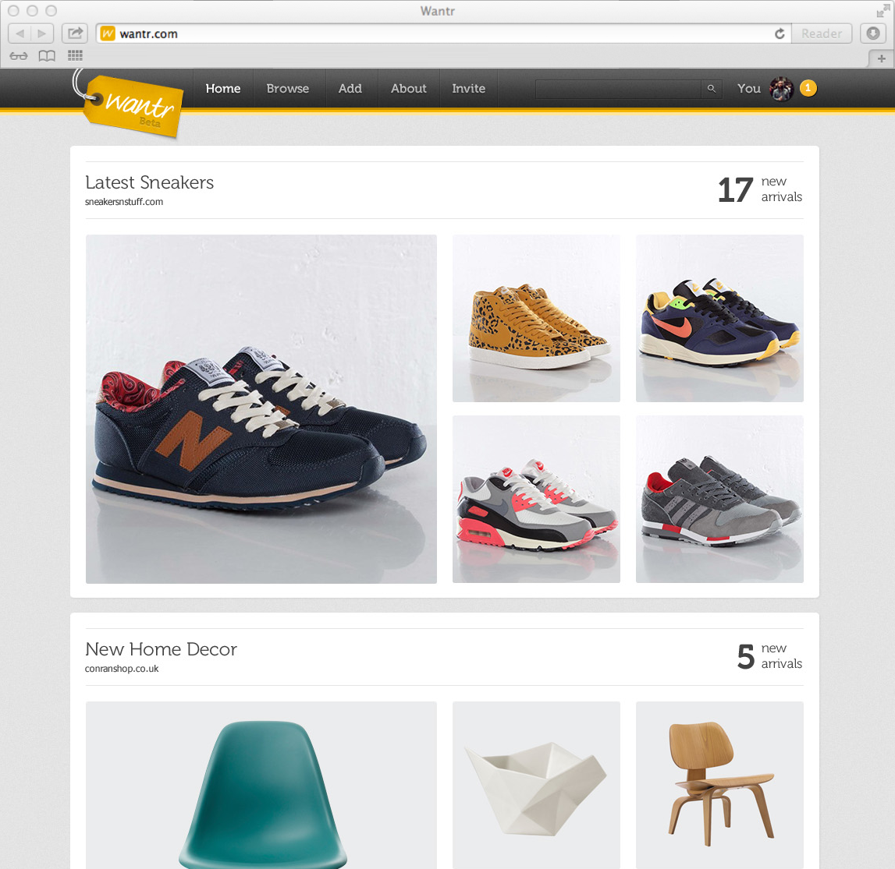
Screenshot of the Wantr home page for a logged-in user

Wantr facts
- Founded in 2012 by Stefan Bech (CEO) and Toke Grøfte (CMO)
- Based out of Copenhagen, Denmark, and counts seven employees
- Featured on This Week in Startups with @jason during beta test
- Launched to the public in March 2013

For more information, please contact

Stefan Bech, CEO/Co-founder, stefan@wantr.com, +45 6166 6551

Toke Grøfte, CMO/Co-founder, toke@wantr.com, +45 2614 9019

