13th of January 2017

US FDA 510(k) Clearance for Luer-Jack® Slip syringe

ConceptoMed AS received FDA 510(k) clearance from the U.S. Food and Drug Administration (FDA) for the first size of the Luer-Jack® syringe.

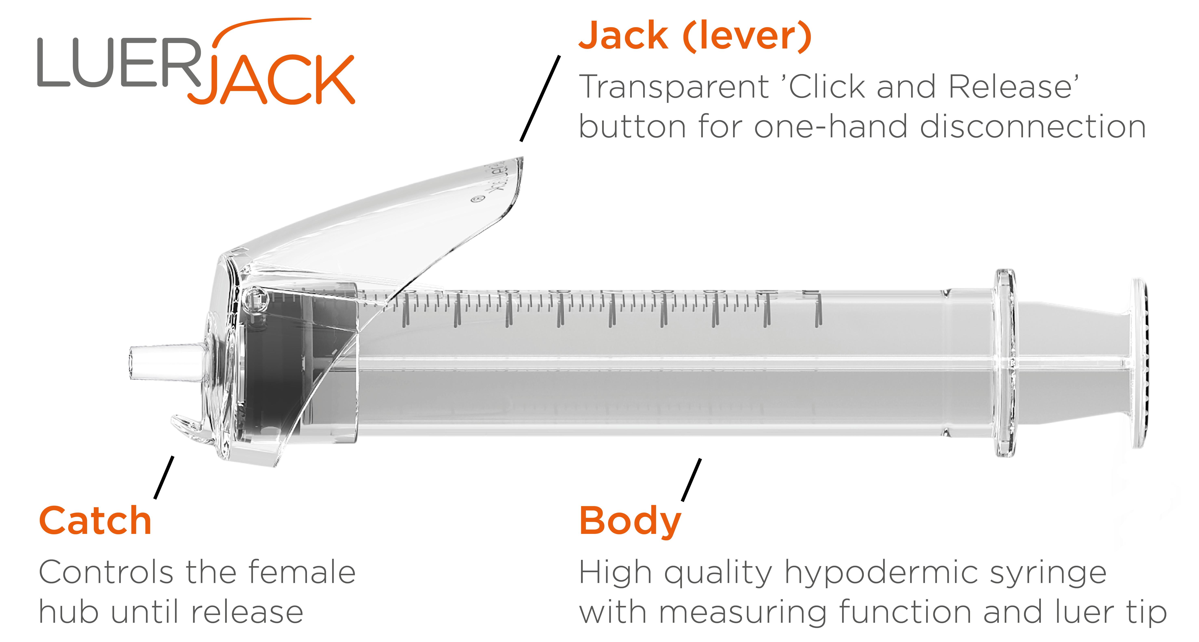

“I am very pleased to receive FDA 510(k) market clearance for our first size of the Luer-Jack® Slip syringe. The FDA 510(k) market clearance represents another important milestone in our global company strategy and will open up potential of establishing a commercial presence of the Luer-Jack® in the world’s largest single US healthcare market”, said Christian Mide, M.D., CEO and founder of ConceptoMed.

About Luer-Jack®
Luer-Jack® is a user-friendly syringe, which will become an important contribution to procedure quality and aseptic procedures when handling medical connections – simply by its one-handed disconnection capability. Luer-Jack® is delivered in a simple to use and uniquely designed packaging – the Steri-Tilt™
.

Health authorities and medical professionals now have the option of implementing a medical device with an integrated and user-friendly one-handed aseptic disconnection technique as part of the medical device itself.

A key element of a next-generation medical syringe could become the development away from using two hands during disconnections.

Luer-Jack® Slip syringes are already CE marked and sold by distributors in Europe.

For more information, please visit www.luerjack.com

ConceptoMed AS is a ISO 13485 certified, ambitious medtech company serving the global market with innovative product categories and unique proprietary technology. We create smart medtech systems that empower healthcare professionals and improve patient care. Excellence through simplicity is our code. We are brave, curious and dedicated. We simply care.
Based in Norway, the team is continuously meeting milestones and expanding its activities for international growth.
For more information on the company and career opportunities, see www.conceptomed.com and www.luerjack.com.
Follow us on MyNewsdesk and LinkedIn.

Luer-Jack® is a registered trademark owned by ConceptoMed AS. The Luer-Jack® technology is widely patent protected throughout the world, currently with almost 50 patents (granted and pending) from 8 patent families.

