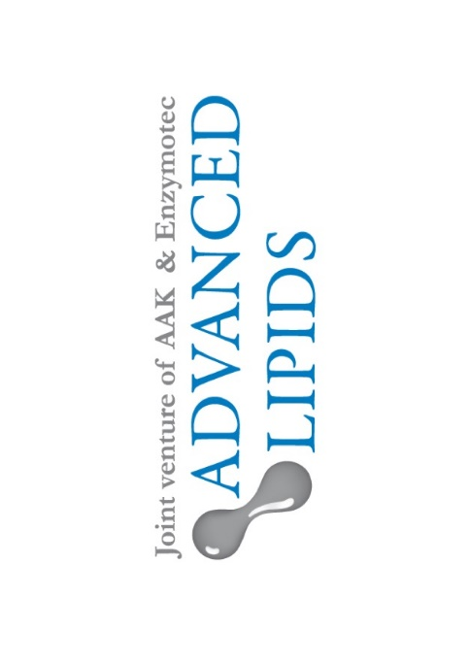
INFAT® may help infant bone growth, study shows

INFAT® – Advanced Lipids’ SN-2 infant formula ingredient – may have the potential to support healthy bone growth, a study has shown.*

Palmitic acid is the most abundant saturated fatty acid in human milk, where it is primarily located in the SN-2 position. SN-2 palmitate is a well-established structured fat added to infant formulas. It is already known to offer a range of benefits for babies, including longer sleep duration and reduced crying.

Recently, researchers set out to explore the effect that SN-2 palmitate has on the length and quality of bones in a catch-up growth model. After restricting the diets of two groups of rats, one group was fed with a diet enriched with INFAT® – Advanced Lipids’ SN-2 palmitate ingredient – and the other with a standard diet.

Weight gain was similar between the two groups and there were no adverse effects from either diet. However, rats in the INFAT® group scored higher on parameters such as humerus length. Values relating to bone quality also seemed higher in the INFAT® group, although the difference did not reach statistical significance.

Researchers also analysed gene expression in the two groups and found that three genes in the liver showed an increase in the INFAT® group. They say these may be associated with growth and development in the Epidermal growth plate.

Commenting on the findings, Dr Sigalit Zchut, Chief Scientist at Advanced Lipids, said:
“INFAT® is already a well substantiated structured fat for infant formula with multiple clinical studies proving its benefits for infant nutrition. However, as an innovative company, Advanced Lipids is testing its effect in other fields as well. This study is exciting because it shows that SN-2 palmitate may have a beneficial effect on the length and quality of bones of mice that were subjected to food restriction, followed by nutrition-induced catch up growth. Though this is a pre-clinical study, its implications may be important, especially for children with growth disorders and children
with special nutritional needs.”

*Notes to Editors

Bar-Maisels M, Gabet Y, Shamir R, et al. ‘Beta Palmitate Improves Bone Length and Quality during Catch-Up Growth in Young Rats’. Nutrients. 2017;9(7):764. doi:10.3390/nu9070764.
https://www.ncbi.nlm.nih.gov/pmc/articles/PMC5537878/

About Advanced Lipids
Advanced Lipids is a joint venture established by Enzymotec, a leading biotech company specializing in lipid-based bio-functional ingredients, and AAK, a global producer and supplier of speciality vegetable fats and oils for the infant formula industry. Combining Enzymotec’s clinical and chemical expertise in lipid technologies with AAK’s international strength in food safety, production and logistics, Advanced Lipids offers a unique package of clinical research, development, flexible blending, quality and logistics. Find out more at www.advancedlipids.com.
For more information contact
Steve Harman
Ingredient Communications
+44 (0)1293 886444
+44 (0)7494 307911
steve@ingredientcommunications.com

