**PRESS RELEASE**2015-04-01

**Sven Hagströmer’s Creades new majority owner of Inet**

**”With their support and knowledge we will grow even faster”**

**Inet has been growing steadily since the start fifteen years ago. They have developed from a small computer store in Gothenburg to one of the largest and most consumer prized computer retailers both online and in store. The investment company Creades is now buying seventy percent of the computer company, in time for Inet’s newest expansion in Barkarby. It will be the second store in Stockholm and the sixth store in Sweden.**

**– We’ve always had big plans for our growth and we’re working hard to become the largest and most popular computer store chain in Sweden. With this new experienced partner at our side, I expect our continued expansion will be both quicker and more enjoyable. I will of course remain as a shareholder, says Erik Wickman, CEO of Inet.**

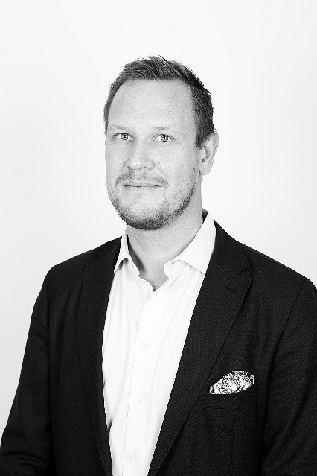Inet’s new majority owners are extremely dedicated and hopeful.

– We’re investing in Inet because we believe in the management team and in the entire company’s ability to keep performing just as good as they have up until this point. Inet are making money in an industry where competition is tough. The main reason is that they take care of all their customers in the best way possible. Inet has an incredibly professional customer service as proven by all the awards they keep receiving, says Per Frankling, CEO of Creades.

Investor and entrepreneur Sven Hagströmer is the principal owner of Creades, whose business idea is to invest in small and medium-sized Swedish companies where they can act as a committed owner.

– There is a strong demand for computers, computer components and accessories, and that demand will remain strong in the future. Our new majority owner and I will work together for continued growth both in the number of stores and online sales, says Erik Wickman, CEO of Inet.

The investment company Creades is buying the majority share of Inet, and will aim for continued growth. Inet’s CEO Erik Wickman welcomes the new owners.

Inet currently has five stores in Stockholm, Gothenburg, Malmö and Uddevalla. The sixth store opens in Barkarby outside of Stockholm in late April.

– The most important thing for us is to keep Inet growing profitably. My belief and hope is that we can grow even faster once the Barkarby store has proven to be a good establishment. There are many different ways to grow, our key aspect lies in Inet’s exemplary way of taking care of their customers, says Per Frankling, CEO of Creades.

**For further information**

Erik Wickman, CEO Inet, +46 (0) 708-65 27 02, [erik.wickman@inet.se](mailto:erik.wickman@inet.se)   
Per Frankling, CEO Creades, +46 (0) 702 68 59 08, [per.frankling@creades.se](mailto:per.frankling@creades.se)

Magnus Sjöbäck, Press Officer Inet, +46 (0) 704-45 15 99, magnus.sjoback@inet.se

<http://www.inet.se/>

<http://www.creades.se/>

**Creades in an investment company** with long term commitments in small and medium sized companies. The holdings include Acne Studios, Avanza Bank, Carnegie and Lindab. The Creade shares are traded on NASDAQ OMX Stockholm’s main market.

**Inet sells computers, components and computer accessories in Sweden**, online and in stores located in Gothenburg, Malmö, Stockholm and Uddevalla. The business started in 2000, has a turnover of SEK 540 million and currently employs around 65 highly trained and responsive staff. Inet’s headquarter is in Sisjön, Gothenburg. Inet was appointed Computer Store of the Year by Sweclockers.com in 2014, Online Store of the Year 2014 by Prisjakt and Online Retailer of the Year 2014 by Pricerunner.