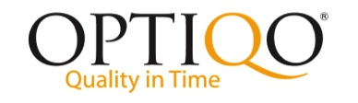

**Sweden 2015-04-23**

**Optiqo Releases an Easy to Use, Low Cost Inspection App for Iphone**

**The app ”Optiqo Inspect” is customized for the cleaning industry and comes with 2 sets of customer types; home cleaning & office cleaning templates. Of course it is possible to add new room types and the tool can also be used for other kinds of services e.g. home help service, technical control or general quality control.**

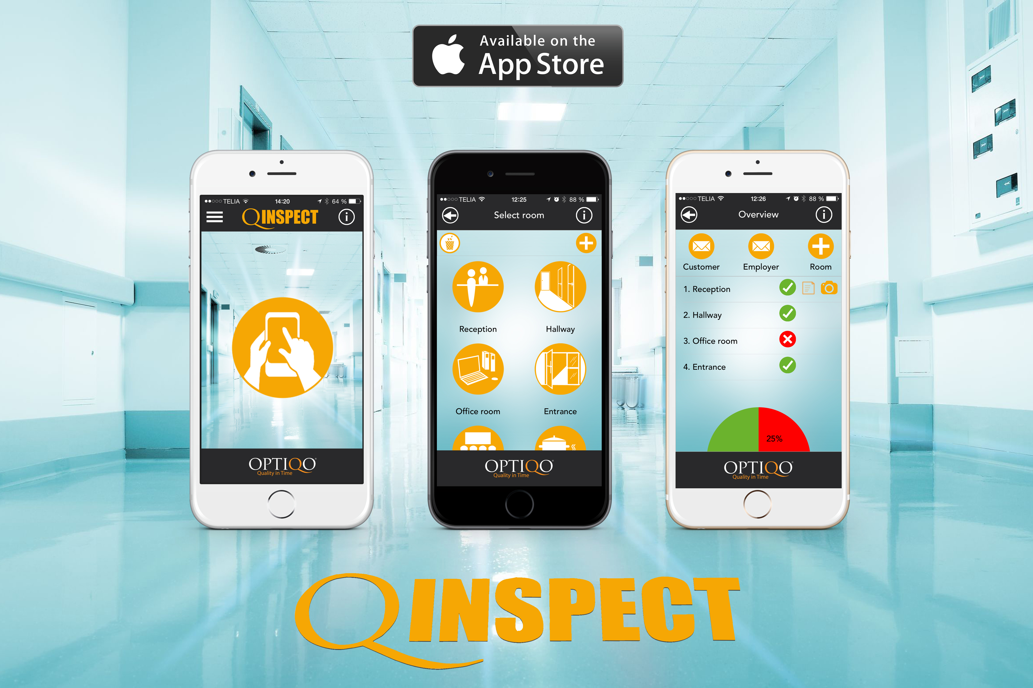

* Contains ready defined room types as well as the possibility to add own types
* Client register
* Possibility to draw on photos to highlight deviations and enter comments.
* Clear pictograms/symbols for easy use.
* Quality reports can be sent directly to the client and employer with a single push of a button
* Supports custom logotype
* GPS tagging
* Date and time for the assignment with timestamp for each room
* Signature of the person who is in charge of the inspection
* User defined language support

The user manual can be found at www.optiqo360.net. Choose "Request access" at the bottom left of the screen and fill in your e-mail address. Soon you will receive an e-mail with a link to where you can create an account.

**For further information regarding the product contact:** Martin Älenmark – Optiqo Sweden AB **Phone number:** (+ 46) 13 13 10 03 **E-mail:** [info@optiqo.com](mailto:info@optiqo.com)

***Optiqo Sweden*** *was founded in 2012 and has 25 years of experience from the international cleaning- and facility –management (FM) industry. Optiqo is a safe partner that helps the costumer achieves a higher level of quality on their services and to have a day to day overview of the completed tasks.*

*The market for cleaning and nursing services is an area in constant change and the only thing that is certain is that it will keep changing. Thanks to Optiqos ability to quickly adapt and respond to new trends and alternating needs of the customers, we will always offer our clients a flexible, functional quality solution that will work all day, all year, regardless of the cultural background of the employees, language skills or educational level.*

Roxtorpsgatan 16B, SE-582 73 Linköping Sweden • www.optiqo.com • (+46) 13 13 10 03

