**GOTHENBURG HOSTS SHOWCASE OF THE NORDIC’S BEST BARISTAS**

|  |  |  |  |
| --- | --- | --- | --- |
|  |  |  |  |
| **Rory Rosenberg**  **(Norway)** | **Steven Moloney**  **(Sweden)** | **Sonja Zwiedick**  **(Denmark)** | **Jarno Peräkylä (Finland)** |

On the 10th of September the national barista champions of Nordic countries will come together for a very special showcase and training weekend. These four baristas, and their teams, represent the best baristas the Nordic countries have to offer. This is a unique opportunity for them to prepare and collaborate befor they all travel to Seoul in South Korea in November to compete in the World Barista Championships.

The superstar baristas will present their championship routine in front of a panel of experienced judges and competitors including 3 time Italian champion **Francesco Sanapo**, 2016 world championship finalist **Lex Wennecker** and world renowned judges **Nora Smahelova**, **Blazej Walczykiewicz** and **Lukasz Jura**. ‘It’s the ultimate opportunity to get the most up to date feedback from fellow competitors and world class judges..’ says Jarno Peräkylä of the showcase.

The World Barista Competition pits national champions against each other in a 15 minute presentation focusing on creativity, precision and mastery of coffee brewing. Each competitor must serve four espressos, four cappuccinos and four signature drinks all focusing on the taste experience of the coffee they have brought for the judges.

Bringing these four champions and their teams together will not only create a stronger and more connected Scandinavian Team, but also provide valuable experience for the competitors and hopefully put Nordic baristas back at the top of the world competitions.

**When:** September 10,2017  
**Where:** Ally Coffee, Gothenburg. Sweden.  
**What:** A world class barista showcase by the four national champions of Sweden, Denmark, Norway and Finland.  
**Why:** Bringing together the 4 best baristas in the Nordic countries to learn, practice and develop together in preparation for the World Barista Competition in Seoul, 2017,

**The Nordic Team Showcase is proudly supported by:**

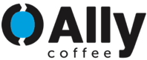 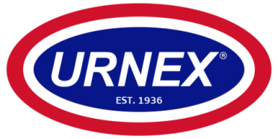

**BIOGRAPHIES**

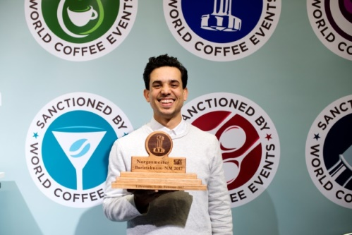**Rory Rosenberg | NORWAY | Kaffa Oslo**

Rory Rosenberg is a 28 year old from South Africa who has been living and working in Oslo for the past 4 years. Previously working for Stockfleths in Oslo as bar manager and trainer he is now developing his own cold brew coffee and tea company there in Norway. At the WBC in November he will be representing Collaborative Coffee Source and Kaffa Oslo using a coffee from Long Miles Coffee Project in Burundi.

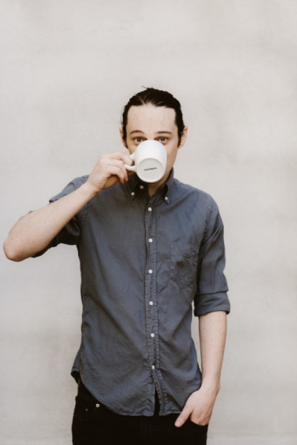**Steven Moloney | SWEDEN | da Matteo**

Strangely, or perhaps not so, 27 year old Steven Moloney only found good coffee after moving from Australia to Sweden in 2012. Ever since, he’s been lucky enough to work with and learn from some of the leaders of the Scandinavian coffee scene. Starting at Love Coffee Roasters in Lund, he has since moved on to head up Da Matteo’s barista training program in Gothenburg.

Steven is a two-time winner of the Swedish National Barista Championship (2016, 2017) and was part of the winning team in the World Barista Cup 2016. He has developed the Barista League from an impromptu gathering of 10 baristas in a countryside roastery (2015) to an event attracting hundreds of the best coffee professionals from all over Northern Europe (2017). He probably won’t rest until it’s taken over the world either.

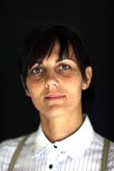**Sonja Zweidick | DENMARK | Independent**

Sonja is a three time national barista champion and is currently living in Åarhus, Denmark. Aside from her work both behind the bar and as a roaster, she has judged in the London Coffee Masters, Danish Aeropress Competition and The Barista League as well as being invited to speak at Reverb: Manila in 2017.

She is the founder of Barista Connect, an international network for female coffee professionals. Barista Connect aims to improve gender equality by creating a space where women from all parts of the industry connect, share knowledge, and inspire each other.

**Jarno Päräkyla | FINLAND | Caffi**

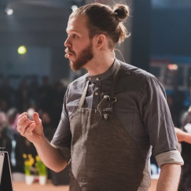Two-time Finnish Barista Champion (2016, 2017), Jarno has worked in coffee business for four years as barista and roaster. After working in several cafés in Sweden and Finland he is currently settled at Caffi in Helsinki as the Head Barista, roaster and Barista trainer. In 2016 Jarno placed 25th of 61 in the World Barista Championships in Dublin.