**UNIDENTIFIED: INSIDE AMERICA’S UFO INVESTIGATION WITH TOM DELONGE**

**EXCLUSIVE PREMIERE SERIES ONLY ON HISTORY®**

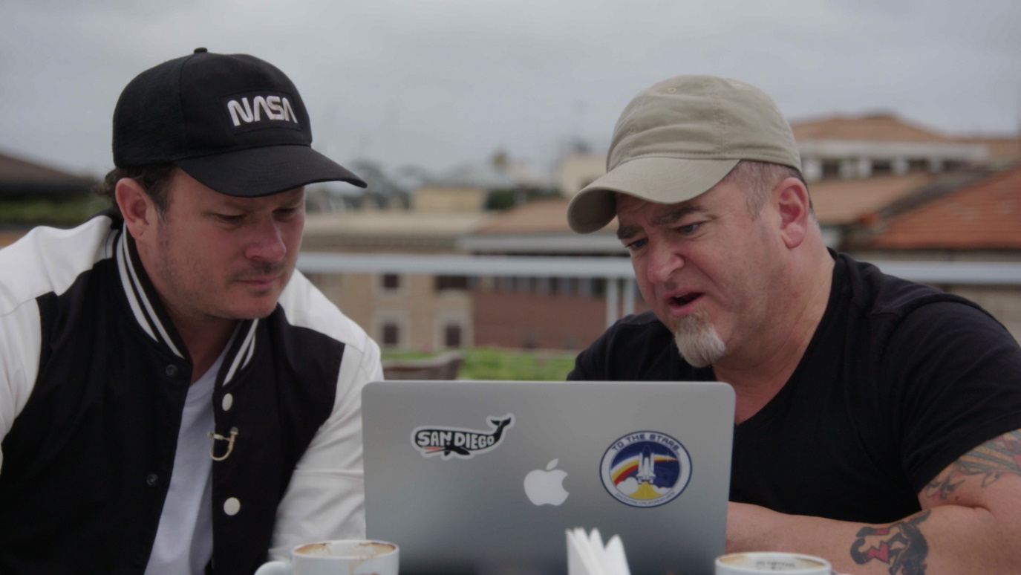

**TUESDAYS AT 22.00 FROM 1ST OCTOBER (6x1)**

**INTERVIEWS AVAILABLE ON REQUEST**

Web: <https://www.history.co.uk/unidentified>

Facebook: [www.facebook.com/HISTORYdanmark](http://www.facebook.com/HISTORYdanmark) | [www.facebook.com/HISTORYnorge](http://www.facebook.com/HISTORYnorge)

Hashtag: #Unidentified

**HISTORY®** exposes the incredible secrets of the American government’s secret UFO programme, shedding new light on unidentified flying phenomena in the USA and around the world.

Following a stunning 2017 frontpage [New York Times expose](https://www.nytimes.com/2017/12/16/us/politics/pentagon-program-ufo-harry-reid.html), which revealed the existence of a hidden Pentagon UFO investigation unit, HISTORY® uncovers shocking revelations from sources close to the pentagon, the FBI and the US government – led by former **Blink-182 frontman** [**Tom DeLonge**](https://www.allmusic.com/artist/tom-delonge-mn0000931045/biography)(pictured left).

Headed up from 2007-2012 by Luis Elizondo (pictured right), a $22 million project - officially dubbed the Advanced Aerospace Threat Identification Program (AATIP) - was tasked with investigating the threat of UFOs over American skies and around the globe.

In this brand-new series, Elizondoreveals details of the US government’s awareness, and cover-up of, extra-terrestrial lifeforms on earth.

AATIP allegedly captured a trove of evidence that was compiled into a top-secret, 600-page ‘blue book’ (named after Project Blue Book, the US government UFO study that ran from 1947-1969). *Project Blue Book* is now a major US drama from HISTORY® featuring Aidan Gillen.

Elizondo, who no longer works in government, keeps one copy at an undisclosed location 300 miles from Washington DC. He is now part of a team of UFO investigators led by rock star **Tom Delonge**, which includes renowned CIA researcher and quantum physicist, **Hal Puthoff**, and former Assistant Secretary of Defence for Intelligence, **Chris Mellon**.

In this exclusive six-part series for HISTORY®, Delonge, Elizondo, Mellon, Puthoff and others reveal for the first time the AATIP’s copy of the United States Blue Book on UFO sightings and analyse its explosive contents.

**Episode 3 to view** [**here**](https://we.tl/t-ZC0Oh6bARy)

**Download key art imagery and digital asset** [**here**](https://www.dropbox.com/sh/1ibl0awj6k9ls09/AAAEbFhqNosZUNSJQEPSN5z3a?dl=0)

**Contributor biographies:**

**Tom DeLonge**

Co-founder of US rock bands Blink-182 and Angels & Airwaves, and having sold over 25 million records worldwide, DeLonge has since dedicated much of his life to exposing the truth about extra-terrestrial lifeforms on earth. After being involved with various other business ventures, DeLonge also co-founded To The Stars Academy of Arts & Science in 2017, and is President of the organisation.

**Luis Elizondo**

Luis Elizondo is a former employee of the Office of the Under Secretary of Defence for Intelligence (OUSDI). He currently serves as Director of Global Security and Special Programs at To The Stars Academy of Arts and Science. Elizondo formerly headed the Advanced Aerospace Threat Identification Program (AATIP) until the program was defunded. AATIP was a secretive $22 million program initiated by the Defense Intelligence Agency in order to study Unidentified Aerial Phenomena (UAP), also known as UFOs. According to the Pentagon, it was cancelled in 2012. In October of 2017, Elizondo resigned from OUSDI after expressing his concern of what he called "bureaucratic challenges and inflexible mindsets" in all levels of the Department. In his resignation letter, Elizondo wondered why "certain individuals in the Department remain staunchly opposed to further research" of "unusual aerial systems interfering with military weapon platforms and displaying beyond next generation capabilities" despite numerous accounts by the United States Navy and other Services.

**Chris Mellon**

Christopher Mellon is the former United States Deputy Assistant Secretary of Defence for Intelligence (the third highest intelligence position at the Pentagon), having served in the Bill Clinton and George W. Bush administrations. He also formerly served as the Staff Director of the United States Senate Select Committee on Intelligence. Mr. Mellon is currently a private equity investor and National Security Affairs Advisor and shareholder in To the Stars Academy of Arts and Sciences.

**Hal Puthoff**

Harold E. Puthoff, Ph.D. is an American physicist who has co-authored several books on gravitational and paranormal research. Puthoff is well known within gravitational physics circles for his papers on alternative approaches to general relativity and quantum mechanics. In the 70s and 80s he directed a CIA/DIA-funded program at SRI International to investigate paranormal abilities. Puthoff was once a United States Navy officer who was assigned to the National Security Agency (NSA), later becoming a civilian employee. He joined SRI International where in 1972 he co-founded a then-highly-classified ‘remote viewing’ program, STARGATE, which was funded over its two-decade-plus history by the CIA, DIA, and various military organizations.

**Programme Information**

**Episode 1: The UFO Insiders – TUESDAY 1ST OCTOBER AT 22.00**

Former U.S. government insiders brought together by rock star Tom DeLonge team up to reveal what the government knows about UFOs. This groundbreaking effort is led by Luis "Lue" Elizondo, who ran the U.S. government's $22 million secret UFO program. Elizondo reveals new details about his Pentagon investigation including five extraordinary capabilities the bizarre craft may share and chases fresh leads. U.S. Navy fight pilots tell him new details about the "tic-tac"-shaped UFO that was caught on film in 2004. Is this incident an indication of a larger threat to U.S. national security?

**Episode 2: Raining UFOs – TUESDAY 8TH OCTOBER AT 22.00**

A former U.S. Navy radar operator emerges from the shadows to reveal the terrifying day it rained UFOs. For the first time, U.S. Navy personnel unveil new details of the stunning encounter, including a shocking capability that could explain why UFOs are sighted over oceans. Evidence of a U.S. military coverup emerges, as the team gets a major lead guiding them to an island with a long, clandestine history of UFO activity. Connections between UFOs and secret U.S aircraft must be explored.

**Episode 3: The Pattern Revealed – TUESDAY 15TH OCTOBER AT 22.00**

The list of military eyewitnesses describing strange and threatening unidentified craft in U.S airspace is growing. And now, a U.S. Navy radar operator has provided something more: Actual coordinates where UFOS appeared and disappeared. Lue Elizondo and a new partner follow the trail, and find that these unidentified craft are still seen. New eyewitnesses provide chilling details, and a correlation to U.S military sightings. As the reports mount, Lue closes in on a location where visitors are not allowed: Ground zero for the sightings.

**Episode 4: UFO Fleet – TUESDAY 22ND OCTOBER AT 22.00**

Evidence continues to mount and patterns emerge, as a group of former U.S. government insiders seek the truth behind UFOs. A shocking new encounter pulls them to another part of the U.S.A. where two more military eyewitnesses risk their career to recount what they saw, describing a mass sighting of UFOs within striking distance of one of the most important cities in the U.S. video, authenticated for the first time, shows bizarre, unidentified craft with incredible abilities, but what the team learns next is chilling: The objects may follow ships and people.

**Episode 5: The Atomic Connection – TUESDAY 29TH OCTOBER AT 22.00**

An encounter in the American heartland indicates a disturbing twist to the UFO phenomenon. The team follows a trail of explosive evidence connecting UFOs to the most destructive weapons in human history. A former U.S Air Force Colonel discloses an encounter on Christmas Eve 1980 at a base hiding a secret stockpile of nuclear weapons, while where another former Air Force officer describes a UFO-related injury. Was the U.S. military planting UFO misinformation to distract attention from top secret test, or are they hiding an even more ominous threat?

**Episode 6: The Revelation – TUESDAY 5TH NOVEMBER AT 22.00**

The investigation has uncovered shocking video evidence, patterns, secret coordinates, and jarring eyewitness testimony about UFOs. The biggest question now is what are they, and are they dangerous? Following a lead, the team goes to an allied European country to probe a case where an UFO allegedly shot down a helicopter. While there, high-ranking military officials drop a bombshell. Former Senator Harry Reid goes on the record, as Elizondo and former Lockheed Martin engineer Steve Justice address the biggest question of all. Will we finally get the truth about UFOs?

**ENDS**

**For more information please contact:**

Jo Fellows at A+E Networks UK / [Joanna.Fellows@aenetworks.co.uk](mailto:Joanna.Fellows@aenetworks.co.uk) / +44 7583 022 665

**Editor’s Notes**

* HISTORY social pages @HISTORYdanmark @HISTORYnorge #Unidentified
* Clips, viewing materials and images to be provided on request
* Interview access available depending on availability
* All information correct at time of writing

**About A+E Networks UK**

A+E Networks® UK is a joint venture between A+E Networks® and Sky. Its portfolio of quality factual and entertainment channels includes HISTORY®, Lifetime®, Crime + Investigation®, H2® and free-to-air channel BLAZE™. A+E Networks UK launched in November 1995 and now operates 18 channels, broadcasting into 56 million homes across 102 countries in the UK, Scandinavia, Benelux, Central & Eastern Europe, Africa and the Middle East. The venture has offices in London, Warsaw and Johannesburg. www.aenetworks.tv @AENetworksUK