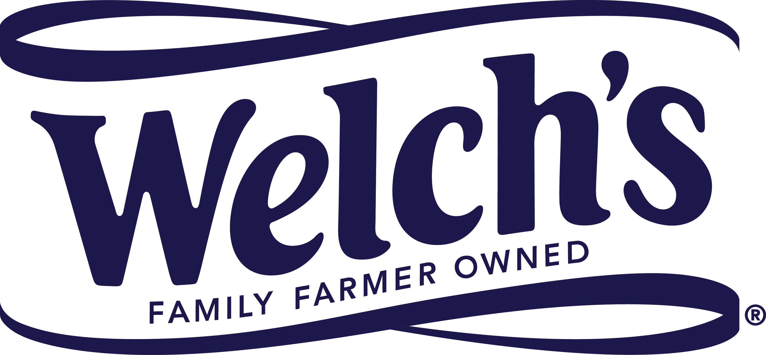

31 October 2018
PRESS RELEASE
Harvest open day showcases Welch’s grape ingredients supply chain
and highlights applications in fine foods
Welch’s Global Ingredients Group threw open the gates to one of its vineyards earlier this month to offer an insight into its family-farmer ownership model and showcase the use of its versatile grape ingredients in gourmet foods.

Customers were invited by the company to visit and tour the vineyard of Tim Grow, one of Welch’s farmer-owners, in Grandview, WA in north-west USA. They witnessed the harvesting of Concord and Niagara grapes and followed their short journey to a nearby processing facility for juicing immediately after picking.

The day was rounded off with a sumptuous five-course meal created by the head chef from partnering restaurant Cork 1794. Each dish was enhanced with ingredients made from Concord and Niagara grapes and paired with a specially chosen fine wine.

Guests attending the ‘Dinner in the Vineyard’ event enjoyed the following dishes:

- Niagara Grapelade & Arbol Chile Marinated Scallop
- Grape Dust Encrusted Duck Breast
- Fermented Niagara Concentrate Poached Walleye
- Foie Gras Stuffed Petite Venison Filet with Crushed & Pressed Concord Grape Demi-Glace
- White Peach & Niagara Bread Pudding

Welch’s Global Ingredients Group is part of Welch Foods, Inc, which is owned by the National Grape Cooperative, a member organization made up of approximately 825 grape growers located across northern regions of the USA and in Canada.

Kevin Kilcoyne, VP & General Manager at Welch’s Global Ingredients Group, said: “We often explain to people that Welch’s is a co-operative owned by farmers who grow our grapes in vineyards that have been in their families for generations. But in truth, nothing comes close to experiencing it in person. The event at Grandview gave many of our customers an opportunity to hear the story behind our supply chain directly from one of our grower-owners, giving them a unique insight into how the grapes are grown, harvested, processed and used in food and beverage products across a range of categories. Our Dinner in the Vineyard, meanwhile, gave us a chance to showcase how Concord and Niagara grape ingredients can bring fine foods to life with a unique twist. We were excited to welcome current customers, along with potential new customers, as we expand into new categories with our ingredients.”

The Concord grape is a distinctive dark purple variety that’s singularly delicious and naturally sweet. The Niagara grape is a close cousin of the Concord grape with a crisp and sweet flavour, a beautiful golden hue and a refreshing taste. Both varieties are quite different from standard red and white table grapes.

Welch’s Global Ingredients Group has harnessed the grapes’ taste benefits to create a range of versatile ingredients that includes 100% fruit juices, purees, pieces and powders. Available to food and beverage manufacturers worldwide, they are perfect for use in beverages, smoothies, snacks, bakery products, confectionery, yogurts, ice cream and desserts, as well as premium ready meals and restaurant dishes. The company is also now selling ingredients as high-quality fillers or base wines for a broad variety of different wine styles.

ENDS

For more information, please contact:
Richard Clarke, Ingredient Communications
Tel: +44 1293 886291 (office) / +44 7766 256176 (cellphone)
Email: richard@ingredientcommunications.com
@ingredientcomms

About Welch’s Global Ingredients Group
Established in 2014 as a division of Welch Foods, Inc. (Welch’s), Welch’s Global Ingredients Group offers grape juice expertise and solutions to companies across the globe. Our primary ingredients are made in the USA and include Concord and Niagara grape single-strength juices, juice concentrates and purées, as well as a range of powders and fruit bites. Our sales territories are North, Central and South America; Asia, with special emphasis in Japan, Korea and China; and EMEA. In EMEA and China we operate through our distribution partner, WILD.

Welch’s is the processing and marketing subsidiary of the National Grape Cooperative. Located across America and in Ontario, Canada, the cooperative’s approximately 825 family farmers own the company and grow the delicious and inherently healthy Concord Grape used in Welch’s juices and other grape-based products. Welch’s is committed to research and development that will meet the growing demand for products that address consumers’ health and nutrition needs. Welch’s products are sold throughout the United States and in approximately 40 countries around the globe. Welch’s is an Equal Opportunity Employer – Minorities/Female/Disabled/Veterans. For more information, visit www.welchs.com.

