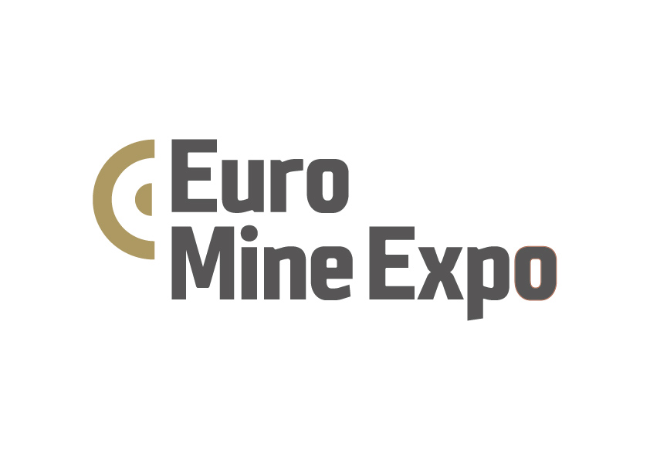

**Euro Mine Expo is reaching it’s goals**

**With just about two weeks to the opening of Euro Mine Expo the conference is nearly fully booked, 200 exhibitors are on their way and Project Manager Jaana Tengman looks forward to this year’s edition.**

When Euro Mine Expo opens on the 12th of June, it is with two fully booked Exhibition halls, about 30 learning sessions, social events and about 200 exhibitors from more than 20 nations, and hopefully more than 2000 participants.

The focus on sustainability is high, supported by the insight that mining is crucial to obtaining the climate goals. This is shown in the conference program with a dedicated session on battery metals, but also on how the mines are striving towards fossil free mining with sessions on electrification and how to utilize hydrogen in iron making. There are also several sessions on new technology, such as AR, VR and machine learning to facilitate mining in various aspects, all the way from establishing the mine to maintenance of machinery. All targeting improved safety, sustainability and productivity.

“Our aim for 2018 was to connect the conference program and exhibition together. We have worked even closer with the mining companies than before. Judging by the line up of speakers and exhibiting companies I think we have taken a significant step towards our goal”, says Ann-Sofie Greander, manager Project Sales.

“All these new innovative technologies also attract start-up companies. As an example EIT Raw Materials hosts a pavilion with 12 start-ups giving an open pitch session on Wednesday June 13th. This is a very interesting development and something we support. It is great to have the large multinational companies at Euro Mine Expo, but we like to have the mix, where niched techies can share their ideas and perhaps find new business partners”, says Jaana Tengman.

Contribute to the future of the Mining Industry – Join Euro Mine Expo!

*For more information:*

Jaana Tengman, Project Manager, Euro Mine Expo

[jaana.tengman@nolia.se](mailto:jaana.tengman@nolia.se)

+46 910-54760, +46 70-2648345

*Euro Mine Expo is an International Trade Fair and Conference for the mining industry and it's suppliers. It will be arranged for the sixth time at the very heart of Sweden’s mining industry June 12-14 2018 in Skellefteå, Sweden. In this region tradition and history go hand in hand with technical development and innovative ideas. Welcome to Sweden, to Skellefteå and to a glimpse of the future of our industry!*

Venue: Skellefteå Kraft Arena, Mossgatan 27, Skellefteå, Sweden