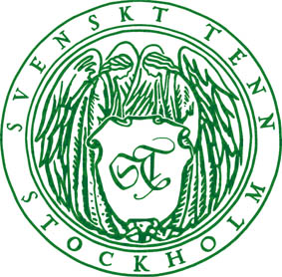
Press release
Stockholm, May 28, 2015

A Journey with Svenskt Tenn Into Josef Frank's World of Prints

Brazil, Delhi, Hawai, Himalaya, La Plata, Manhattan, Teheran, and Under Ekvatorn are all names of some of Josef Frank's textile prints on display this summer at Svenskt Tenn’s store on Strandvägen 5 in Stockholm.

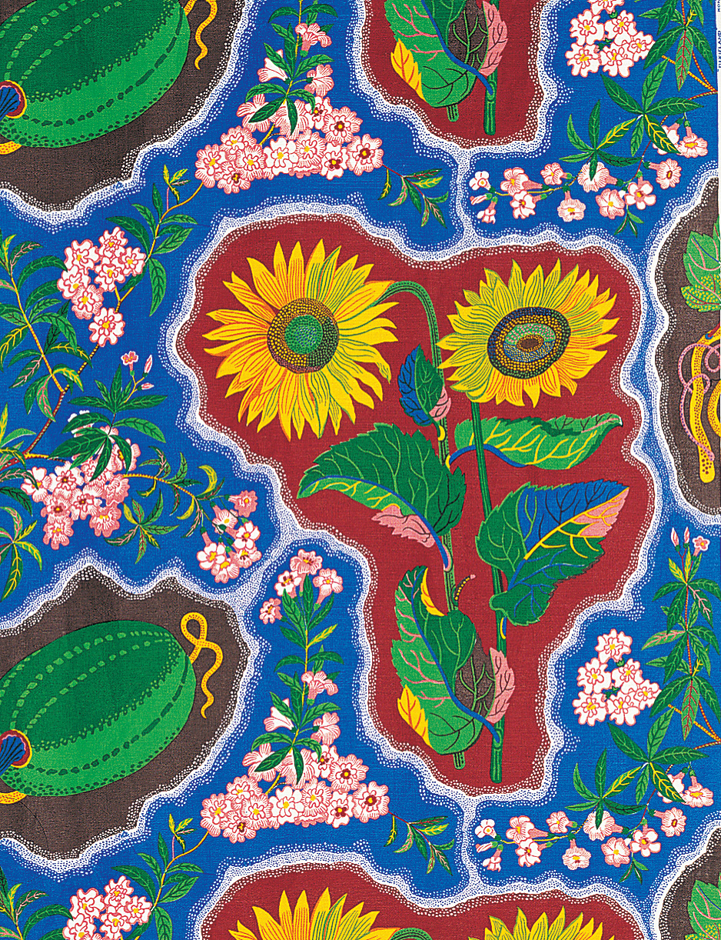
Josef Frank designed a total of about 200 textile, carpet and wallpaper prints for Svenskt Tenn. Many have names relating to places all over the world, among them the 17 textile prints that now can be experienced together in the Svenskt Tenn store in Stockholm, May 28 through August 12.

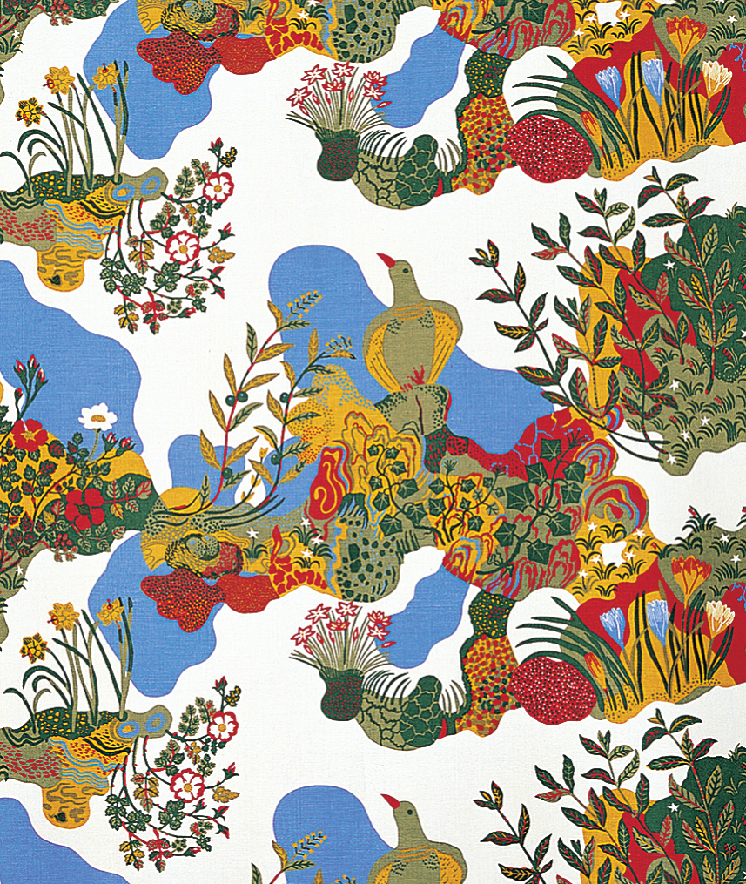
The most well known of all his prints is perhaps Manhattan, one of two map prints that Josef Frank designed during his time as a guest lecturer in New York 1941-1946. The other of the two is called Dixieland after the southern US. It depicts the Atlantic Ocean foaming against the beaches of South America with watermelons, and Africa portrayed with giant sunflowers. It was printed for the first time in 1974.

Anakreon, designed by Josef Frank for Svenskt Tenn in 1938, is named after a Greek poet who lived around the year 500 BC. This print has its origin in a 3,500 years old fresco from the Palace of Knossos in Crete.

''It was Estrid Ericson who first saw the Minoan wall painting that Josef Frank later transformed into a textile print. They often worked like that. They inspired each other and together they developed a timeless interior style that Svenskt Tenn still represents today,” says Thommy Bindefeld, Marketing Director at Svenskt Tenn.

For further information, please contact:

Vicky Nordh, Marketing Assistant: +46 8-670 16 23 or vicky.nordh@svenskttenn.se

Thommy Bindefeld, Marketing Director: +46 8 670 16 02 or thommy.bindefeld@svenskttenn.se

Svenskt Tenn is an interior design company with retail stores at Strandvägen in Stockholm and online. Since 1975, Svenskt Tenn is owned by the Kjell and Märta Beijer Foundation, which provides research grants within ecology, medicine and the preservation of Swedish interior design tradition.

