

**PRESS RELEASE**

**For immediate release: Monday 19th May 2014**

**Specialist mental health recruitment team raises £1,015.05 during Mental Health Awareness Week**

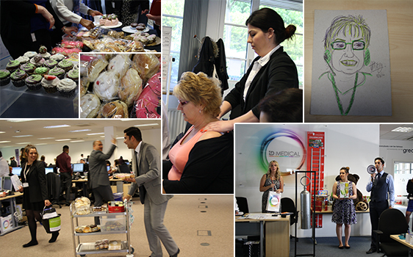

From Monday 12 May to 16 May 2014, the week of Mental Health Awareness, ID Medical Mental Health, a specialist sub-division of the leading Milton Keynes based healthcare recruiter ID Medical, raised a phenomenal total of **£1,015.05** through the co-ordination of an entire week of creative and feel-good factor fundraising events to support the work of the Mental Health Foundation.

The Mental Health Foundation, the UK's leading mental health research, policy and service improvement charity, chose this year's campaign theme as anxiety - one of the most common mental health problems in almost every country in the world.

As the company continues to experience increased demand from NHS Trusts and continues to grow in size, ID Medical understands its employees’ wellbeing is conducive to delivering a premier level service. Led by its mental health division, ID Medical’s week-long fundraising activities aimed to motivate all staff, comprising of massages, a cake sale, an employee auction, art competitions and a raffle prize draw finale.

Harjit Nandha, ID Medical's mental health division manager comments, "Mental Health Awareness Week is a key date in our diary and we are so proud to be involved in such a fantastic campaign. This year we aimed to beat last year's total of £146 and by raising awareness of mental health issues across the company, we achieved this with flying colours, making this our most successful fundraising event to date.

Our division supplies mental health professionals to over 75% NHS Mental Health Trusts in the UK so this campaign couldn't mean more to us. We’ve also extended our fundraising efforts, inviting our candidates and clients to donate to the Mental Health Foundation through our dedicated [JustGiving page](http://www.justgiving.com/ID-Medical-MHAW) so that together we will make a difference."

**ENDS**

**About the Mental Health Foundation**

The Mental Health Foundation is the UK’s leading mental health research, policy and service improvement charity. The charity is committed to reducing the suffering caused by mental ill health and to help everyone lead mentally healthier lives. With a dedicated focus on everyone’s mental health, the Mental Health Foundation works across all age ranges – whatever their condition or circumstance. Fundraising allows them to achieve their ultimate goal of delivering change and helping to empower people to make real changes in their lives.

**About ID Medical**

Award-winning, multi-discipline healthcare recruiter ID Medical was formed in 2002 and is a superior quality supplier of locum doctors, nurses, allied health professionals and clerical staff to over 90% of NHS hospitals and private medical sector organisations.

From its headquarters in Milton Keynes as well as its central London office, ID Medical provides practical, cost-effective and innovative workforce solutions, supplying more than 3 million hours to the NHS per annum. Crown Commercial Service (CCS), HealthTrust Europe (HTE) and London Procurement Partnership (LPP) framework approved, ID Medical supplies medical staff into over 38,000 available shifts per month in hospitals nationwide.

Within each of its professional divisions, the workforce solutions provider has dedicated client and candidate teams covering the multitude of medical specialties and roles to ensure every valued customer receives its premier level service, ultimately ensuring patients are always put first. Further to this, ID Medical School was launched in 2014 to offer candidates Continuing Professional Development accredited courses and workshops to enhance their medical careers.

Since its foundation, the company has earned itself industry-wide accreditation and success with an amounting collection of accolades. These include the Recruiter FAST 50, Real Business Hot 100, Recruitment International Top 250 and The Sunday Times Virgin Fast Track 100. Most notably, through an abiding focus on employee satisfaction, ID Medical was crowned Recruitment International’s ‘Best Recruitment Company to Work for 2013’ and made its debut in The Sunday Times Best Companies to Work for 2014 at list position 33. ID Medical is delighted that for the second year running it features in The Sunday Times Best Companies to Work for 2015.

For more information please visit our website at [www.id-medical.com](http://www.id-medical.com/), view our[Facebook](https://www.facebook.com/IDMedical) page or follow us on Twitter [@IDMedical](https://twitter.com/IDMedical).

You can also contact ID Medical’s head of marketing Caryn Cooper direct on:

**Caryn Cooper**

head of marketing

Description: markdes

ID MEDICAL - ID House - 1 Mill Square - Wolverton Mill South - Milton Keynes - MK12 5ZD

**t:** +44 (0) 1908 555 498 **f:** +44 (0)1908 552 825

**w:** id-medical.com   **e:** [caryn.cooper@id-medical.com](mailto:caryn.cooper@id-medical.com)

[cid:image002.png@01CF5FCD.A84FA500](http://www.facebook.com/IDMedical)  [cid:image003.png@01CF5FCD.A84FA500](http://www.twitter.com/idmedical)  [cid:image004.png@01CF5FCD.A84FA500](https://plus.google.com/104338735298043774830/posts)  [cid:image005.png@01CF5FCD.A84FA500](http://www.youtube.com/user/IDMedical2012/videos)