E.N.T
Resident Band of Little Saigon Restaurant & Bar
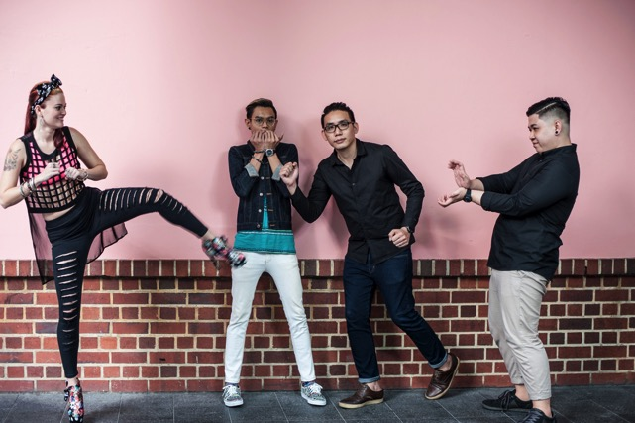(Monday-Thursday from 9.30pm, Friday & Saturday from 10.45pm till late)

One Of The Bands Behind Live Music Singapore

E.N.T has been putting smiles on the face of Singaporeans through their music for some years now. So, they understand Singapore and its inhabitants so well. The band has been providing live music to Singapore residents for so many years. Right now, the story of live music Singapore is not complete without the mention of E.N.T’s Little Saigon Restaurant & Bar's resident band.

With the aid of their state of the art acoustic musical equipment, they have been dishing out not just music but soul lifting and mind blowing live music all over Singapore. What makes this band unique is their ability to strike an impressive balance between voice (vocal), keyboard, guitar and drum. If you think you are not in the mood to listen to music, try and watch them perform. You would not know when you will begin to clap and shake your body to the rhythm of their music

One thing is to dish out good music, another is to carry your audience along. E.N.T knows how to read the reaction of their audience. So they know when to change the tempo and the tune of the music to dazzle their audience. Entertainment is not only about singing. It also comprises dancing. With E.N.T you will get enough.

Any restaurant and bar where E.N.T performs always witnesses a drastic increase in sales and customers stay a lot longer. Singaporeans have come to appreciate live music because of its freshness, vitality, energy and connection between the audience and the live musical group. This is the major advantage that live music has over recorded ones.

Live performance also allows every member of a band to display their individual entertainment skills. You can’t get that from recorded music. During a live performance, guests can even dance with the group and feel the energy. That is not possible with pre-recorded music.

E.N.T keeps improving in their skill, in their musical equipment and in their dancing steps all to ensure their audience get the very best. Over the years, they have been able to carve an international niche for themselves. They found a way to get to the top of live music in Singapore and they have since remained there.

In a continuous bid to remain at the top, they have brought in another great performer in the name of Gabrielle Ferdinands. She is young and talented. But she is not a total stranger in Singaporean Entertainment terrain. Gabrielle has been so passionate about music since she was 4. And at 22, her performance earned her a spot among the top 24 finalists of Singapore Idol in 2008. Thereafter, she has performed on several live television shows and at different impressive venues.

At some point in her budding career, Gabrielle performed alongside her father and uncle (Mel and Joe Ferdinands respectively) in the “Mel and Joe 40th anniversary concert” in 2010. Two years ago, she was a supporting singer for Nathan Hartono during his 2014 music showcase.

In April 2014, she made a giant stride in her career with a stage debut in the “Mandarin musical by the Theatre Practice”. She is currently a key member of E.N.T.

Other live music live up at Little Saigon are:
- Cosmic Jam performing every Friday and Saturday from 8.30-10.30pm
- Matt performing every Sunday from 9pm onwards

-----------------------------------------------------------------------------------------------------------------------

Little Saigon Bar & Restaurant
BLK E, Clarke Quay #01-02
River Valley Road
Singapore 179024
Tel: +65-6337 5585
Fax: +65-6337 8750
Email: info@littlesaigonasia.com
Website: www.littlesaigonasia.com
Operating hours:
Sunday to Thursday: 12pm to 1am
Friday, Saturday and Eve Public Holidays: 3pm to 3am

For high-resolution images or more information, please contact:
Fransisca – fransisca@tembusuprojects.com or 6334 7315
Brand Marketing Manager
Tembusu Projects

