**Jessica Bäckman 2nd in her STCC-comeback for Brink Motorsport   
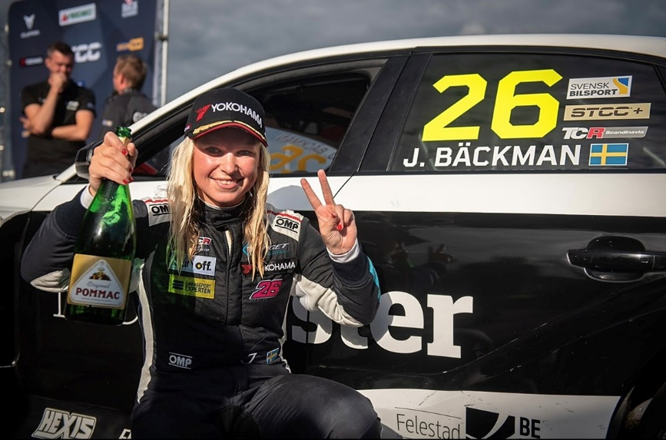**Jessica Bäckman 2nd in STCC at Anderstorp   
Photo: Brink Motorsport (Free rights to use images)  
  
**Jessica Bäckman took her first podium of the season this weekend when she finished in 2nd place in Race 3 at Anderstorp. It was also Jessica's second podium in STCC at Anderstorp. In 2019, Jessica made a one-off race in her Hyundai i30 N TCR car for Target Competition and finished 3rd, and this time she finished 2nd in her comeback with an Audi RS 3 LMS TCR car for Brink Motorsport.  
- It feels like a relieve to bring home a 2nd place, especially after the difficult season we are having in FIA WTCR, therefore this podium feels extra good, Jessica Bäckman says.**

STCC (Scandinavian Touring Car Championship) is Sweden's most prestigious motorsport championship and is today the leading class for Touring Car Racing. The cars are built according to the global TCR regulations, which means that they are the same cars used in the remaining TCR championships around the world. The series consists of six races run on different Swedish tracks and last weekend, September 4-5th, the championship's fourth race weekend was held at the traditional Scandinavian Raceway in Anderstorp, Jönköping; The only track in the Nordics with Formula 1 history, where names like Ronnie Peterson and Niki Lauda have previously competed. It was also Jessica's first race at home for a long time since she last drove in Sweden 2019 in STCC at Anderstorp and finished in 3rd place in her Hyundai i30 N TCR car for Target Competition.

**Second podium at Anderstorp**Jessica started the weekend strong and was second fastest in the first free practice session, despite the short time she has had in the new Audi RS 3 LMS TCR car. In the qualifying she had a bad flow with yellow flags which meant that she never got the maximum out of the car and had to start the first two races on Sunday from the 9th position. Despite this, she still had good chance, because in STCC it is a reverse grid starting order for the top 8 placed cars after Race 2. Jessica managed to drive up to a 7th place in Race 2, and through this reverse starting order system she got to start Race 3 from the 2nd starting position and had every chance of a good result.

Jessica did a good start from her 2nd starting position and came through the first corner as second and then managed to keep this 2nd position all the way to the finish. This podium is Jessica's second in STCC at Anderstorp. In 2019, she finished 3rd in her Hyundai i30 N TCR car for Target Competition and this weekend she finished 2nd with an Audi RS 3 LMS TCR car for Brink Motorsport.

- It feels like a relieve to bring home a 2nd place, especially after the difficult season we are having in FIA WTCR, therefore this podium feels extra good. It was really a challenging weekend to learn a brand-new car in such a short time but very happy and grateful for this result. Good work by the whole team Brink Motorsport all weekend, a big thanks, **Jessica Bäckman says.**

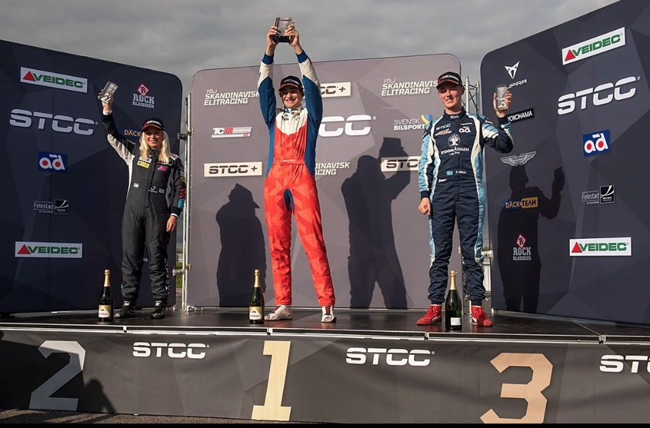

**Jessica’s results:**Free Practice 1: 2nd place  
Free Practice 2: 9th place  
Qualifying: 9th place  
Race 1: DNF  
Race 2: 7th place  
Race 3: 2nd place

***Free rights to use images***