Jays launches a-JAYS – high performance earphones with three-tiered pricing

This spring award-winning Swedish earphone manufacturer Jays is launching a-JAYS, a great value high quality earphone made in three different specifications at three different price levels.

Jays is expanding its product line with the new entry-level earphone priced from $39.99 (ex VAT). It will be available with three scales of upgrade, numbered One, Two and Three, in order to offer the best sound quality to all music-lovers, regardless of their budget.

All a-JAYS have the same sized speaker, with a dynamic element at 8.6mm and differ slightly in sound. Three also uses advanced TCD-technology (titanium coated diaphragm). The cord on all three models is the newly-developed flat, tangle-free 115cm TPE-cord, previously found only on considerably more expensive earphones.

Each upgraded model comes with added accessories and finish. For example, the finish of the earphones is sleek black on One, highly polished on Two, and with a rubber coating on Three. Three also has a stereo splitter, a flight adapter and protective case.

“By giving our customers the option of excluding some of the added extras, we are able to offer a very high quality product to everyone, regardless of price,” says Peter Cedmer, senior product manager at Jays. “All three models offer unbeatable performance for fantastic value, with the sound and power you would expect from Jays.“

a-JAYS One, Two and Three will be available at $39.99, $49.99 and $59.99 (ex VAT) respectively, from April 2010.

* a-JAYS: www.jays.se/products/earphones/a-jays.html

* Test results:
http://www.jays.se/products/general/awards-reviews.html
* Activists: www.jays.se/blog/words-about

For more information, please contact:
Peter Cedmer, product manager Jays
Cell: +46 (0)73 828 52 36
E-mail: peter.cedmer@jays.se

Jays AB develops, designs and produces earphones and equipment for portable media players. Jays supplies high quality products, aimed to provide the user with maximum sound experience. Jays passion is the quest for the perfect sound – the sound that affects and inspires user’s body and soul.
The company is expanding rapidly and its products are being sold in more than 20 countries worldwide. Learn more at: www.jays.se

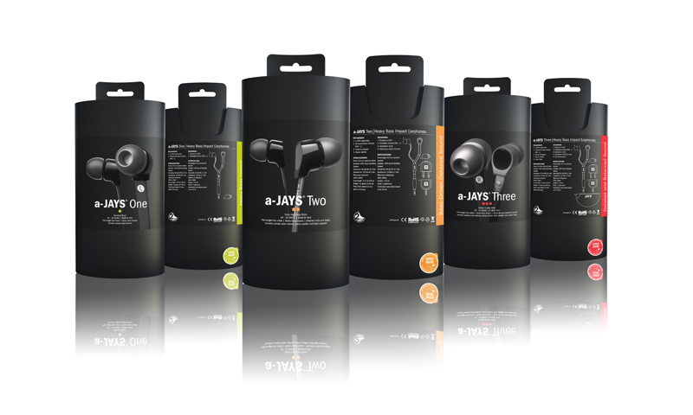
 | a-JAYS One | a-JAYS Two | a-JAYS Three
Color / finish | Standard Black | Deep High Gloss Black | Rubber Coated Black
Speaker | 8.6mm Dynamic Speaker | 8.6mm Custom Speaker | 8.6mm TCD Speaker
Isolation | JAYS Sound Isolating System | JAYS Sound Isolating System | JAYS Sound Isolating System
Sensitivity | 95 dB @ 1 kHz | 96 dB @ 1 kHz | 97 dB @ 1 kHz
Impedance | 16 Ohm @ 1 kHz | 16 Ohm @ 1 kHz | 16 Ohm @ 1 kHz
Frequency response | 20 Hz - 18 kHz | 20 Hz - 20 kHz | 20 Hz - 22 kHz
Cord type | Flat tangle free TPE cable | Flat tangle free TPE cable | Flat tangle free TPE cable
Cord length | 115 cm (45in) | 115 cm (45in) | 115 cm (45in)
Cord dimensions | Width: 5mm, Thickness: 1.2mm | Width: 5mm, Thickness: 1.2mm | Width: 5mm, Thickness: 1.2mm
Weight | 14 grams (0.49 oz) | 14 grams (0.49 oz) | 14 grams (0.49 oz)
Plug | Straight, gold-plated | Straight, gold-plated | Straight, gold-plated
 | stereo 3.5mm (1/8 in) plug | stereo 3.5mm (1/8 in) plug | stereo 3.5mm (1/8 in) plug
Accessories | Silicone sleeves (XXS - L) | Silicone sleeves (XXS - L) | Silicone sleeves (XXS - L)
 |  | Stereo Splitter | Stereo Splitter
 |  | Flight Adapter | Flight Adapter
 |  |  | Travel case

