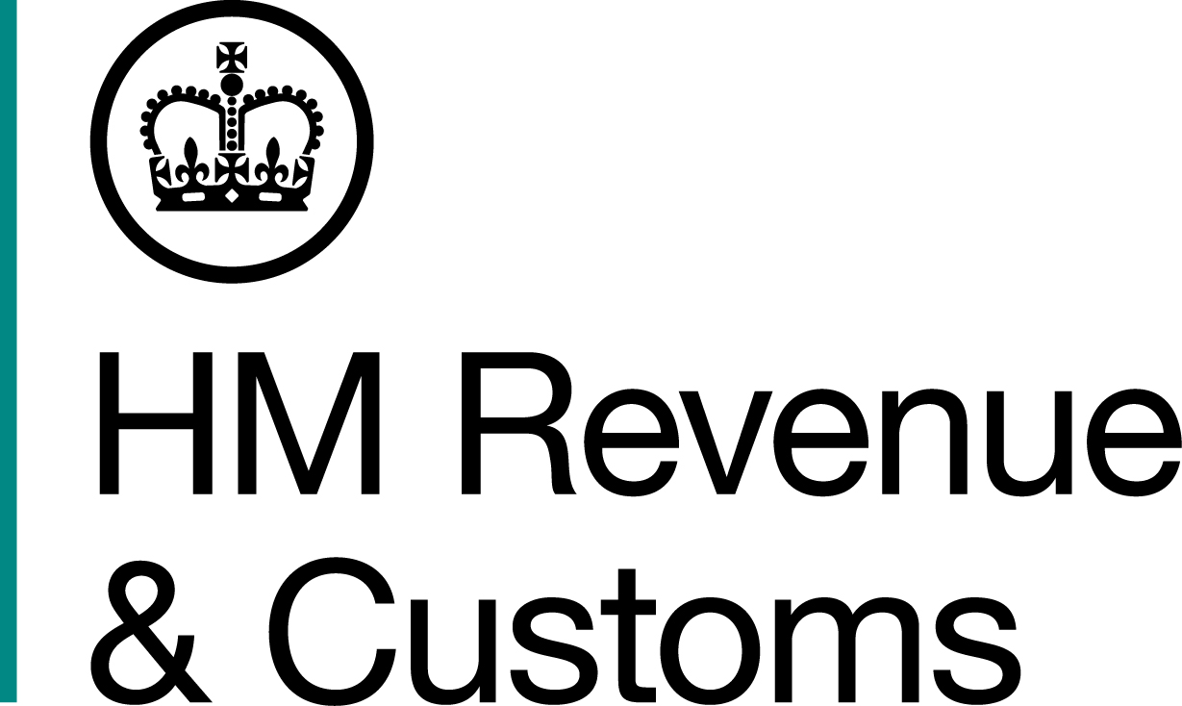
News Release

 | For the attention of News Desks |  | No of pages: 3
 | Date: | 28 October 2016 | Ref: | NTH 09/16

Tobacco and alcohol seized in West Yorkshire
An operation to disrupt the sale and supply of illegal tobacco and alcohol in West Yorkshire uncovered more than 132,000 cigarettes, 49 kilos of hand-rolling tobacco and 52 litres of alcohol, all believed to be illicit.

Officers from HM Revenue and Customs (HMRC) visited 37 retail premises across Leeds, Bradford and Dewsbury on Wednesday 26 October and Thursday 27 October.

The visits, as part of HMRC’s Tobacco Taskforce activity, led to suspected illegal tobacco and alcohol products being seized from 22 premises. This included:

- 132,550 cigarettes, with an estimated £33,600.00 duty evaded
- 49.85 kilos of hand-rolling tobacco, with an estimated £9,875.00 duty evaded
- 20.40 kilos of shisha, with an estimated £2,119.76 duty evaded
- 52.9 litres of alcohol, with an estimated £585.29 duty evaded

Sandra Smith, Assistant Director, Fraud Investigation Service, HMRC, said:

“The sale of illegal tobacco and alcohol will not be tolerated by us or our partner agencies. Disrupting criminal trade is at the heart of our strategy to clamp down on the illicit tobacco market, which costs the UK around £2 billion a year, and the sale of illicit alcohol which costs the UK around £1 billion per year. This is theft from the taxpayer and undermines legitimate traders.

“We encourage anyone with information about the illegal sale of tobacco or alcohol to contact the Customs Hotline on 0800 59 5000.”

During the searches, officers uncovered a total of 15 concealed compartments used to store illicit tobacco and conducted on-site interviews with 19 people.

In Bradford, a male shop worker fled the scene as HMRC began an inspection, leaving officers to secure the shop on their departure. Also in Bradford, a male scaled a wall at the rear of a shop, dumping bags containing cigarettes as he ran.

Elsewhere, a retailer in the city was referred to West Yorkshire Police Licensing after he was found to be selling alcohol without a licence when HMRC seized 26 litres of spirits.

And in Dewsbury, 7,800 cigarettes and a small quantity of hand-rolling tobacco were found in a caravan belonging to the owner of shop where 7,990 cigarettes were also seized.

A number of individuals are continuing to assist HMRC with their enquiries and will be further interviewed in due course.

Notes for editors

- Since 2000, the illicit market in cigarettes has more than halved. In the last two years, over 3.5 billion cigarettes and almost 600 tonnes of illicit hand-rolling tobacco have been seized and 848 criminals involved have been prosecuted.

- Through its Tackling Alcohol Fraud strategy, HMRC has almost tripled the amount of revenue protected through its enforcement work to over £3.6bn. Since the strategy was refreshed in 2010 HMRC and Border Force have seized more than 50 million litres of alcohol, with a revenue value of over £106 million.

- HMRC can also levy civil penalties on anyone handling, using or supplying non-duty paid tobacco or alcohol products.

- HMRC taskforces target specific high-risk sectors where there is a risk that some are not paying the tax they owe. Since taskforces began in May 2011, more than 140 taskforces have been launched, bringing in more than £540 million.

- Taskforces bring together various HMRC compliance and enforcement teams for intensive bursts of activity targeted at specific sectors and locations where there is evidence of high risk of tax evasion and fraud. The teams visit traders to examine their records and carry out other investigations.

- Anyone with information regarding tobacco fraud is encouraged to contact the Customs Hotline on 0800 59 5000 or via the website http://www.hmrc.gov.uk/reportingfraud/online.htm

- Follow HMRC’s Press Office on Twitter @HMRCpressoffice

Issued by HM Revenue & Customs Press Office

Press enquiries only please contact:

Joshua Shrimpton-Dean
Tel: 03000 554556 / 07469 023445
Email: joshua.shrimpton-dean@hmrc.gsi.gov.uk
Or
Natalie Brown
Tel: 03000 519123 / 07464 982005
Email: natalie.brown@hmrc.gsi.gov.uk

Out of hours
Tel: 07860 359544

Website www.gov.uk/hmrc

