Turkish shipowners and operators Güngen invest
in KONGSBERG simulators for crew training in sustainable cargo handling
Güngen Maritime & Trading has signed up to receive a new liquid cargo-handling simulator from Kongsberg Digital for crew training and testing, as a means of building and verifying crew competence in sustainable shipping operations
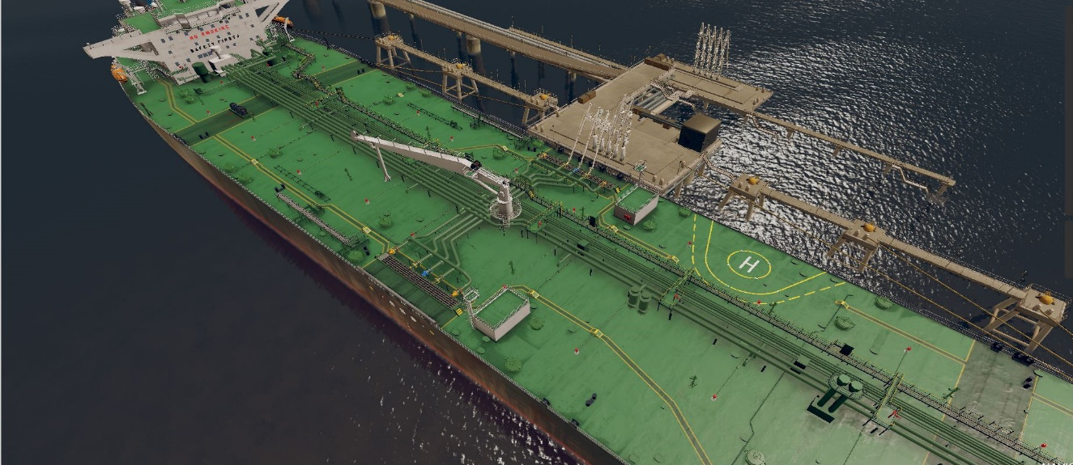
K-Sim Cargo handling simulator with visual display of the deck of a generic crude oil tanker model
Kongsberg, Norway, June 18th, 2020 – Kongsberg Digital has won a contract with Turkish shipowners and operators Güngen Maritime & Trading A/S for delivery of a K-Sim Cargo Handling Simulator, interfaced to a real KONGSBERG K-Chief 600 marine automation system. This comes 10 years after Kongsberg Digital initially supplied Güngen with a similar simulator, interfaced to the KONGSBERG K-Chief 500 marine automation system.
The K-Sim Cargo simulator model replicates a modern Suezmax crude oil tanker, reflecting the layout and specification of Güngen’s own vessels. Operating in tandem with the
K-Chief 600, the integrated system will be used by Güngen to optimize the company’s routines for cargo handling as well as for training, testing and verifying the competence of the firm’s crew.
Upon delivery, the high-performance simulator system will have an identical number and volume of cargo/ballast tanks as Güngen’s real crude oil tankers, while all pumps and pipelines will have the same characteristics. Inert gas and cargo heating system representations will also be included. All simulated equipment and functionality will provide the same response to the crew as they will experience when using the real systems after they come on board. In addition to the K-Chief 600 interface, the simulator model will also contain a ballast water treatment control system.
The simulator system will be installed at the shipowners’ office. New employees will undergo internal simulator training before signing on to the company’s vessels, and the training will reduce the overlap time needed on board when new employees sign on.
“We have had a very positive experience in training crews on simulators integrated with the same equipment as is found on board our tankers,” says Capt. Tugrul Vural, responsible for managing Güngen’s training center. “Back in 2008, we bought a KONGSBERG simulator integrated with KONGSBERG’s K-Chief 500 to train our crews and improve our routines. Since this approach has been hugely successful, it was natural for us to come back to KONGSBERG when we needed a new type of cargo simulator model with an interface to the latest K-Chief 600.”
“Güngen is a company with high ambitions when it comes to setting and applying the International Standards of Liquid Cargo Transportation,” adds Tone-Merete Hansen, Sr. Vice President, Kongsberg Digital. ”We are pleased to be able to deliver simulators which are specifically adapted to Güngen’s training and verification needs, and are confident that our simulator systems will continue to help in improving the safety and sustainability of the company’s shipping business.”
Ends

For further information, please contact:

Anne Voith
Marketing Manager, Maritime Simulation
Kongsberg Digital
Tel: +47 4567 8255
anne.voith@kdi.kongsberg.com

David Pugh
Saltwater Stone
Tel: +44 (0)1202 669244
d.pugh@saltwater-stone.com

About Kongsberg Digital
Kongsberg Digital is a provider of next-generation software and digital solutions to customers within maritime, oil and gas, and renewables and utilities. The company consists of more than 500 software experts with leading competence within the internet of things, smart data, artificial intelligence, maritime simulation, automation and autonomous operations.
Kongsberg Digital is subsidiary of KONGSBERG (OSE-ticker: KOG), an international, knowledge-based group delivering high-technology systems and solutions to clients within the oil and gas industry, subsea, merchant marine, defence and aerospace. KONGSBERG has 11.000 employees located in more than 40 countries.
Web: Kongsberg Gruppen | Kongsberg Digital
Social media: LinkedIn | Twitter | Facebook

