PRESS RELEASE

A Classic Christmas at Pan Pacific Singapore

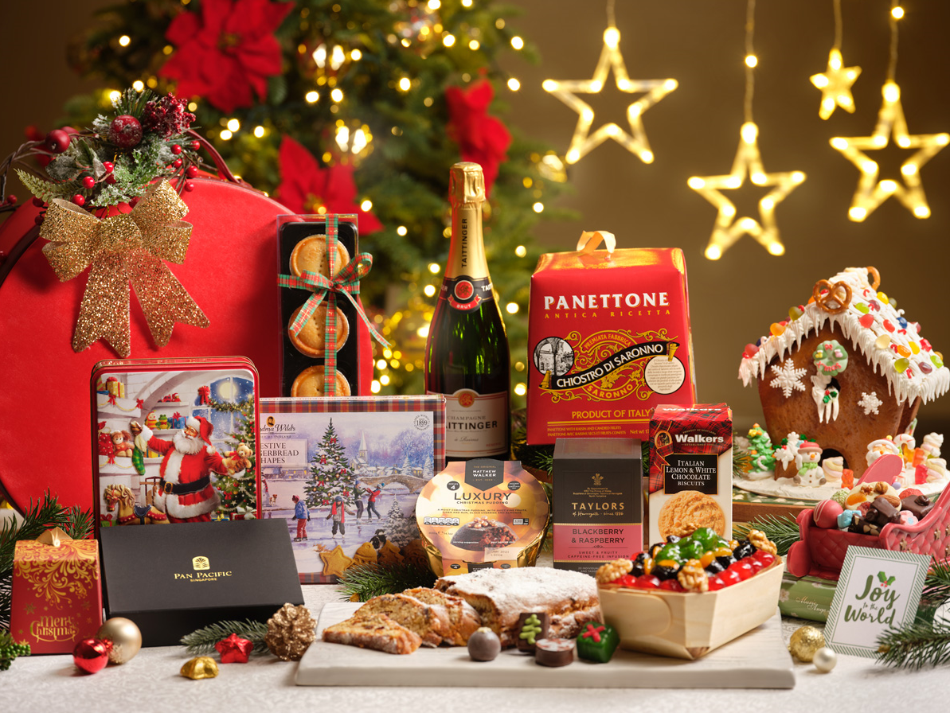
Pacific Supreme Hamper and Festive Goodies from Pacific Marketplace

Singapore, 24 October 2019 – Relive classic Christmas memories at Pan Pacific Singapore as the hotel presents luxurious festive spreads for diverse palates at award-winning Edge, Hai Tien Lo and Keyaki. Guests can elevate their celebrations with a magical ensemble of holiday treats from Pacific Marketplace or partake in a captivating festive high tea at Atrium and tantalising Christmas-themed combos at Poolside Patio. To achieve that radiant festive glow, St. Gregory Spa’s indulgent treatment packages offers the perfect pampering experience.

Please refer to the appendices for the full details.

EDGE
An Epic Festive Celebration
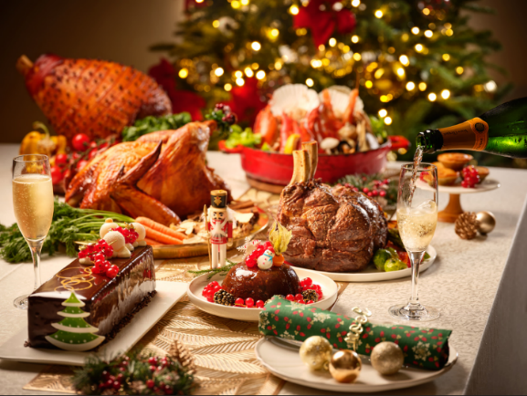
Revellers can look forward to extravagant buffet spreads as Edge takes on a delicious festive twist in the months of November and December.

The tantalising experience features hearty holiday treats and succulent roasts including Christmas Bread Pudding with Stuffed Pistachios and Dried Fruits, Pineapple and Honey-glazed Bone-in Gammon Ham, Eight Spices Roasted Whole Turkey, Oven-roasted Tomahawk Steak with Herb and Butter, and Roasted Butternut Squash Pumpkin Velouté with Honey Chestnuts. Complementing the celebratory highlights, guests can expect an immersive smorgasbord of fresh seafood items including Boston Lobster, Alaskan King Crab, Giant Barbecued Squid, Citrus Marinated Whole Salmon Fillet, Dry Curry Crab with Deep-fried Golden Buns and Whisky Glazed Seafood Bisque.

The meal is further sweetened with traditional Christmas delights such as Minced Fruit Pie, Christmas Stollen, Black Forest Log Cake, and Christmas Pudding with Brandy Sauce.

An Unforgettable Thanksgiving Feast
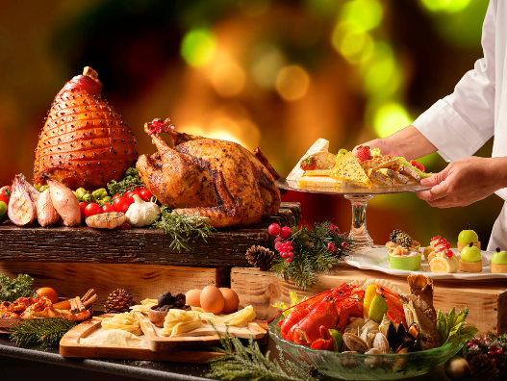
A bountiful Thanksgiving at Edge awaits, featuring classic favourites such as Cajun-roasted Whole Turkey, Pineapple and Honey Glazed Gammon Ham and Slow-roasted Lamb Shoulder with Cumin, Fennel Seeds and Citrus. The feast concludes on a memorable note with a decadent line-up of sweet treats including Pumpkin Roulade, Pumpkin Cheesecake, Granny Smith Pie, and Apple Blackberry Cobbler.

A Glamorous New Year Affair
Usher in the New Year with a showcase of festive specialties including Roasted Rosemary Whole Turkey, Brick Oven Roasted Whole Baby Lamb, Oven-roasted Mustard Angus Tomahawk and Herb-baked Australian Barramundi. The experience concludes sweetly with a lavish selection of desserts including Chocolate Bread and Butter Pudding with Crème Anglaise, Strawberry Panna Cotta and Lemon Verrines, Hazelnut Paris-Brest, Jasmine Spiced Mango Gateaux and Strawberry Rhubarb Tartlets.

PACIFIC MARKETPLACE

Glorious Meats for Celebratory Feasts
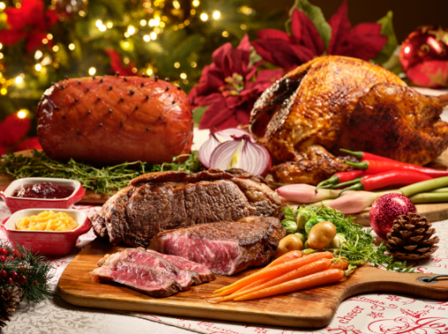
Pacific Marketplace presents a mouthwatering ensemble of ready-for-serving gourmet meats to save revelers the hassle of pre-celebration preparation. Serving as perfect centerpieces for the dining table and handcrafted by the hotel’s in-house Master Butcher Kurt Roelli and dedicated culinary team, gourmands can select from the top-selling Traditional Roasted Turkey with Chestnut Stuffing, Roasted Australian Wagyu Beef Strip Loin, Honey-glazed Gammon Ham with Spiced Pineapple Marmalade and more. A must-try is the new Baked Tamarind Turkey, an East-meets-West festive specialty with Asian ingredients of Steamed Chestnut Mushrooms, Ginger, Chilli and Lime. It is served with Biryani Rice and Cucumber Raita.

Spectacular Festive Sweets for Sharing and Gifting
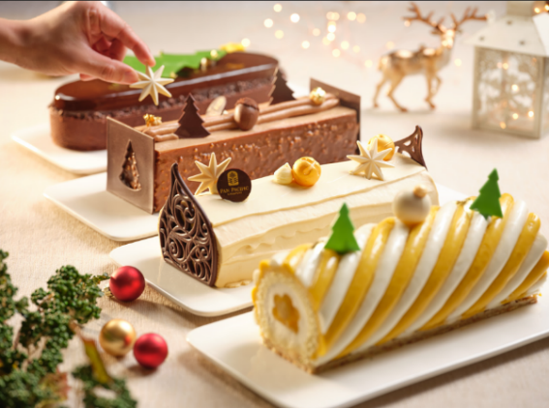
Pan Pacific Singapore’s pastry team presents three irresistible new log cake flavours this holiday – the decadent Mao Shan Wang and Gula Melaka Log Cake for the ardent lovers of the king of fruits, the divine Jivara Milk Chocolate Pear William and Caramel Nut Log Cake containing a classic combination of pear cubes, pear curd and caramelised hazelnuts as well as a tangy Coconut Mango Calamansi Log Cake for a tropical twist. Chocoholics will adore the indulgent Hazelnut Chocolate Tart made with artisanal Araguani chocolate, hazelnut praline mousse and crunchy feuilletine.

Also available at Pacific Marketplace is an extensive 33 festive treats from a Homemade Gingerbread House, Giant Santa Claus Chocolate with Pralines to the well-loved Traditional Rich Fruit Cake and Homemade Pralines. For a stunning gift guaranteed to impress, choose from four festive hampers featuring an irresistible array of Christmas favourites.

Enchanting Festive Bundles for Joyous Gatherings
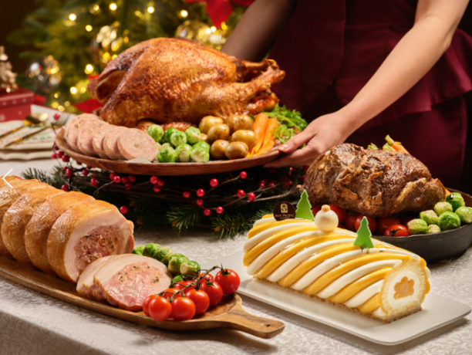
Pacific Marketplace presents three show stopping Christmas bundles for guests to serve up on the table. Revellers can select from the Heritage Christmas Bundle which includes the Baked Tamarind Turkey, Mao Shan Wang Gula Melaka Log Cake and Steamed Chestnut Mushroom Biryani Rice, the Traditional Christmas Bundle featuring a Traditional Roasted Turkey, Honey-glazed Ham and Jivara Milk Chocolate Pear William and Caramel Nut Log Cake, as well as the newly launched Premium Christmas Bundle featuring four items in total - Traditional Roasted Turkey, Roasted Kurobuta Pork Belly, Slow-roasted Australian Beef Rib Eye and Coconut Mango Calamansi Log Cake.

Please refer to the festive goodies order form for full selection and pricing.

ATRIUM

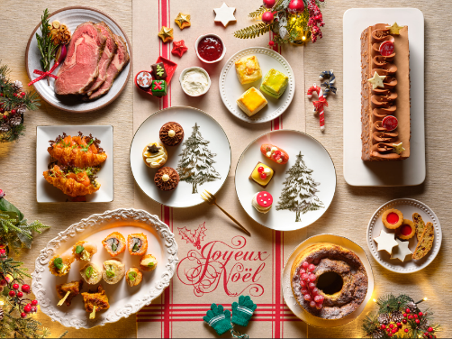
Festive Weekend High Tea Buffet
Diners can enjoy a gastronomic break from festive shopping with Atrium’s tantalising array of unlimited English and Peranakan signatures this year-end. Specially for the holiday season, the culinary team has prepared highlights of Homemade Christmas Bonbons and Pralines, Coffee Caramel Roulade, Slow-roasted Australian Ribeye with Glazed Winter Vegetables and Bordelaise Sauce, Kecap Manis Chicken Skewers and more.

Magnificent Countdown to 2020
Concluding the year in style, Atrium presents a Holographic-themed countdown party at its iconic venue featuring an eclectic collection of seating pods and a dramatic 44-metre bar. For one night only, partygoers can wine, dine and be merry in a scintillating setting with DJ performance, unlimited canapés and house pours and a magnificent balloon drop at the stroke of midnight.

HAI TIEN LO

An Oriental Feast
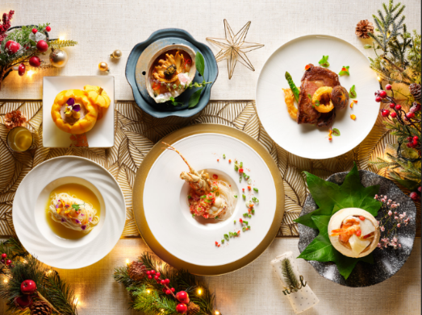
Executive Chef Ben Zeng presents a selection of splendid Christmas and New Year menus for joyous family reunions. Guests can look forward to exquisite Cantonese highlights with festive accents including Chilled Fresh Abalone with Jellyfish, Caviar and Golden Flakes, Baked Sea Perch with Almond Flakes in Champagne Sauce, Pan-fried Ribeye Beef with Red Wine Sauce and more.

Alternatively, guests can indulge in a bountiful array of 50 classic and contemporary
dim sum items at Hai Tien Lo’s Christmas and New Year Dim Sum Buffet.

Please refer to Appendix 2 for Hai Tien Lo’s Menus

KEYAKI

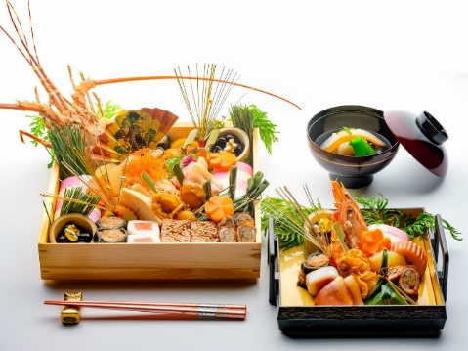
Celebrate new beginnings with Keyaki’s special New Year Eight-Course Set Menu including the exquisitely presented Traditional Osechi Ryori, a medley of traditional Japanese New Year’s food items served in special boxes, as part of the set menus. These traditional foods are shared communally as they symbolise happiness and well wishes in welcoming the New Year, and enjoy them with Ozoni (New Year Mochi Soup), both available as a la carte orders.

To welcome the New Year with a bang, Keyaki is organising a Sake Barrel Breaking Ceremony on New Year’s Eve evening. All adult guests who are dining for dinner on New Year’s Eve, New Year’s Day lunch and dinner will receive a complimentary masu sake.

Enhance your weekend revelry with a kaiseki-style Weekend Brunch at Keyaki that is presented in an okonomi concept, featuring a menu of seven courses with multiple options per course. Pair it with a selection of unlimited Taittinger Brut Réserve Champagne, Tiger Beer and selected Sake, Red and White Wines.

POOLSIDE BAR

Festive Combo at Poolside Bar
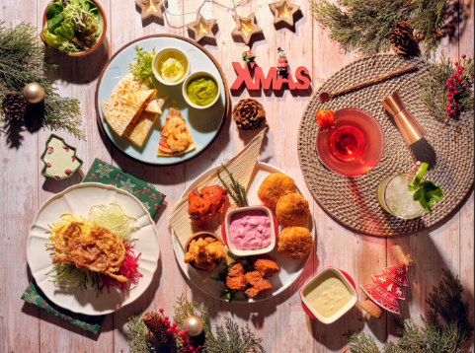
Have a tropical christmas at Pan Pacific Singapore’s breezy Poolside Bar. Diners may customise the festive combos with their choice of premium appetiser and beverage. Highlights include Chicken and Lamb Kebabs, Prawn Quesadillas and Deep-fried Softshell Crabs. The mains may be paired with either Lime Mojito, Margarita, draft beer or house wines.

ST. GREGORY SPA
For a tranquil retreat from the urban jungle, revellers can treat themselves to the pampering treatments by skilled therapists at St. Gregory Spa. Specially for the holiday season, the award-winning spa offers savings on the Rejuvenate and Glow Body Ritual which includes a body massage, foot massage and body scrub, or the Rejuvenate and Glow Face Ritual, comprising a facial treatment, back massage and foot massage.

CELEBRATIONS TO REMEMBER
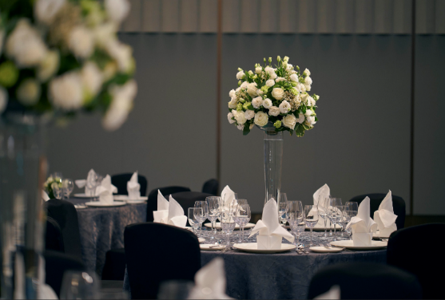
This festive season, guests can celebrate spectacular moments at Pan Pacific Singapore with specially crafted Festive Buffet or Four-course Set Menus perfect for festive luncheons, year-end corporate dinners with business associates or heart-warming reunions with loved ones. Special venues guaranteed to impress include the luxurious Pacific Ballroom, intimate Ocean Ballroom and suites at Level 22 with magnificent views of the Singapore city skyline.

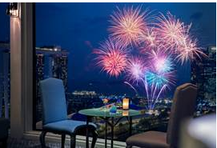
FIREWORKS BY THE BAY
For a hypnotic New Year’s Eve celebration, Pan Pacific Singapore’s “Fireworks by the Bay” room package offers the best of both worlds- an idyllic stay in the comfort of well-appointed rooms enhanced with bespoke services and mesmerising views of the fireworks to usher in the new year.

• Complimentary Breakfast for Two at Edge
• Access to our outdoor swimming pool and round-the-clock fitness centre
• High speed wireless internet access
• Complimentary local calls and parking

Valid for stays from 27 December 2019 to 3 January 2020.

For reservations and enquiries, call 6336 8111 or email reserve.ppsin@panpacific.com. Visit panpacific.com/singapore for more details.

All prices are subject to 10% service charge and prevailing Goods and Services Tax unless indicated otherwise.

For more information, visit panpacific.com/singapore.
For dining reservations or enquiries, please call 6826 8240 or email dining.ppsin@panpacific.com.

Please refer to the Appendix below for a breakdown of promotional dates and pricing at our dining establishments, St. Gregory Spa and corporate venues.

High-resolution images can be downloaded here.

ENDS

Media Contact
Melissa Ng
Senior Marketing Communications Executive
Pan Pacific Singapore
Email: melissa.ng@panpacific.com
Tel: +65 6826 8094

Annie Choy
Director of Marketing Communications
Pan Pacific Singapore
Email: annie.choy@panpacific.com
Tel: +65 6826 8079

About Pan Pacific Singapore
Located in the heart of Marina Bay and with easy access to world-class shopping, Suntec Singapore International Convention and Exhibition Centre and the Central Business District, Pan Pacific Singapore offers 790 contemporary rooms and suites that are ideal for business or leisure. Savour epicurean delights at our award-winning restaurants and bars or rejuvenate at our swimming pool and spa. Pan Pacific Singapore is proud to be named Asia’s Leading Business Hotel by the World Travel Awards from 2006 to 2012, World’s Leading Business Hotel by the World Travel Awards from 2007 to 2010 and 2012, and World’s Leading City Hotel by the World Travel Awards in 2011. The hotel was also recently named a “Four-Star Hotel” by Forbes Travel Guide 2019 and Top 25 Hotels in Singapore in Tripadvisor’s 2019 Traveller’s Choice Awards.

About Pan Pacific Hotels and Resorts
With hotels, resorts and serviced suites across Asia, Oceania and North America, Pan Pacific provides a safe harbour in an ever-changing world. Places with less worry about because, when you stay with us, rest assured that all will be taken care of. For this is where you will find your balance.

About Pan Pacific Hotels Group
Pan Pacific Hotels Group is a wholly-owned hotel subsidiary of Singapore-listed UOL Group Limited, one of Asia’s most established hotel and property companies with an outstanding portfolio of investment and development properties.

Based in Singapore, Pan Pacific Hotels Group owns and/or manages more than 40 hotels, resorts and serviced suites including those under development across 24 cities in Asia, Oceania, North America and Europe.

Voted “Best Regional Hotel Chain” by readers in Asia in 2017 and 2018, Pan Pacific Hotels Group comprises two acclaimed brands: its signature brand, Pan Pacific and its deluxe brand, PARKROYAL.

Sincerity is the hallmark of Pan Pacific Hotels Group. The Group is known to its guests, partners, associates and owners for its sincerity in people and the sense of confidence which alleviates the stresses of today’s complex world.

About Edge
Edge presents an engaging gastro-tainment dining experience and a culinary tour of Singapore, the region and the Pacific Rim. Awarded ‘Best All-Day Dining Buffet’ and ‘Award of Excellence’ at the G Restaurant Awards 2016 organised by The Peak Selections: Gourmet and Travel, and ‘Best Buffet’ at both the Wine & Dine Singapore’s Top Restaurants Guide 2015 and 2016, as well as the Epicurean Star Award 2014 organised by the Restaurant Association of Singapore (RAS), the seven ‘live’ food theatres present a la minute cuisine which include a variety of delectable Asian and Pacific cuisines – including Chinese, Malay, Indian, Singaporean, Japanese and Pan Pacific’s signature “Pacific Cuisines”. For the ultimate indulgence, Sunday Champagne Brunch is a convivial event with traditional roasts, crustacean on ice, freshly-made pasta, 30 types of cheese and 20 varieties of dessert.

About Atrium

Located in the heart of the lobby, Atrium presents a curated collection of craft beers, boutique wines and spirits. Guests can enjoy a bespoke cocktail at the dramatic 44-metre (144 feet) long bar – the longest in Asia – or have an intimate tête-à-tête at a private pod floating over a reflection pool.

About Keyaki
The award-winning restaurant, Keyaki, is renowned for its use of fresh ingredients imported from Japan. Our team of dedicated Chefs presents an array of authentic and immaculately presented sashimi, sushi, teppanyaki and much more. Perched on Level 4 of the hotel, Keyaki is surrounded by a beautifully sculpted Japanese garden and a new Garden Pavilion which opens up to lush green landscape and a beautiful koi pond. This private dining space can be customised for any occasion, from private luncheons and dinners to cocktail receptions and intimate weddings.

About Hai Tien Lo
Helmed by Executive Chef Ben Zeng, Hai Tien Lo epitomises traditional Cantonese dining with a contemporary twist. Enjoy exquisite dim sum, double boiled soups, Peking duck and classic braised dishes, in addition to modern interpretations like the “Australian Abalone with Japanese Mushrooms and Black Truffles” or “Double-boiled Chicken Soup with Abalone, Dried Scallops, Fresh Prawns and Chinese Mushrooms served in Young Coconut”.

About Poolside Bar
Set amidst lush greenery, this urban tropical bar offers icy cold beverages, delicious cuisines and mouth-watering desserts. Bask in the relaxing poolside ambience sipping refreshing cocktails, bubblies or fresh juices, while enjoying the comfort of luxurious cabanas and sun loungers.

Appendix 1
Highlights | Date and Time | Price / Reservation details
Edge
An Epic Festive Celebration
Festive Lunch | 11 to 30 November 2019 (Excluding Sundays), 12pm to 2:30pm  1 to 24 December and 26 to 31 December 2019 (Excluding Sundays), 12pm to 2:30pm | SGD62 per adult, SGD31 per child  SGD75 per adult, SGD37.50 per child
Festive Dinner | 11 to 30 November 2019, 6:30pm to 10:30pm  1 to 23 December 2019 and 26 to 30 December 2019, 6:30pm to 10:30pm | SGD98 per adult, SGD49 per child  SGD108 per adult, SGD54 per child
Festive Brunch | 17 and 24 November 2019, 12:00pm to 3:30pm  1, 8, 15, 22 and 29 December 2019, 12:00pm to 3:30pm | SGD208 per adult (Alcoholic with Rosé Champagne), SGD188 per adult (Alcoholic), SGD128 per adult (Non-alcoholic), SGD64 per child  SGD228 per adult (Alcoholic with Rosé Champagne), SGD208 per adult (Alcoholic), SGD158 per adult (Non-alcoholic), SGD79 per child
Christmas Dinner | 24 December 2019, 6:30pm to 10:30pm  25 December 2019, 6:30pm to 10:30pm | SGD208 (Alcoholic), SGD158 per adult (Non-alcoholic), SGD79 per child  SGD168 per adult (Alcoholic), SGD128 per adult (Non-alcoholic), SGD64 per child
Christmas Day Brunch | 25 December 2019, 12:00pm to 2:00pm  25 December 2019, 2:30pm to 4:30pm | SGD238 per adult (Alcoholic with Rosé Champagne), SGD218 (Alcoholic), SGD168 per adult (Non-alcoholic), SGD84 per child  SGD258 per adult (Alcoholic with Rosé Champagne), SGD238 (Alcoholic), SGD178 per adult (Non-alcoholic), SGD89 per child
An Unforgettable Thanksgiving Feast
Thanksgiving Dinner | 28 November 2019, 6:30pm to 10:30pm | SGD98 per adult, SGD49 per child
A Glamorous New Year Affair
New Year’s Eve Dinner | 31 December 2019, 6:30pm to 10:30pm | SGD188 per adult, SGD94 per child  Top up SGD50 for unlimited Champagne, gin, cocktails, red and white wines.
New Year’s Day Brunch | 1 January 2020, 12pm to 4pm | SGD128 per adult, SGD64 per child  Top up SGD60 for unlimited Champagne, gin, cocktails, red and white wines.
New Year’s Day Dinner | 1 January 2020, 6:30pm to 10:30pm | SGD98 per adult, SGD49 per child
Pacific Marketplace
Festive Goodies, Festive Hampers, Christmas Bundles and Gourmet Meats
Festive Goodies, Festive Hampers, Christmas Bundles and Gourmet Meats | 11 November to 26 December 2019 | Festive goodies can be purchased at Pacific Marketplace (level 1) or via online orders at ppsinshop.com. Guests can collect their purchases at Pacific Marketplace between 11:30am and 9:00pm. Enjoy 15% early bird credit card savings for orders made from 11 to 30 November 2019. Please refer to our festive goodies order form for full details.
Atrium
Festive Weekend High Tea Buffet
Festive Weekend High Tea Buffet | Every Saturday and Sunday from 23 November until 29 December 2019,  including 24, 25 December 2019 and 1 January 2020 (Excludes 31 December 2019)  2:30pm to 5:30pm | SGD58 per person, inclusive of two beverages
Magnificent Countdown to 2020
“LET’S HOLO UP” Countdown Party | 31 December 2019, 9:00pm to 1:00am | - SGD108 per adult: Free-flow Wine, Beer, Soft Drinks and Canapés exclusively for dine-in guests from Edge, Hai Tien Lo and Keyaki after dinner from 10:30pm  - SGD118 per adult: Free-flow Wine, Beer, Soft Drinks and Canapés for guests joining from 10:30pm  - SGD148 per adult: Free-flow Wine, Beer, Soft Drinks and Canapés for guests joining from 9:00pm to 1:00am  - SGD98 per child: Free-flow Soft Drinks, Juices and Canapés (6 to 12 years old)  Additional bottle of Tattinger champagne is priced at SGD108.  Last order for food and drinks is at 11:30pm and 12:30am respectively.
Hai Tien Lo
Six-course Festive Set Menus
Six-course Festive Set Menus | 22 December 2019 to 1 January 2020  11:30am to 2:30pm; 6:30pm to 10:30pm | Set Menu A: SGD138 per diner and includes a glass of champagne  Set Menu B: SGD168 per diner and includes a glass of red wine
Dim Sum Buffet
Christmas Dim Sum Buffet | 24 and 25 December 2019  11:30am to 2:30pm | SGD98 per adult; SGD49 per child (6 to 12 years old)  Includes complimentary Honey-glazed Ham, Yule Log Cake, Abalone Tart and a glass of champagne per diner
New Year Dim Sum Buffet | 31 December 2019 and 1 January 2020  11:30am to 2:30pm | SGD98 per adult; SGD49 per child (6 to 12 years old)  Includes complimentary Stir-fried Pork Spare Ribs, Abalone Tart and Deep-fried Mini Glutinous Rice Dumpling with Rum per diner
Keyaki
New Year’s Lunch and Dinner Eight-course Set Menu
New Year’s Lunch and Dinner Eight-course Set Menu | 31 December 2019 to 3 January 2020  11:30am to 2:30pm; 6:30pm to 10:30pm | SGD208 per person  Traditional Osechi Ryori and Ozoni (New Year Mochi Soup) available a la carte
A Japanese Weekend Brunch Affair
Weekend Brunch | Every Saturday, Sunday and Public Holiday  11:30am to 2:30pm | Adult: SGD135* and SGD75  *includes unlimited alcoholic beverages
Poolside Bar
Festive Combo at Poolside Bar
Festive Combo at Poolside Bar | 18 November to 25 December 2019  Monday to Friday, 11:00am to 10:00pm; Saturday and Sunday, 10:00am to 10:00pm | SGD28 per combo set
ST. GREGORY SPA
Rejuvenate and Glow Rituals
Rejuvenate and Glow Body Ritual | 1 November 2019 to 29 February 2020 | SGD297 Nett (usual SGD330 Nett)  60-minute Balinese Massage or Relaxing Aromatic Body Bliss Massage  30-minute Foot Massage  30-minute Body Scrub  For bookings and enquiries, call 6826 8140 or email stgregory.ppsin@panpacific.com.
Rejuvenate and Glow Face Ritual | 1 November 2019 to 29 February 2020 | SGD289 Nett (usual SGD340 Nett)  75-minute Elemis Skin Specific Facial  30-minute Anti-Stress Back Bliss Massage  30-minute Foot Massage  For bookings and enquiries, call 6826 8140 or email stgregory.ppsin@panpacific.com.
Celebrations to Remember
Festive Buffet or Four-course Set Menu | 1 to 30 December 2019 | Lunch at SGD98 per person; Dinner at SGD118 per person  Includes unlimited flow of soft drinks, coffee, tea and welcome Christmas mocktail.  For dining reservations or enquiries, please speak with us  at 6826 8055 / 6826 8052  or email celebrate.ppsin@panpacific.com.

All prices listed are subject to 10% service charge and Prevailing Goods & Services tax, unless otherwise stated.

Appendix 2

Hai Tien Lo

佳节精選中式套餐 A
Christmas Celebration Set Menu A

蜜汁火腿生菜松，红桑果虾球，脆皮烧腩肉
Stir-fried Minced Honey-glazed Ham with Lettuce, Deep-fried Prawn with Raspberry Sauce, Crispy Barbecued Pork Belly

竹笙菜胆龙虾鱼骨汤
Double-boiled Lobster with Bamboo Pith and Chinese Cabbage in Fish Bone Broth

紅曲酱烧排骨
Stir-fried Pork Spare Ribs with Fermented Red Yeast Rice Sauce

香槟汁杏香酱焗鲈鱼柳
Baked Silver Sea Perch Fillet with Almond Flakes in Champagne Sauce

味菜火鸡丝炒河粉
Wok-fried Rice Noodles with Shredded Turkey and Preserved Vegetables

鲜果香茅冻拼树桐蛋糕
Combination of Chilled Lemon Grass Jelly with Fresh Fruits and Yule Log Cake

每位客人均可免费享用一杯香槟
(One Complimentary glass of house pour champagne for every diner)

$138 per diner
(Minimum of two diners)

佳节精選中式套餐 B
Christmas Celebration Set Menu B

金箔鱼子海蜇冻鲜鲍
Chilled Fresh Abalone with Jelly Fish, Caviar and Golden Flakes

椰皇干贝花胶浓鸡汤
Double-boiled Lobster with Bamboo Pith and Chinese Cabbage in Fish Bone Broth

红酒汁香煎雪花牛柳
Pan-fried Ribeye Beef Fillet with Red Wine Sauce

自制剁椒银丝蒸龙虾
Steamed Lobster with Vermicelli in Homemade Chopped Red Chili and Minced Garlic

香煎带子伴日本面线
Stewed Japanese Rice Vermicelli accompanied with Pan-fried Scallops

银杏果南瓜露
Cream of Pumpkin with Sago and Ginkgo Nut

每位客人均可免费享用一杯香槟
(One Complimentary glass of house pour red wine for every diner)

$168 per diner
(Minimum of two diners)

龍皇玉帶鴛鴦沙律
松茸燉鮑魚海中寶
黑椒煎鱸魚蒜茸蒸
五香脆皮童子雞
百福腊味賀壽飯
洋參官燕燉雪梨凍
祝壽蟠桃
$118 per person ( Min 2 )
父亲节套餐 ( II )
巧手乳豬小拼
海鮮皇津膽濃鸡汤
原只三頭澳鮑伴海參
蜜椒醬香羊小扒
百福腊味賀壽飯
洋參官燕燉雪梨凍
祝壽蟠桃
$168 per person ( Min 2
龍皇玉帶鴛鴦沙律
松茸燉鮑魚海中寶
黑椒煎鱸魚蒜茸蒸
五香脆皮童子雞
百福腊味賀壽飯
洋參官燕燉雪梨凍
祝壽蟠桃
$118 per person ( Min 2 )
父亲节套餐 ( II )
巧手乳豬小拼
海鮮皇津膽濃鸡汤
原只三頭澳鮑伴海參
蜜椒醬香羊小扒
百福腊味賀壽飯
洋參官燕燉雪梨凍
祝壽蟠桃
$168 per person ( Min 2
龍皇玉帶鴛鴦沙律
松茸燉鮑魚海中寶
黑椒煎鱸魚蒜茸蒸
五香脆皮童子雞
百福腊味賀壽飯
洋參官燕燉雪梨凍
祝壽蟠桃
$118 per person ( Min 2 )
父亲节套餐 ( II )
巧手乳豬小拼
海鮮皇津膽濃鸡汤
原只三頭澳鮑伴海參
蜜椒醬香羊小扒
百福腊味賀壽飯
洋參官燕燉雪梨凍
祝壽蟠桃
$168 per per

