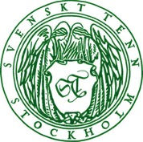
Press Release
Stockholm, September 4, 2015

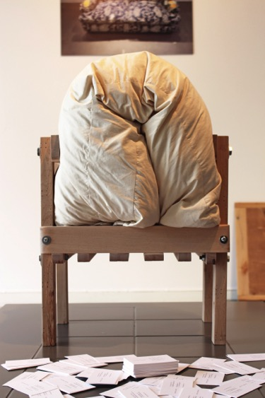
Thomas Lissert awarded the Svenskt Tenn design scholarship
Thomas Lissert, 32, has been awarded the 2015 Svenskt Tenn design scholarship for his project Make Up at The Beckmans College of Design. His work is now presented at the interior design company’s store in Stockholm.
In his project, Thomas Lissert uses a worn sofa. The owner’s interest in this piece of furniture had waned over time, to eventually be completely lost. Thomas disassambled it and started to explore how the various elements could be reused.
The inner fabric became a dress. The upholstery and padding a woven carpet. The wooden frame was turned into a chair, a tray table, ladles and spoons. These objects are now on display along with a movie describing the Make Up project and Thomas Lissert’s method in the Svenskt Tenn store in Stockholm from September 4 through 13.
“A balanced consumption and a sustainable approach to our planet’s limited resources are necessities today, and will be so even more in the future. Thomas Lissert made these insights the framework of his creative process where he skillfully crafted new objects from end-of-life furniture,” said Thommy Bindefeld, Marketing Director at Svenskt Tenn.
The sofa’s suspension was basically the only part left unused.
“To make use of the suspension, I did not just want to throw something together. The springs have a rather complex composition, which may be utilized instead of picking them apart. I’ve saved them in my materials library,” Thomas Lissert said.

For further information, please contact:

Vicky Nordh, Marketing Assistant: +46 8-670 16 23 or vicky.nordh@svenskttenn.se

Thommy Bindefeld, Marketing Director: +46 8 670 16 02 or thommy.bindefeld@svenskttenn.se

Svenskt Tenn is an interior design company with retail stores at Strandvägen in Stockholm and online. Since 1975, Svenskt Tenn is owned by the Kjell and Märta Beijer Foundation, which provides research grants within ecology, medicine and the preservation of Swedish interior design tradition.

