2015 FIRST QUARTER RESULTS (April – June)

eDreams ODIGEO met growth targets with a 6% rise in revenue margin, 4% more bookings, and an adjusted EBITDA of €22.4 million

- Between April and June, the company registered 2.6 million bookings (+4%), which together with a 2% growth in revenue margin per booking, resulted in a revenue margin of €113.8 million (+6%)

- Flight and non-flight business has grown through an increased number of bookings and a higher revenue margin per booking. The revenue margin of each business grew by 6% and 7% respectively, while the non-flight business has increased its revenue margin per booking by a significant 12%

- Expansion markets continue to lead the growth in the company's business with a 21% increase in revenue margin

- Adjusted net income of €3.4 million, increasing 24% vs the same period last year.

- Strong cash flow performance with cash end of quarter up to €123.3 million

- Increased focus on mobile continues to attract a large share of our customers with 4.9 million mobile downloads (+73%)

Barcelona, August 27th, 2015 - eDreams ODIGEO (www.edreamsodigeo.com), one of the main distributors of online flights in the world, has closed the first quarter of its 2015-16 fiscal year, ending June 30th, with positive changes to its business figures. Bookings increased by 4% up to 2.6 million, accompanied by a 2% increase in revenue margin per booking. This resulted in a 6% growth of the consolidated revenue margin for a total of €113.8 million.

Evolution of revenue margin Evolution of revenue margin per booking

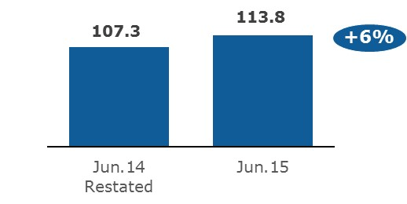
In € Million
42.8
43.5
June 14
June 15
€ Per booking
+2%

The strong performance of both business areas, particularly non-flight, together with major continued growth outside of Europe and the increase in revenue margin per booking, have led to positive business figures and profitability, which are in line with the targets set for the 2015-16 fiscal year:

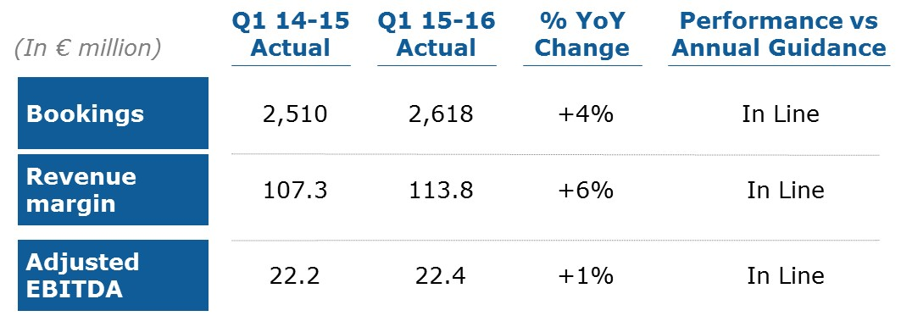

Dana Dunne, CEO of eDreams ODIGEO, commented "We are satisfied with the performance in the first quarter, which recovers growth after a difficult year. We have made very good progress in continuing to deliver an enhanced customer experience and launching new products such as mobile, and this is laying strong foundations for our future growth".

Implementation of changes to the strategy

The company has a strong position reflected in its business model: a high volume of incoming traffic; a powerful and patented search engine that provides unique offers; international, local, and specialized knowledge; unique management of revenue and key business data; and a powerful search engine that is expanding (Liligo).

In order to uphold its strong leadership position and increase its perfomance, the company has adapted its strategy plans through the introduction of six key initiatives last June:

- Optimizing traffic sources by reassessing the channel mix in order to focus on low-cost channels and customer retention.
- Expanding the focus on the mobile network. This has attracted an increasingly higher percentage of customers.
- Improving the customer's experience from start to finish by simplifying the user interface, resolving problem areas, and improving value and customer service.
- Maintaining an adjusted and agile model, with improved product quality, by increasing our flexibility in order to adapt to the constantly changing environment in which we operate.
- Diversifying our revenue by providing value-added products and services that increase the size of the shopping basket of products purchased by customers, while improving their experience.
- Promoting culture and talent by creating a passionate and empowered organization that drives long-term success.
This new strategy is being executed in a plan that contains two phases. The first phase launched in the 2015-16 fiscal year is focused on short-term performance and includes:
- Optimizing cost allocations in order to increase the number of customers
- Improving customer loyalty by focusing on service
- Expanding the mobile business and improving user experiences
- Diversifying the revenue mix building on top of our strong flight business
- Improving our corporate culture and talent
Those strategic actions have already shown positive results in several areas such as:
- Mobile: positive results are evident in the increase of mobile use by customers, which has been enabled through the introduction of a number of mobile developments.
  - Mobile downloads increased by 73% in Q1 2015-16 vs the same quarter of last year, by up to 4.9 million in total
  - 38% increase in the quarterly number of mobile bookings
  - Increase from 15% to 20% in share of mobile bookings (+29%)
- One Front implementations: one of the company’s biggest projects is to unify its Front-end Platforms which will lead to accelerated innovation and improvement in conversion rates. Deployment now covers 80% of total bookings coming from sites fully operational in the One Front platform and conversion has increased by more than 6% in Opodo and GoVoyages combined
- Dynamic Packages: The migration from the legacy platforms to new a booking engine which offers Dynamic Packages has driven growth:
  - More coverage: up from 23% in Q4 to 77% in Q1 2015-16
  - More conversion: Opodo sites see a conversion improvement in Q1 year over year, with over 10% more conversions following the move to the new booking engine.

2015-16 Outlook

For the 2015-16 fiscal year, the company is maintaining the targets announced in June with more than 9.7 million bookings, a revenue margin higher than €436 million, and an adjusted EBITDA of €91-94 million.

Results by business area: flight vs. non-flight
From April to June the company continued to improve its revenue margin in the flight business, which amounted to €90.8 million. This represented a growth of 6%, generated by an increase in bookings of 5% and a 1% increase in revenue margin per booking.

In addition, non-flight businesses (hotels, car rentals, dynamic packages, other) continued to show healthy growth rates and contributed to 20% of the group’s overall revenue margin. The growth for this business was 7%, with a revenue margin per booking increase of 12% which offset a slight decrease of 4% in bookings.

Revenue margin - Flights Revenue margin – Non-flights
Millions of €
Millions of €
85.8
90.8
June 14
June 15
+6%
21.5
23.0
June 14

June 15
+7%

Results by geographic region
The company's solid performance in the first quarter 2015-16 fiscal year was driven by growth in bookings, revenue margin per booking, and the strong performance of our expansion markets (including some large markets like the UK and Germany) that are growing both in revenue margin and bookings by 21% and 26%, respectively.

In the Core markets of eDreams ODIGEO (Spain, France & Italy), the optimization of near term performance is starting to deliver results, with the inflection point in booking trend confirmed and the improvement in booking trend continuing in the second quarter of the current fiscal year. The Core markets revenue margin amounted to €64.2 million, a slight decrease of 3%, representing 56% of the overall group's revenue margin.

Revenue margin Revenue margin
Core Markets Expansion Markets

Millions of €
Millions of €
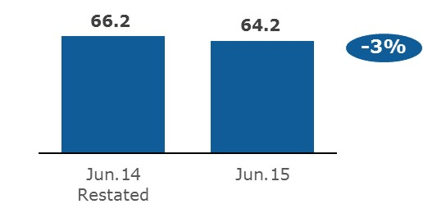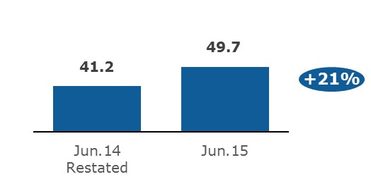
The Expansion markets continue to drive growth with 21% Year on Year increase in revenue margin and 26% in bookings, representing 44% of the group’s overall revenue margin. International markets (which exclude Germany, the UK, and the Nordic region), a subset of expansion markets saw also a strong revenue margin growth of 53% in the first quarter 2015-16 fiscal year, reaching 16% of the company's total revenue margin.

Adjusted EBITDA

The adjusted EBITDA stood at €22.4 million in the first quarter 2015-16, which shows a 1% increase and is in line with our company annual guidance for 2015-16 fiscal year:

Evolution of the Adjusted EBITDA Adjusted Ebitda quarterly evolution (YoY variation)

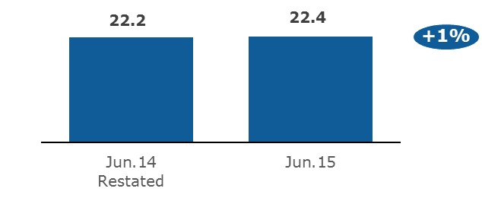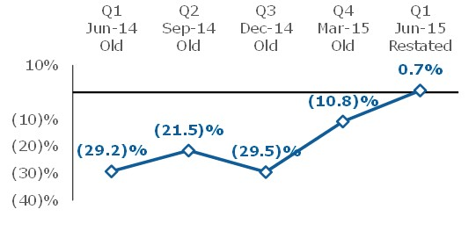

Income Statement - Summary

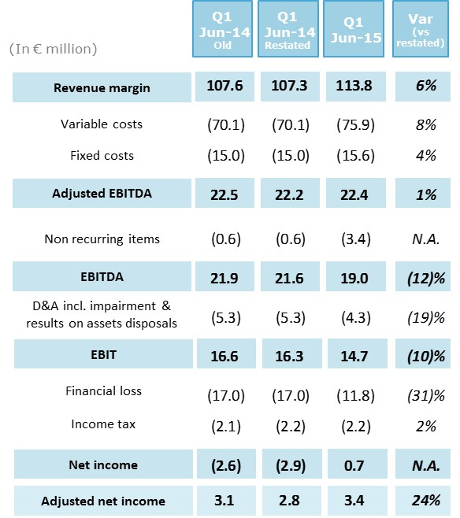

The main points to highlight in the income statement for the first quarter of the 2015-16 fiscal year are:

- A 6% increase in the revenue margin, reaching €113.8 million, in line with annual targets

- Higher variable costs driven by higher cost per booking, which remained stable on a per booking basis over the past four quarters; higher fixed costs mainly relating to higher personnel costs, and also stable on a per booking basis.

- An increase on non-recurrent items compared to last year as a results of some exceptional consultancy cost on strategic support, the costs related to the Long term Incentive Plan and selective termination contracts.

- Financial expenses have decreased by €5.2 million, primarily due to the reduction on 2019 notes as a result of their partial redemption (€800,000), a €5.8 million impact related to last year’s 2019 Notes partial redemption, which has been partially mitigated by FX gains and losses as well as (€300,000) related to the consent fee to the change in covenants. .

- The higher income tax primarily reflects the €5 million reversal in deferred taxes due to the accumulated losses that were registered last year and were partially mitigated by business trends in countries where eDreams ODIGEO operates and pays taxes, such as Spain.
______________________________________________________________________________
*NOTE
Core Markets: Spain, Italy, and France
Expanding Markets: All except the Core Markets
International Markets: All except the Core Markets, Germany, the United Kingdom, and the Scandinavian countries

About eDreams ODIGEO
eDreams ODIGEO (www.edreamsodigeo.com) is one of the main distributors of online flights in the world (in terms of revenue) and one of the largest European e-commerce companies. Under its five brands—eDreams, GO Voyages, Opodo, Travellink and Liligo—it offers the best deals in regular and charter flights, low-cost airlines, hotels, cruises, can rentals, holiday packages, travel insurance, and stays of various durations to more than 16 million customers throughout the world. It is also a very effective platform for advertisers to reach their target markets in a personalized manner, both locally and globally. Present in 44 markets, the company has a team of about 1,700 professionals. In addition, eDreams ODIGEO is listed in the Spanish Continuous Market.

For additional information

- eDreams ODIGEO Press Office
pmalingre@tinkle.es +34 620 915 756
mcastellana@tinkle.es +34 679 983 310

- eDreams ODIGEO Investor Relations
investors@edreamsodigeo.com +44 (0)870 352 5354

