HAGLÖFS INTRODUCES the LEFTOVER SLEEPING BAG

The Haglöfs Leftover Sleeping bag looks different, because it is different. It's made from leftovers: hence its random colors. Pieces of high-performance material that, instead of being piled on to the world’s growing waste problem, have been turned into 105 comfortable sleeping bags - offering a great night's sleep on any outdoor adventure.
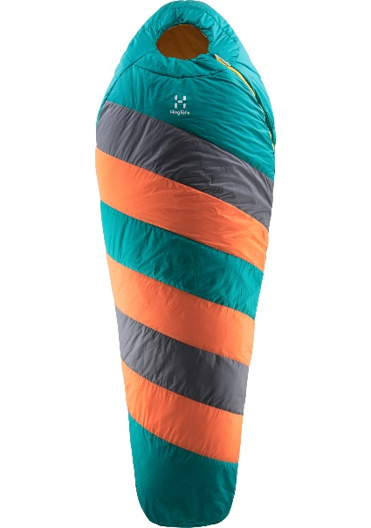
“At Haglöfs, sustainability is at the core of everything we do. It’s a fundamental part of our business, and we work hard to improve continually, as well as finding solutions that will reduce the impact our business has on the environment. This also fuels our creative process - and that's how we created the Leftover Sleeping bag. We wanted to find a way to use unused material left over from our production processes. Making them into colorful sleeping bags turned out to be a great idea” - Jennie Johansson, Designer and Developer at Haglöfs.
The Leftover Sleeping bag’s signature stripes and colorful bands of material aren't just a design feature. They tell the story of how the bag has been made; from material that otherwise would have been trimmed, collected and discarded during the production process.
As well as looking unique, the Leftover Sleeping bag is equipped with all the features needed for outdoor adventures. It's made from high-performance materials, such as a recycled bluesign® polyester and polyamide shell fabric treated with fluorocarbon-free DWR for waterproofing. It's insulated with Trifusion® Eco, which is a smart, versatile and resilient material that packs down nicely, and it will keep you comfortable in conditions ranging to -11°C. It's built with a mummy shape, a snug fitted hood and a side zip for easy access, and weighs in at around 1700g, excluding its compression bag.
The Leftover Sleeping bag is available in a limited edition of 105 pieces. It will be available at Haglöfs Brand stores, on haglofs.com and through selected retailers in May 2019. Estimated retail price: €160.

To read more about how Haglöfs work towards the goal of a sustainable outdoor industry, please find the sustainability report here https://www.haglofs.com/gb/en-gb/sustainability/sustainability-report/

For more information, please contact:
Lisa Grübb
Publishing Coordinator
+ 46 7 685 274 64
lisa.grubb@haglofs.se
LEFTOVER SLEEPING BAG - FACT SHEET
- Fabric:
  - Shell fabric: 20D polyamide plain weave 32 g/m², bluesign® approved and 50D 100% Recycled Polyester 72 g/m², bluesign® approved
  - Lining: 75D polyester
  - Insulation: Trifusion® Eco

- Fluorocarbon-free DWR treated surfaces to help repel water and dirt

- Comfort temperature: -4°C. Limit temperature: -11°C. Extreme temperature: -30°C

- Mummy shape, ergonomically-designed foot box and snug fitted hood

- ¾ side zip with anatomically shaped curvature for easier access

- Draft tube anti-snag tape
- Internal pocket and internal pillow pocket
- External hang loops
- Differential cut
- Offset construction
- Four-way compression bag
- Pack size: 24 x 33 cm. Compressed pack size (height): 26 cm

- Weight: around 1700g (excluding compression bag)

