Contact Details:

For more information, contact Mike Williams, CEO on 07748620235 or newsdesk@ukbjja.org

**\*For immediate release\***

**Wales has its first ever Brazilian Jiu Jitsu World Champion**

An athlete from Swansea has become the first ever Welsh competitor to win a world championship in Brazilian Jiu Jitsu (BJJ).

Ffion Eira Davies, who trains at CF24 Jiu Jitsu in Cardiff, flew out to Long Beach, California last weekend to compete in the World IBJJF Jiu Jitsu Championship. The event is the largest and most prestigious BJJ competition in the world, attracting nearly 4,000 competitors from around the globe. It was held from 31 May to 3 June, 2018.

Ffion battled through four tough fights, winning three by submission and one by points to reach the finals.

Ffion was one of a handful of women who between them brought home a total of six medals to the UK, including three golds! The other gold medals came from Margot Cicarelli-Tang at Purple Belt and relative newcomer Agnes Wrodarczyk at White Belt. Laura Barker won silver at Brown Belt and Vanessa English and Samantha Cook won the UK’s first ever medals at Black Belt with a bronze each.

Although relatively new to the UK, Brazilian Jiu Jitsu is one of the fastest growing sports with over 20,000 people (adults and juniors) regularly training in gyms across the country. It is a combat sport that focuses on grappling on the ground. It is suitable for all ages, both male and female. The governing body is the UKBJJA (<http://www.ukbjja.org>), which offers insurance, a club directory and a national ranking system for both adult and junior athletes. A key aim is to increase participation from female athletes, through an initiative called Unstoppable Girl and community and schools outreach programmes.

A full list of results, as well as video of the gold medal matches, can be found at the following link: <https://www.flograppling.com/results/6207361-2018-world-ibjjf-jiu-jitsu-championship/24562>

About the UKBJJA:

The UKBJJA ([www.ukbjja.org](http://www.ukbjja.org)) is a not-for profit organisation which aims to provide a governance structure for the martial art of Brazilian Jiu-Jitsu, that promotes and develops the sport while allowing individual clubs and practitioners the space and freedom to practice the martial art in the way they enjoy. The UKBJJA is currently under assessment to be recognised by Sport England as the governing body for Brazilian Jiu Jitsu in the UK.

The UKBJJA was formed in 2013, and the association’s goal is to foster the development of BJJ at elite, community and grassroots levels, raising the profile of the sport but also providing pathways for development and involvement across communities in the UK. Visit UKBJJA at www.ukbjja.org or follow us on Twitter @ukbjja.

Contact Details:

For more information, contact Mike Williams, CEO on 07748620235 or newsdesk@ukbjja.org

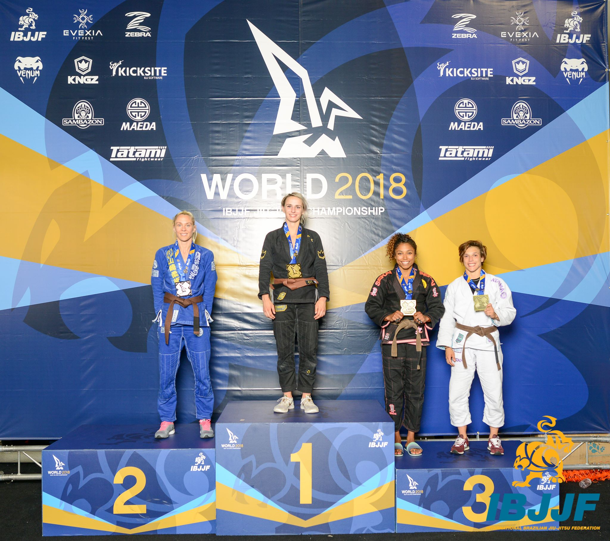

Ffion Eira Davies – World Champion

(Photo © Kenny Jewel for GrappletV)

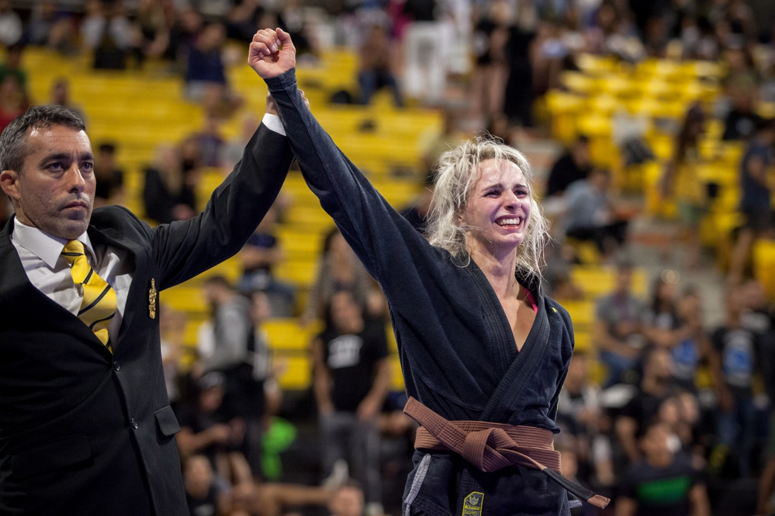

Ffion Eira Davies – World Champion

Photo © Maggie Left, [maggieleft.com](http://maggieleft.com/)