Tough weekend for Jessica Bäckman at the Lausitzring
Last weekend, August 20-22nd, the weekend started strong as Jessica was in the match right from the beginning of the free practice sessions. In the first qualifying, it was very tight for Pole Position between Jessica and championship leader Martin Andersen. In the end, only 42 thousandths separated both drivers and Jessica had to settle for second place. In qualifying 2 on Saturday, Jessica was hungry for revenge and this time she took home the Pole Position with a 1.5 tenths margin on a wet track and had two good starting positions for both races.
- The weekend has been a rollercoaster to say the least, the speed has been very good, but the race was everything else than what I could have imagined. Now I just have to put this weekend behind me and focus on the next race in about 1 months’ time, Jessica Bäckman says.
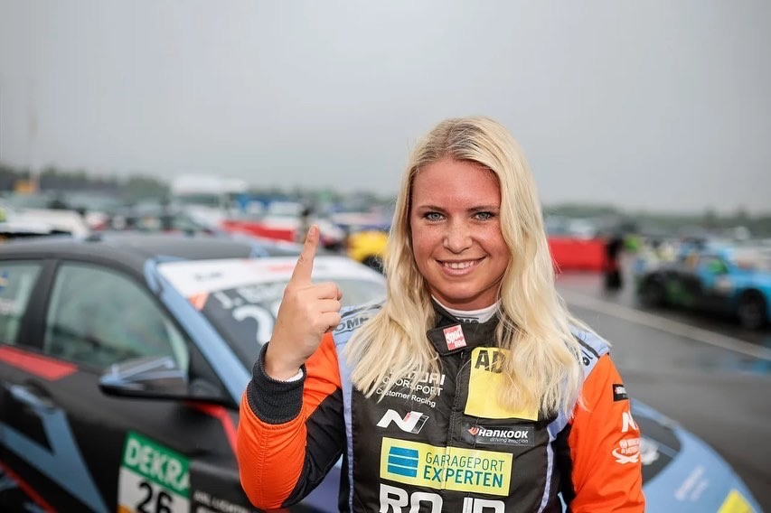
ADAC TCR Germany is one of the toughest TCR series in the world and has a high status for the drivers who come from several different countries around Europe. Each race weekend consists of two free practice sessions on Friday, one-time qualifying session on Saturday which determines the starting position in Race 1 on Saturday, and one-time qualifying session on Sunday which determines the starting position in Race 2 on Sunday. Points are awarded to the top 8 in each time qualifying and the top 15 in each race. The driver with the most points after the final race at the Hockenheimring at the end of October will take home the driver's title "ADAC TCR Germany Drivers Title" in the ADAC TCR Germany series. Last weekend, August 20-22nd, the fifth round was held at the Lausitzring track in Germany, where Jessica scored her second Pole Position of the season, but which ended with two disappointing races.
- The weekend has been a rollercoaster to say the least, the speed has been very good, but the race was everything else than I could have imagined. Now I just have to put this weekend behind me and focus on the next race in about 1 months’ time, Jessica Bäckman says.
Second Pole Position of the season
The first qualifying on Friday was very tight between 1st and 2nd driver where the best lap time was only separated by a margin of 42 thousandths, so this was the tightest qualifying of the season. The Sweden National Team driver had to settle for second place but was then extra motivated to take Pole Position on Saturday. It was a tough qualifying with a wet track which then got drier and drier towards the end. Jessica chose the right strategy and had good speed during qualifying and then took her second Pole Position of the season by 1.5 tenths margin and then had two good starting positions for both races.
- The qualifying’s was very exciting, it's fun when it's so close at the front, then it's important to always set the perfect laps to take home the first place. I am satisfied with the speed this weekend and satisfied that I achieved a Pole Position on wet surfaces, Jessica Bäckman says.
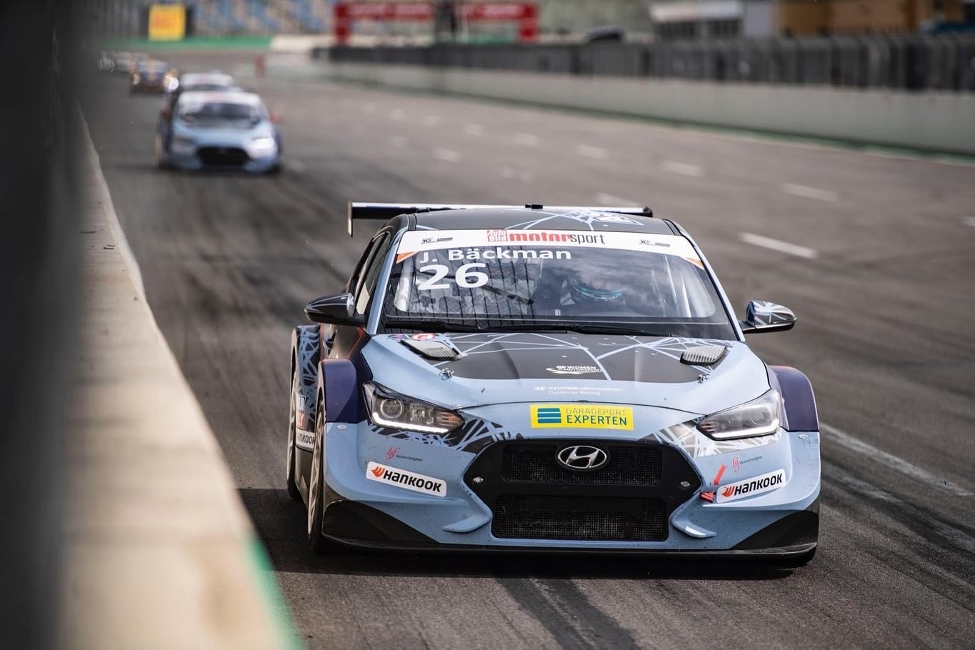
Tough races for the Sweden National Team driver at Lausitzring
In Saturday's first race, Jessica started from the second position on a rainy Lausitzring. Jessica had too much wheelspin at the start and dropped down to 6th place. Then she had many fights to get up in the field but didn't really have the grip with her and then had a big snap in the car and had to retire the race in the gravel. In Race 2 on Sunday, Jessica didn't get a super start either and was down to fourth place but fought hard the entire race for the podium places. In the end, Jessica worked her way up to third place and then had her sights set on second place with two laps remaining. When the Sweden National Team driver then braked into the first corner, she was hit hard from behind and ended up on the side of the track. She was then able to continue the race, but the fight for the top positions was completely over and Jessica had to settle for a disappointing 8th place. After this weekend, Jessica is 71 points behind championship leader Martin Andersen and now has a hard time collecting these points if nothing dramatic happens. Despite this weekend's tough results, Jessica is in second place in the championship with two race weekends remaining.
- It was a tough weekend, especially when there were crashes that I can't control, it’s disappointing when I had the aim and the chance for the championship. I will do everything I can to get good results for the rest of the season and enjoy and have fun, anything can happen in motorsport so I will not give up the fight, Jessica Bäckman says.
Jessica’s results:
Free Practice 1: 6th place
Free Practice 2: 1st place
Qualifying 1: 2nd place
Race 1: DNF
Qualifying 2: 1st place
Race 2: 8th place (Crash with 2 laps remaining)
Championship standings:
ADAC TCR Germany – Total (Top three)
ADAC TCR Germany 2022 (after 5 of 7 rounds)
1: Martin Andersen (DKK), 302 p.
2: Jessica Bäckman (SWE), 231 p.
3: Szymon Ladniak (POL), 214 p.
Click to see the full championship standings
TV links in case you missed the races:
Race 1: Click to watch Race 1
Race 2: Click to watch Race 2
Free rights to use images.

