IQR gasifies biofuels in unique CHP plant
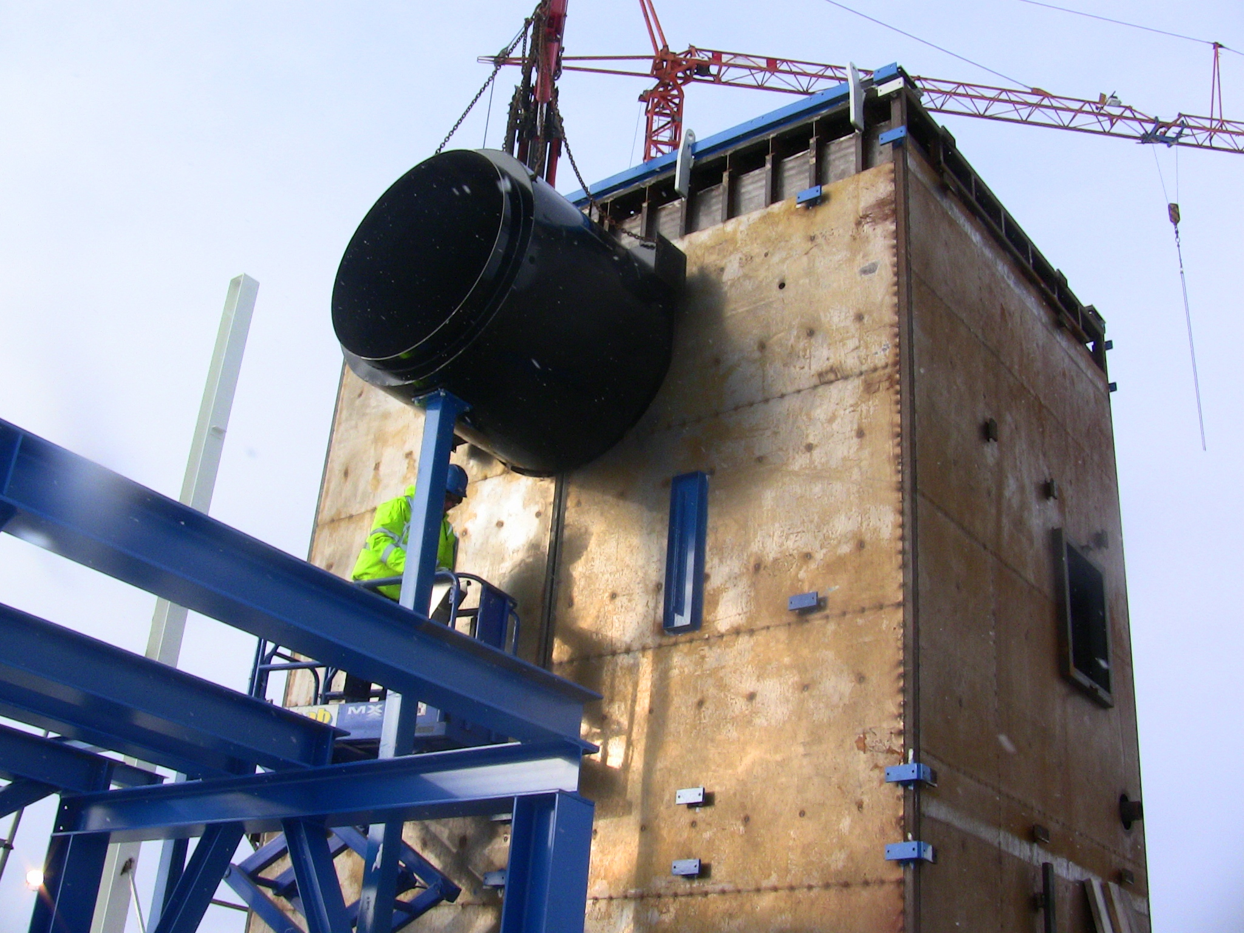
IQR Systems has developed a biofuel gasifier for 2-25 MW_{th} production. The gasifier can be implemented in full scale CHP plants and the construction of plant number two is now up and running.
The gasification unit that now is being built is going to use various kinds of biomass fuels - with a moisture contents of up to 60%. A similar 14 MW gasification unit is since 2008 installed at Svenljunga Energy's incineration plant. Plant number two, ordered by Munkfors Energy, will be powered up this fall.
"Decisive for us was to produce electricity and district heating while maintaining low emissions, regardless of what biofuels we use," says Jörgen Karlsson, CEO of Munkfors Energy. "This gasifier provides great fuel flexibility, and there is of course a financial gain for us when we can use less demanded fuels."
Munkfors Energy expects to burn a wide range of wooden fuels from the local area. Possible fuels can be anything from recycled or impregnated wood to forest waste and peat.
The gasifier will be able run as low as on a 10% load, while maintaining a complete combustion with unaffected emission levels. For district heating suppliers like Munkfors Energy, this means that they do not have to start and stop production during the summer, and can instead run on a low, steady load. The new cogeneration plant of 10 MW will also make Munkfors Energy fossil fuel independent.
IQR Systems sees electricity and heat production as two out of many possible applications for their gasification unit.
"We are extremely pleased with our patented technology and have only really begun to investigate the potential of the market," says Daniel Karlström, CEO of IQR Systems. "For an energy intensive process, it is of course very interesting to be able to replace oil with biofuels. The customer gets a biofuel plant, but still retains the oil burner's technical advantages, which has previously been impossible."
For more information, please contact:
Daniel Karlström
+46-40-680 89 95
daniel@iqr.se

