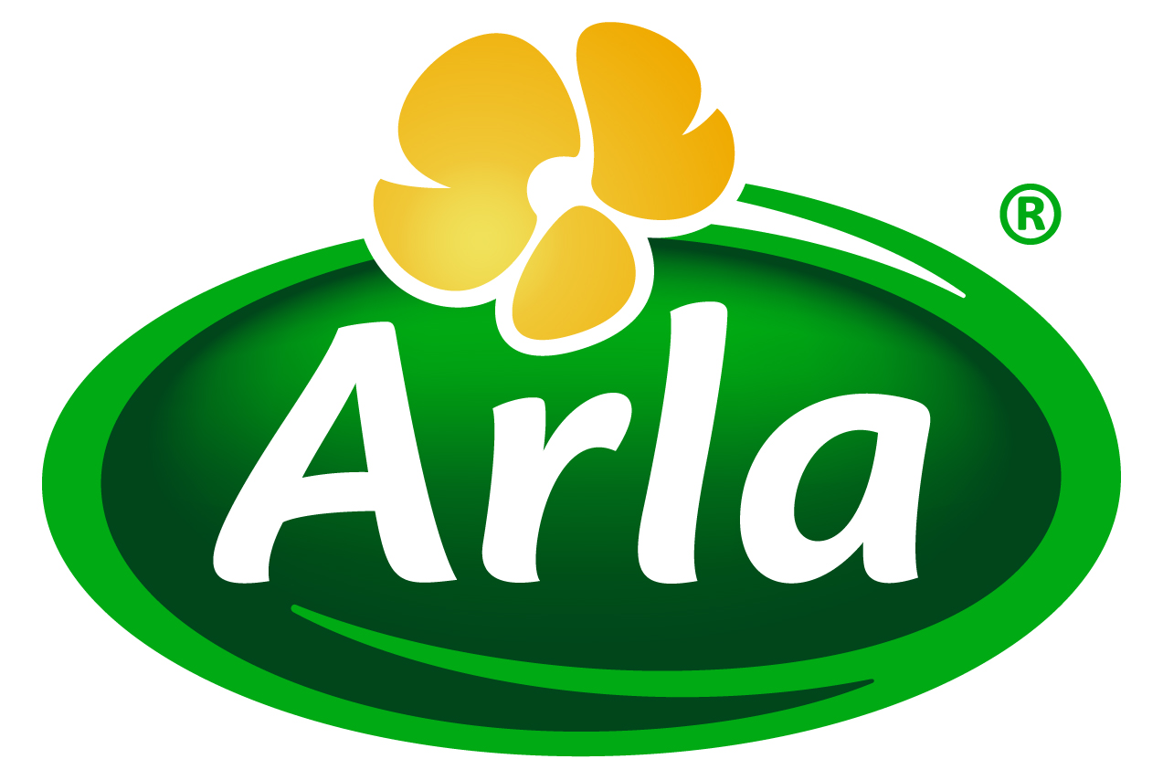
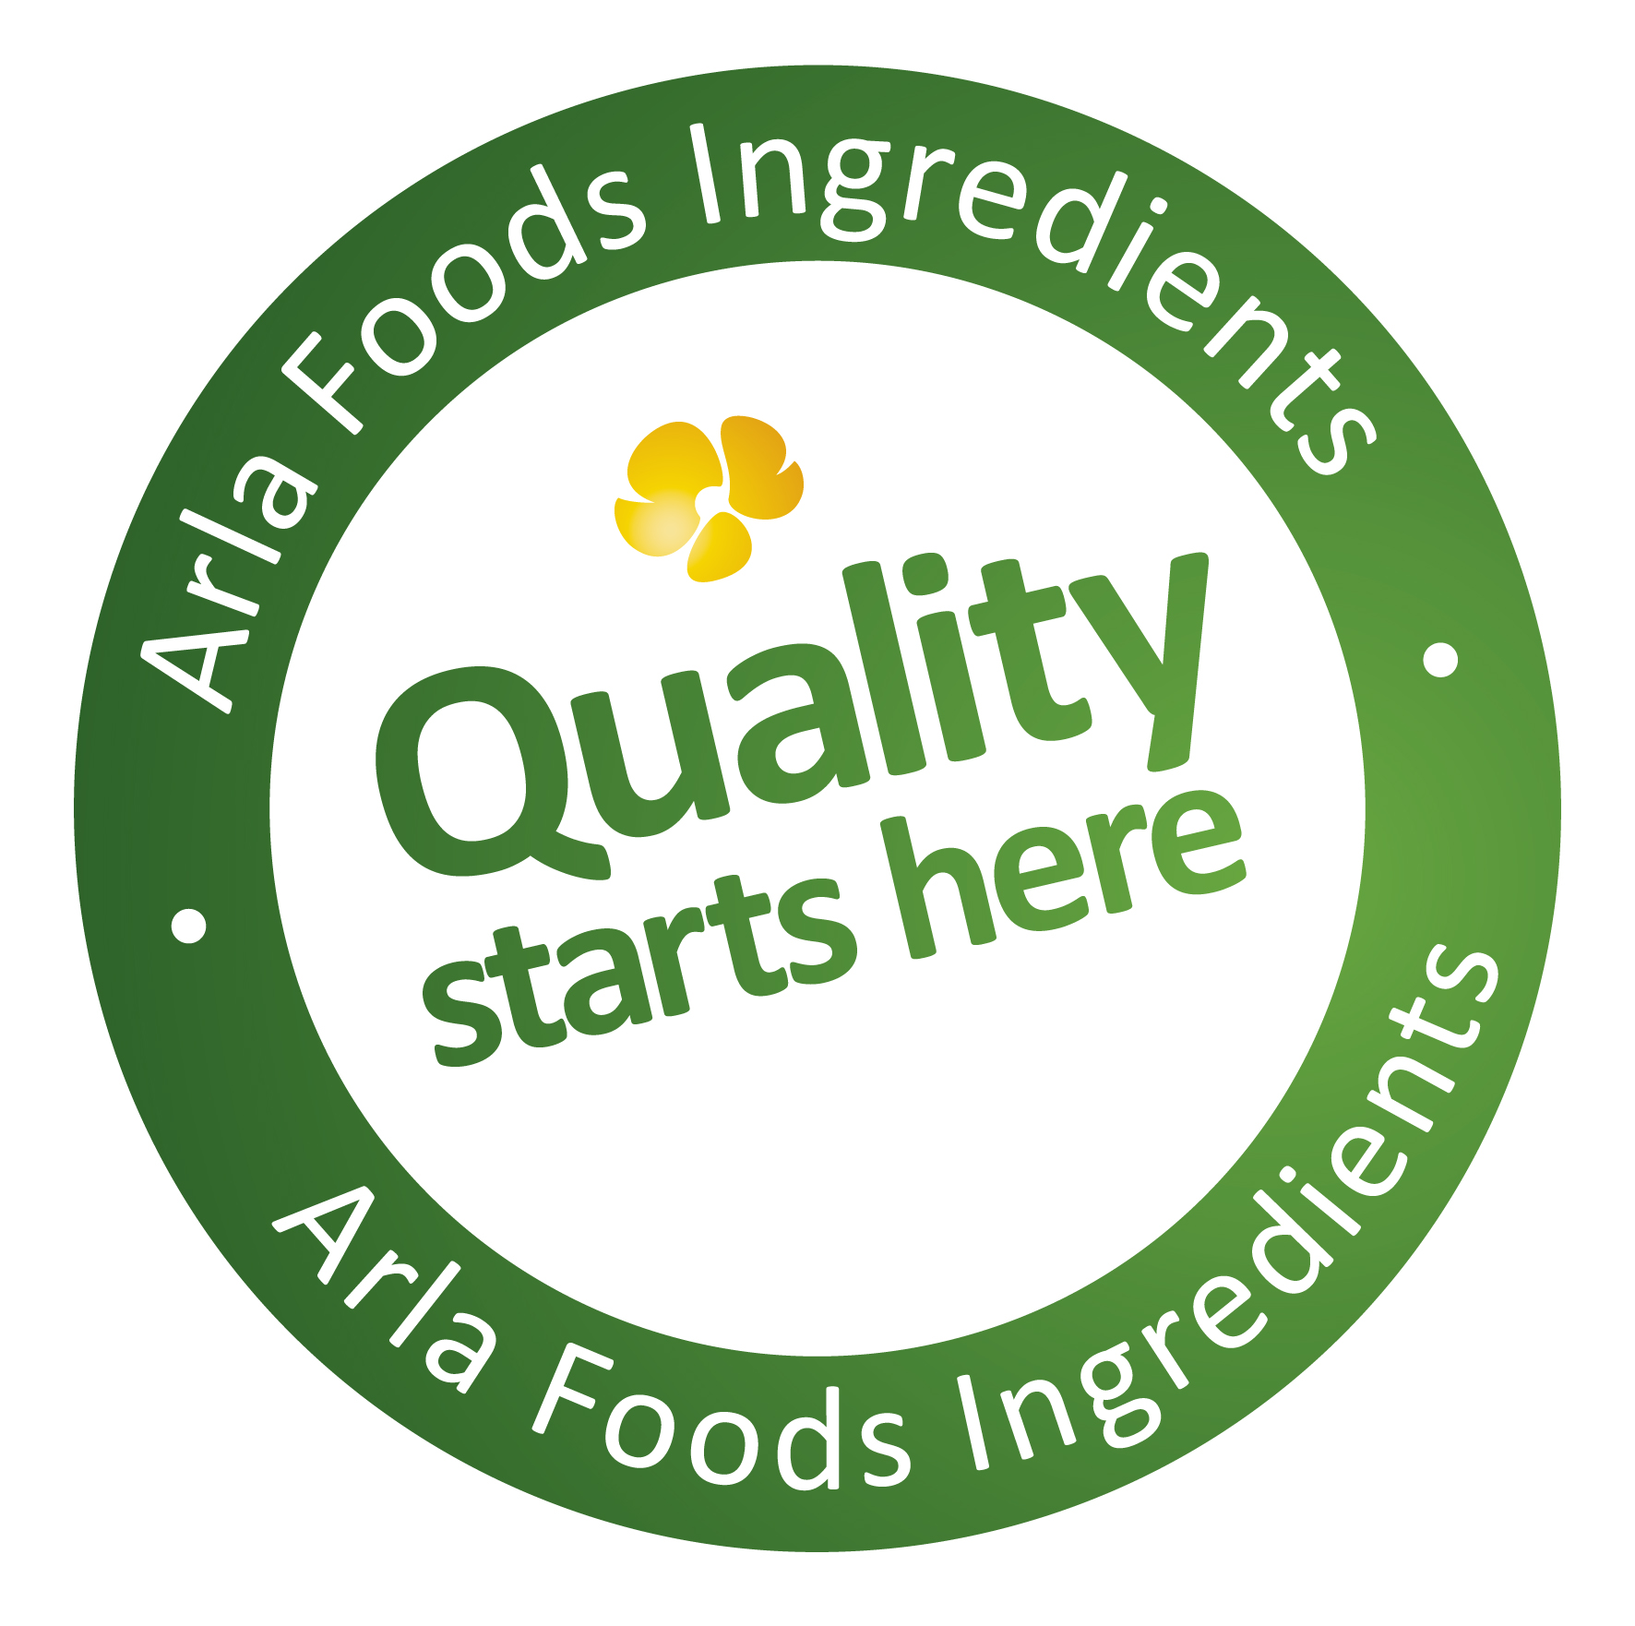

30 April 2015
PRESS RELEASE
Dairy proteins set to keep sales of weight
management products in good shape

Arla Foods Ingredients has developed a new generation of dairy protein ingredients designed for inclusion in delicious and filling weight management products that fit seamlessly into consumers’ every-day routines

The weight management category remains strong, registering growth of 13% between 2008 and 2013, according to Euromonitor, with further growth of 7% forecast from 2013 to 2018. Within weight management, protein takes centre-stage, with 57% of consumers seeking out protein sources.

Lindsey Ormond, Business Development Manager for Health & Performance Nutrition at Arla Foods Ingredients, said: “The weight management market is booming and shoppers are looking for products that help them maintain a healthy weight without significantly altering how they eat. They want products that are convenient, taste good and are effective. This is where dairy proteins come in. They can be used to create products that offer all of these qualities, while also delivering the health benefits of high quality protein.”

Evidence is mounting that a high proportion of protein in the diet increases weight loss and prevents weight gain. This is believed to be due to protein’s beneficial impact on appetite, satiety and energy expenditure. The energetic cost of metabolizing protein is higher than for carbohydrates and fat. Whey protein also leads to greater diet-induced thermogenesis (heat production) than soy or casein protein, increasing energy expenditure, which can lead to improved body composition. Evidence is also growing that whey enhances glycemic regulation.
Exhibiting on Stand P40 at Vitafoods Europe (Geneva, 5-7 May 2015), Arla Foods Ingredients will present two concepts to showcase the potential of its proteins in the weight management category:

- A smoothie made with Lacprodan® Smooth80, a whey protein that can boost the protein content of smoothies to as high as 6% without negatively impacting on taste or texture
- A snack bar formulated with Nutrilac® PB-8420 – a natural milk protein – which offers a delicious taste and a long shelf life with a pleasant soft texture that is retained for more than a year

Lindsey added: “Dairy proteins hold an attraction for consumers seeking a more natural, nutritious and long-term way to manage their weight instead of a quick-fix. They also offer a convenient and sociable approach to watching food intake compared with the hassle of counting calories. With weight management such a good proposition right now, we’ve created Lacprodan® Smooth80 and Nutrilac® PB-8420 to make it easy for manufacturers to develop high protein products that weight-conscious consumers will want to buy again and again.”

ENDS

For more information, contact Kine Bjoralt, Ingredient Communications
Tel: +44 141 280 4141 Email: kine@ingredientcommunications.com

About Arla Foods Ingredients
Quality starts here: Arla Foods Ingredients is a global leader in natural whey ingredients for products in a range of categories – from sports nutrition, beverages, bakery, dairy and ice cream to clinical and infant nutrition. The cornerstones of our business are innovative ingredients, world-class facilities and a staff of dedicated experts. Drawing on our portfolio of functional and nutritional whey proteins, milk minerals, lactose and permeate, our expert team delivers solutions that bring new food products quickly and efficiently to market. Our application centres run hundreds of customer product trials every week. All ingredients are produced using state-of-the-art processing technology at our plant in Denmark, or by one of our joint ventures in Argentina, Germany and the UK. Arla Foods Ingredients Group P/S is a 100% owned subsidiary of Arla Foods, a global dairy company and cooperative owned by dairy farmers in Denmark, Sweden, the UK, Germany, the Netherlands, Belgium and Luxemburg.

RSS Feed
Visit our website at http://www.mynewsdesk.com/arla-foods-ingredients and sign up to our News RSS feed for all the latest developments – updated regularly.

Twitter
Follow us on twitter for all the latest updates @ArlaIngredients

LinkedIn
http://www.linkedin.com/company/arla-foods-ingredients

Bendtsen LQ et al. 2013; Effect of dairy proteins on appetite, energy expenditure, body weight and composition – a review of the evidence from controlled clinical trials. Adv. Nutr. 4: 418-438.
Jakubowicz D & Froy O 2013; Biochemical and metabolic mechanisms by which dietary whey protein may combat obesity and Type 2 diabetes. Journal of Nutritional Biochemistry 24, 1-5

