New LARS solution will increase efficiency, improve safety and reduce risk of damage to AUVs

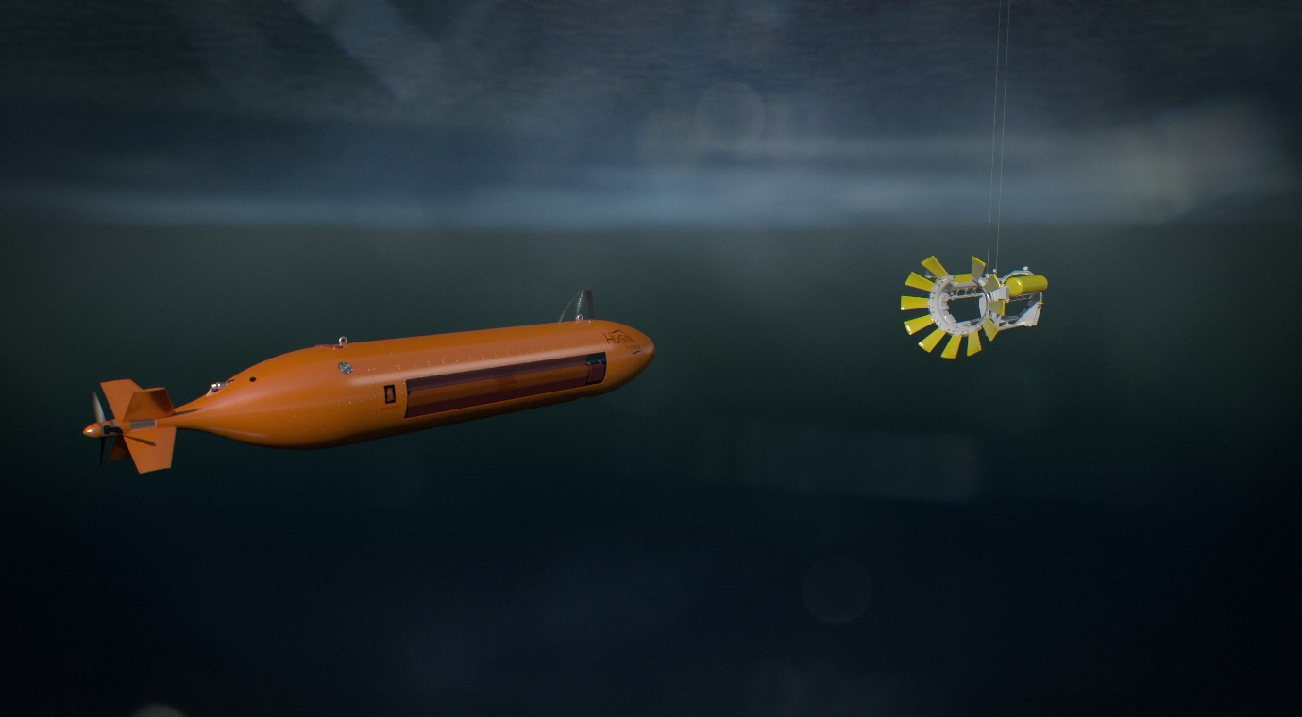
A Kongsberg Maritime HUGIN AUV approaches the new LARS docking system

Kongsberg, Norway, 31st March 2020 – Kongsberg Maritime has developed a new LARS (Launch and Recovery System) solution for its HUGIN range of Autonomous Underwater Vehicles (AUVs), which is set to bring about a series of far-reaching operational improvements.
The new LARS solution benefits from the uniquely integrated combination of advanced in-house technologies which the KONGSBERG group offers, reinforced with years of accumulated expertise. After evaluating techniques and procedures in depth, Kongsberg Maritime has arrived at an optimal solution, namely to have the new LARS operating from midships, with the release and capture of HUGIN marine robots occurring beneath the sea surface.
Launching and recovering AUVs under water, away from the splash zone, lessens the possibility of their being damaged, while midships deployment averts any likelihood of AUVs being run over by the launch vessel. The new LARS’ subsea capabilities provide an extra benefit in that launch and recovery processes can be carried out in much higher sea states. This reduces the risk of weather damage to marine robots, while boosting productivity to deliver significant cost savings.
There are also tangible crew benefits. Operating the new LARS from midships will free up valuable aft deck space, and safety will be considerably enhanced as no personnel will be required to work over the stern in potentially challenging conditions.

The design allows AUVs to be deployed from a hangar or container, and multiple robots may be managed from a single LARS. It is flexible with regards to placement – although midships is optimal – and can be operated from anywhere on board, including the stern. It may also be installed higher than on the main deck, to accommodate the vessel layout.
For deployment and recovery, the LARS cradle is lowered into the water to a pre-determined depth. It is positioned safely below the splash zone and propeller wash, enhancing both the weather window and safety, and is heave-compensated to stabilise the effect of waves and ship movement. Once in the water, HUGIN is released to start its mission. During recovery the AUV finds its way home to the cradle using the onboard navigation system and a KONGSBERG MicroPAP located in the LARS. Once nearby, the HUGIN drives itself into the cradle and is locked in before it is lifted out of the water.
“There is limitless scope in this new LARS design,” says Bjørn Gjelstad, Marine Robotics R&D manager, Kongsberg Maritime. “It could of course be installed on newbuilds which are being commissioned by naval forces, where it would aid the deployment of marine robots in the execution of duties ranging from subsea surveying and Search & Rescue to mine detection and clearance.
“It could also be installed into an AUV hangar on a platform supply vessel, facilitating a broad range of subsea tasks related to the offshore oil & gas infrastructure, or even retrofitted in a containerised solution. Coupling this new LARS with our highly manoeuvrable, stable, compact and customisable HUGIN AUVs, which utilise a modular payload system capable of accommodating a comprehensive variety of sensors, will transform commercial, oceanographic and military applications of all kinds.”
Ends
For further information, please contact:

Gunvor Hatling Midtbø, VP Communication
Kongsberg Maritime
Tel: +47 9921 4209
gunvor.hatling.midtbo@km.kongsberg.com

David Pugh
Saltwater Stone
Tel: +44 (0)1202 669244
d.pugh@saltwater-stone.com

About Kongsberg Maritime
Kongsberg Maritime is a global marine technology company providing innovative and reliable ‘Full Picture’ technology solutions for all marine industry sectors including merchant, offshore, cruise, subsea and naval. Headquartered in Kongsberg, Norway, Kongsberg Maritime has manufacturing, sales and service facilities in 34 countries.
Kongsberg Maritime solutions cover all aspects of marine automation, safety, manoeuvring, navigation, and dynamic positioning as well as energy management, deck handling and propulsion systems, and ship design services. Subsea solutions include single and multibeam echo sounders, sonars, AUV and USV, underwater navigation and communication systems.
Training courses at locations globally, LNG solutions, information management, position reference systems and technology for seismic and drilling operations are also part of the company’s diverse technology portfolio. Additionally, Kongsberg Maritime provides services within EIT (Electro, Instrument & Telecom) engineering and system integration, on an EPC (Engineering, Procurement & Construction) basis.
Kongsberg Maritime is part of Kongsberg Gruppen (KONGSBERG), an international, knowledge-based group that celebrated 200 years in business during 2014. KONGSBERG supplies high-technology systems and solutions to customers in the oil and gas industry, the merchant marine, and the defence and aerospace industries.
Web: Kongsberg Gruppen | Kongsberg Maritime
Social media: LinkedIn | Twitter | Facebook

