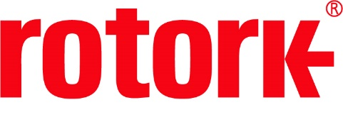
APPROVED PRESS RELEASE (3.1008) 20th August 2020
Rotork electric and fluid power actuators supplied to oil production site in the Middle East
Rotork has supplied over 250 IQ3 intelligent electric actuators with IW quarter-turn gearboxes, five GP heavy-duty scotch yoke pneumatic actuators and five SI electro-hydraulic actuators for use at an oil production site in the Middle East.
The actuators will be installed on a remote header application at one of the world’s largest exporter of crude oil and condensates. This is one of several new build sites in the country. The actuators will be used to control the flow of crude oil from remote header manifolds to nearby refineries for further processing.
Rotork’s IQ3 multi-turn actuator allows for unparalleled data analysis of a valve’s condition and operational status, delivered through an intuitive user interface and advanced dual-stacked display. In this application, the IQ3s have been installed with IW quarter-turn worm gearboxes which enables them to reach a torque output range of up to 826,888 Nm (609,881 lbf.ft). The gearboxes include low lead angle gearing designed to be inherently self-locking.
The Rotork GP pneumatic quarter-turn actuator is designed to provide a rotary movement for either on/off or modulating duty. Featuring corrosion resistant cylinders, the GP can deliver an output torque of up to 600,000 Nm (442,500 lbf.ft).
The SI range of intelligent self-contained electro-hydraulic actuators offers a unique and reliable solution for electric fail-safe and both two position and positioning control. Available in spring-return or double-acting configuration, the SI can offer a linear torque output range of 1.5 to 3,850 kN and part-turn torque output range of 65 to 600,000 Nm.
The customer also ordered five Rotork Master Stations. Each one can control up to 240 actuators on a single highway option and comes with a large touch screen interface which allows operators and engineers to see exactly what is happening on the site. Fully hot standby, the Rotork Master Station has all interfaces replicated i.e. CPU, power supplies, display, network interfaces and control interfaces.
Rotork Middle East has supplied these products to the oil production site. The after sales service that is available to the valve maker, EPC and end user is being managed by Rotork Middle East.

END
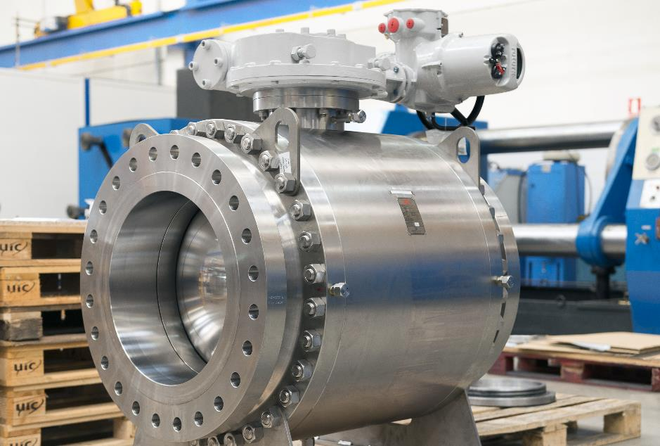
Photo caption
Rotork IQ intelligent actuator with an IW gearbox installed on a ball valve.

For further information please contact Rotork PLC
Sarah Kellett Brassmill Lane
Group Marketing Communications Manager Bath
Telephone: +44 (0) 1225 733492 BA1 3JQ
Email: Sarah.Kellett@rotork.com UK

About Rotork
Rotork is a market-leading global provider of mission-critical flow control and instrumentation solutions for oil and gas, water and wastewater, power, chemical process and industrial applications. We help customers around the world to improve efficiency, reduce emissions, minimise their environmental impact and assure safety.

