Sany Germany GmbH
Sany Allee 1
50181 Bedburg
T: 0049 2272 90531 100
F: 0049 2272 90531 109
E: info@sany-germany.de
I: www.sany-germany.de

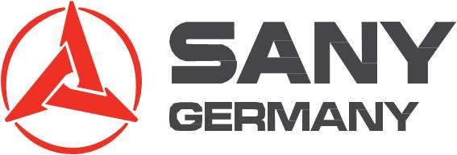

Sany Germany GmbH is the European Headquarter of the SANY Group founded in 1989 in Changsha, China. SANY Group is the fifth largest construction equipment manufacturer worldwide.
SANY Germany develops and produces mobile port machinery for the European and global markets. The company also supports development of crawler cranes and hydraulic excavators for the developed markets. Producing mobile port machinery with European components to create CE-compliant products is the main function of the 10.000m² production hall, which is part of the SANY Germany industrial park in Bedburg inaugurated in 2011. The current range of products contains:
- Mobile port machinery: Reachstackers in different configurations and Tier III and Tier IV emission engine compliant offering. Empty Container Handlers and Heavy Duty Forklifts are under development and scheduled to form part of the European product offering within 2014.
- Lifting Equipment: Crawler Cranes ranging between 50 – 300t
- Earthmoving Machinery: Hydraulic Crawler Excavators between 7 to 33t. The portfolio is being expanded throughout the course of 2014.
The built in Germany mobile port machinery products are available for customers and dealers worldwide through the SANY regional organizations.
In terms of After Sales, SANY Germany acts as a Centre of Excellence for the support to dealers and customers but also to other SANY regional organizations. A large parts inventory has been established in Bedburg and lead times to customers worldwide are extremely short due to various reasons: A central position in Europe that offers a first class infrastructure, favourable import and trade regulations for deliveries out of Europe as well as the use of efficient communication and administration systems. Their service team provides regular and in-depth trainings to their dealers either in their own training facilities or at the customer site.

Another key factor to success is SANY Germany’s team of industry experts with in-depth knowledge in terms of products, customers and applications. The international team covers multiple languages and brings to the company many years of experience from market leading companies in the port, lifting and construction machinery sectors.

