Swedish ed-tech company Strawbees raises SEK 20m ($2.2) from Zenith Group to fuel global expansion

Fast growing STEAM ed-tech company Strawbees today announces a SEK 20 million ($2.2m) capital raise from Swedish tech investor Zenith Group. Since launch in 2015, Strawbees has been a growth magnet empowering tens of thousands of learners worldwide.
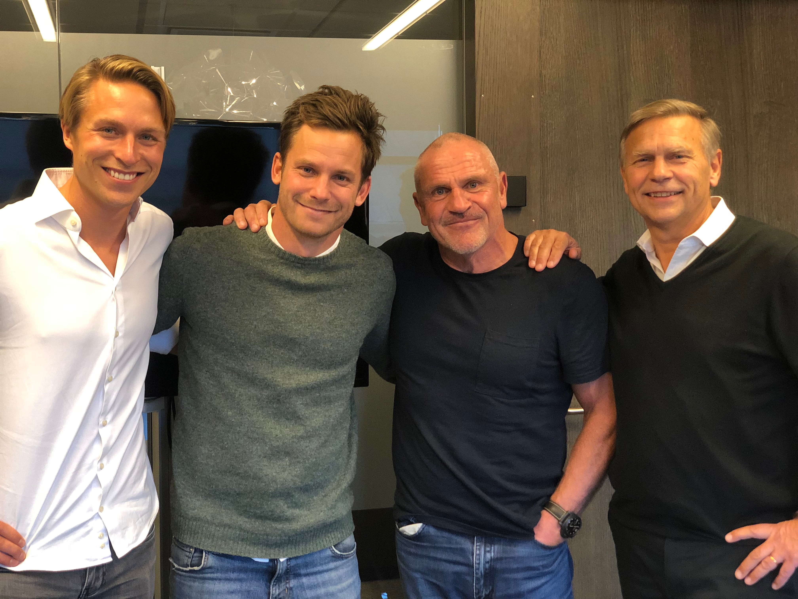(From left to Right)Erik Lindblad, Investment Manager Zenith; Erik Bergelin, CEO Strawbees; Tommy Jacobson, Partner Zenith; Lars Thoren, Chairman Zenith
Swedish Strawbees has developed a full range of STEAM products, for the age group 4-19 years, to teach engineering, coding, robotics and sustainability in a playful and affordable way. Since launch in 2015 Strawbees has experienced a rapid growth and established the brand in several key markets. The company’s largest market today is the US but Strawbees is also experiencing high demand from several markets in Asia and Europe. As two examples Strawbees is today being used by tens of thousands of Kindergartens in South Korea and are currently rolling out the solution to all schools in Thailand.
In addition to Strawbees current markets the company signed an agreement with the UN in October 2018 to offer Strawbees’ learning solutions worldwide with a special focus on public schools in Latin America and Africa. Following the signing Strawbees launched a first pilot in Ghana in November this year.


Strawbees workshop in Wenchi, Ghana, on applied maths and engineering

To meet and leverage the strong demand Strawbees today announces the raise of SEK 20m ($2.2m) from Swedish Venture Capital firm Zenith Group. Zenith has a strong track record of successful investments in Truecaller, Zound industries and Leeroy among others, and are now looking to support Strawbees on their growth journey.

”We were fortunate to have a few investors to choose from, but from the start Zenith shared our values and beliefs that Strawbees will contribute to a more equal world, where everyone can use our amazing and engaging tools for learning about the environment, as well as being creative with technology.” says Erik Bergelin, CEO of Strawbees.

”We are excited about backing Strawbees on their journey to become a global educational brand. In a fast changing world it’s difficult to predict what skills today’s children will need to be prepared for the future of tomorrow. But like the team at Strawbees we strongly believe that programming, creativity, engineering and sustainability will be crucial. Strawbees’ offer ticks all these boxes at an affordable price point making it very attractive and scalable.” says Erik Lindblad, Investment Manager, Zenith Group

“We believe that Erik Bergelin and the team at Strawbees have what it takes to make an amazing journey and hope to contribute by letting Strawbees leverage Zenith’s experience and network. We further believe in the global trend of STEAM education and see that Strawbees taps right into this trend.” Says Tommy Jacobson, Chairman of the board, Zenith Group

About Strawbees
Strawbees AB was founded in Gothenburg 2014 by Erik Thorstensson and Erik Bergelin and launched its first products through a Kickstarter campaign in 2014. In 2017 Strawbees acquired the company Quirkbot and their robot specially designed for the Strawbees construction systems.

Strawbees lets the user construct objects with the Strawbees Construction kit and then make the construction come alive by applying the Strawbees robot. The robot is subsequently programmed via the Strawbees coding platform. In addition Strawbees offers an Upcycling System making it possible for the user to produce their own construction parts and Strawbees connectors from waste material.

Example of Strawbees resellers (apart from the educational sales): Barnes & Noble, Amazon, Åhléns, Centre Pompidou, DesignTorget, Urban Outfitters and Strawbees e-commerce at www.strawbees.com/store

About Zenith Group
Zenith Group is a Stockholm based investment firm investing in strong entrepreneurial teams with focus on tech. Zenith invests through its three funds Zenith VC, Zenith Growth and Zenith Real Estate. All three funds are listed on NGX.
www.zenithgroup.se

For more info, please contact Strawbees CEO Erik Bergelin or Zenith Group Investment Manager Erik Lindblad:

Erik Bergelin
Erik.bergelin@strawbees.com
+46768710747

Erik Lindblad
Erik.lindblad@zenithgroup.se
+46737080231

Pictures: LINK (pictures of team, logo, products)
https://www.dropbox.com/sh/g4gird5bjqbyvrm/AAAtsFOOlhkp_v3JjZKSeaToa?dl=0

Science, Technology, Engineering, Art & Mathematics

