World Summit Tour 2017—because inspiration and confidence matters
Press Contact
Kerstin Wettby
Senior Manager
Global Communication & PR
Aminogatan 1
SE-43121 Mölndal, Sweden
Phone: +46 705 16 32 02
kerstin.wettby@dentsplysirona.com

About Dentsply Sirona Implants
Dentsply Sirona Implants offers comprehensive solutions for all phases of implant therapy, including
ANKYLOS®, ASTRA TECH Implant System™ and XiVE® implant lines, digital technologies, such as ATLANTIS™ patient-specific CAD/CAM solutions and SIMPLANT® guided surgery, SYMBIOS®
regenerative solutions, and professional and business development programs, such as STEPPS™. Dentsply Sirona Implants creates value for dental professionals and allows for predictable and lasting
implant treatment outcomes, resulting in enhanced quality of life for patients.

About Dentsply Sirona
Dentsply Sirona is the world’s largest manufacturer of professional dental products and technologies, with a 130-year history of innovation and service to the dental industry and patients worldwide. Dentsply Sirona develops, manufactures, and markets a comprehensive solutions offering including dental and oral health products as well as other consumable medical devices under a strong portfolio of world class brands. As
The Dental Solutions CompanyTM, Dentsply Sirona’s products provide innovative, high-quality and effective solutions to advance patient care and deliver better, safer and faster dentistry. Dentsply Sirona’s global headquarters is located in York, Pennsylvania, and the international headquarters is based in Salzburg, Austria. The company’s shares are listed in the United States on NASDAQ under the symbol XRAY.
Visit www.dentsplysirona.com for more information about Dentsply Sirona and its products.
Press Release

April 2016—The dynamic, interactive and state-of-the-art World Summit Tour, a scientific congress on implant dentistry, is coming to Tokyo, San Diego, Nice and Shanghai during 2017.

Dedicated to enhanced quality of life for patients and a vision of a world where everyone eats, speaks and smiles with confidence, Dentsply Sirona Implants will tour the globe on the premise “Because inspiration and confidence matters” to inspire clinicians and researchers to come together to share scientific knowledge and clinical experience and to discover the latest innovations in implant dentistry.

“Attending international scientific congresses is a must for today’s dental professionals in order to keep up with the latest scientific, clinical and digital development, especially in implant dentistry. And with a tour like this, you are able to attend a congress that is not just geographically close to where you live, but also tailor-made to your needs and the market that you work in,” says Professor Clark Stanford from University of Illinois at Chicago, and also a member of the International Scientific Committee for the World Summit Tour.

The World Summit Tour will welcome 1,200 dental professionals in each of the four cities of the tour. At each tour stop, dental professionals will experience an international yet intimate and familiar setting, with a congress program made up of scientific lectures from international and regional speakers, hands-on workshops on various solutions, a display of the comprehensive portfolio, and hospitality second-to-none.

International Scientific Committee
An international group of well-renowned experts will contribute to the scientific program for the World Summit Tour:
- Tomas Albrektsson—University of Gothenburg; Malmö University, Sweden
- Christoph Hämmerle—University of Zurich, Switzerland
- Ye Lin—Peking University, China
- Jan Lindhe—University of Gothenburg, Sweden
- Clark Stanford—University of Illinois at Chicago, USA
- Meike Stiesch—Hannover Medical School, Germany
- Tetsu Takahashi—Tohoku University, Japan

Follow the World Summit Tour 2017 on social media at #worldsummittour
And on the web at
www.worldsummittour.com
IMAGES
are available in our News & Press Room at:
www.dentsplyimplants.com/en/Resources/News-and-Press

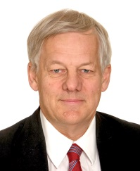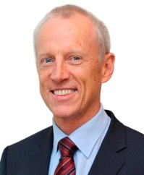
Fig.1: International Scientific Committee

 |  | 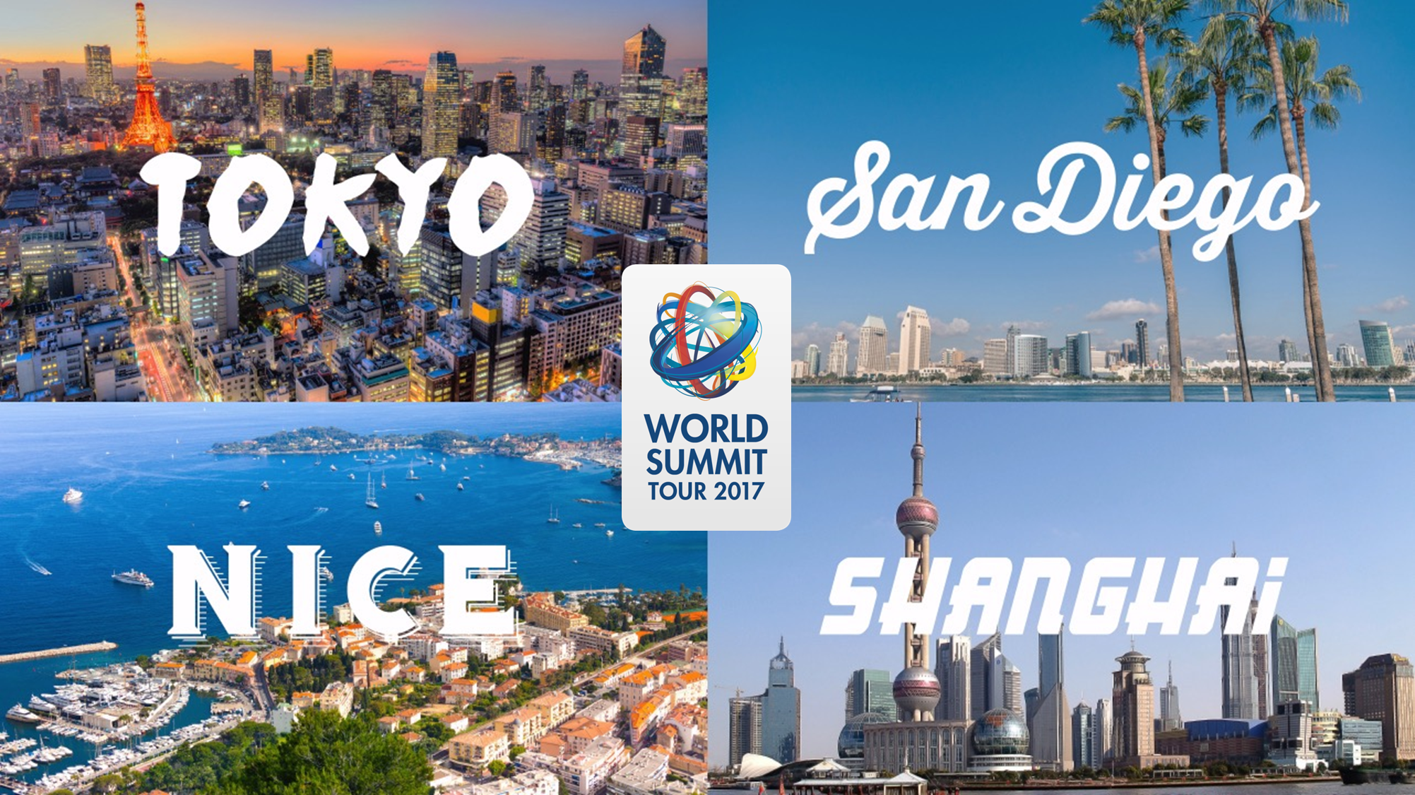
Fig.2: World Summit Tour 2017 |  | Fig 3: World Summit Tour 2017

