**FOR IMMEDIATE RELEASE**

Contacts:

|  |  |  |  |
| --- | --- | --- | --- |
| EU: | Daniela Karthaus | Japan: | Kazuki Fujiwara |
|  | Hitachi Rail Europe Ltd. |  | Hitachi, Ltd. |
|  | +44 (0)7920 205 631 |  | +81-3-5208-9324 |
|  | Daniela.karthaus@hitachirail-eu.com |  | kazuki.fujiwara.td@hitachi.com |

**Hitachi Unveils Train for the UK Intercity Express Programme**

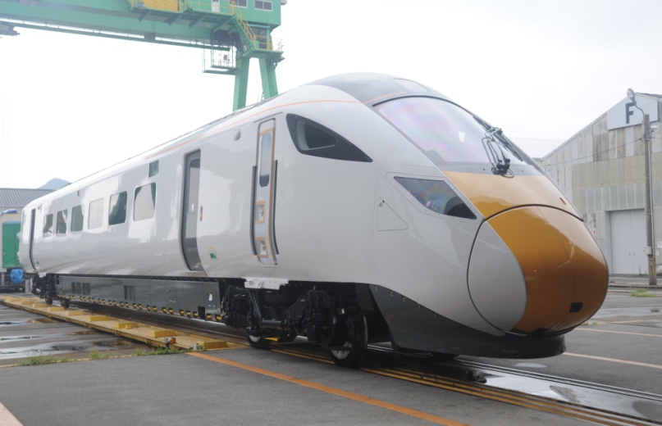

The newly unveiled Class 800 Train

Tokyo, Japan, November 13, 2014 – Hitachi, Ltd. (TSE:6501, “Hitachi”) announced today that it has unveiled the first train being manufactured for the UK Department for Transport’s Intercity Express Programme (IEP). The order for these new trains was received back in July 2012 and the first pre-series models are scheduled to be completed by the end of 2014. They will then be shipped to the UK for test operations in the first half of 2015.

This project is being undertaken based on a Public Private Partnership (PPP) scheme led by the UK Department for Transport. Financial support is being provided by the Japan Bank for International Cooperation (JBIC), Nippon Export and Investment Insurance (NEXI) and other organisations.

Hitachi is currently manufacturing three pre-series trains for the IEP at Kasado Works in Kudamatsu City, Yamaguchi Prefecture. Of the total 122 trains ordered, twelve, including the one recently unveiled, are being manufactured at Kasado Works. The remaining 110 trains are scheduled to be manufactured at the rail vehicle manufacturing facility that is currently under construction in Newton Aycliffe, County Durham, in the UK.

The Class 800 series trains now scheduled for delivery will be equipped with underfloor diesel engine generators to run not only on electrified routes but also non-electrified routes. Furthermore, the diesel engine generator can be removed, facilitating a smooth transition to electric operations as the electrification programme expands. Passenger rail transport service using the Class 800 series trains is scheduled to start from 2017 on the Great Western Main Line (GWML) and from 2018 on the East Coast Main Line (ECML).

Aside from high-speed railways, in October 2014, Hitachi secured preferential negotiating rights from the railway operating company Abellio (head office: the Netherlands) for delivery of 234 AT-200 cars (70 trains) for standard suburban operations, and for a long-term maintenance contract. The two companies are currently in the final stages of contract negotiations. Hitachi will continue to undertake proactive sales activities targeting railway plans in countries around the world, as part of its efforts to accelerate the global rollout of its railway systems.

■Class 800 Series specifications

|  |  |
| --- | --- |
| Number of cars per train | 5-12 cars |
| Power supply type | AC25kV |
| Maximum operating speed | 201km/h (Max. design speed: 225km/h) |
| Car length | 26m |
| Gauge | 1,435mm |
| Car width | Approx. 2.7m |
| Passenger capacity | 5 car trains: 315 seats; 9 car trains: 627 seats |
| Interior facilities | - Comfort air conditioning  -Wheelchair-accessible bathrooms and space in cars to accommodate wheelchairs  - Closed-circuit TV  - Passenger information system  - Wi-Fi for passengers  - Seat reservation display  - Bicycle storage space (with security locks)  - Full kitchen and catering service |

**About Hitachi, Ltd.**

Hitachi, Ltd. (TSE: 6501), headquartered in Tokyo, Japan, delivers innovations that answer society’s challenges with our talented team and proven experience in global markets. The company’s consolidated revenues for fiscal 2013 (ended March 31, 2014) totalled 9,616 billion yen ($93.4 billion). Hitachi is focusing more than ever on the Social Innovation Business, which includes infrastructure systems, information and telecommunication systems, power systems, construction machinery, high functional materials and components, automotive systems, healthcare and others. For more information on Hitachi, please visit the company's website at <http://www.hitachi.com>.

**# # #**