Dear Sirs,

On behalf of the Swedish Helsinki Committee for Human Rights I would like to express my deep concern about the unlawful decision by the Mayor of Chisinau to ban the peaceful Pride manifestation 11 May 2008 and the failure of the Moldovan police to protect the participants of the manifestation.

In accordance with Moldova’s newly adopted law on assembly the NGO GenderDoc-M informed relevant authorities about their peaceful manifestation on Sunday 11 May 2008, and the planned route for the event. This should be sufficient according to the law, since the event was not to attract more than 50 persons. Nevertheless, the Mayor of Chisinau decided to ban the manifestation. The Mayor’s decision was not confirmed by a court order, thus GenderDoc-M decided to realise the manifestation.

Police officers who were stationed in front of GenderDoc’s office assured the organizers that the demonstrators would be protected. When the Pride participants arrived at the planned location an aggressive crowd of more than 200 persons immediately surrounded their bus. No police was to be seen, and for 45 minutes the participants, including two representatives of the Swedish Helsinki Committee, were basically held hostage in the bus. Parts of the engine were removed and the driver was taken out of the bus. On at least eight occasions the trapped people in the bus called the Moldovan emergency number, without the police taking any action.

The decision of the Mayor is discriminatory and not in accordance with existing Moldovan laws on freedom of assembly. The right to freedom of assembly is furthermore guaranteed in the European Convention on Human Rights, which Moldova has signed. The police should have facilitated the manifestation of GenderDoc-M and protected them from the angry mob outside the bus. The police had no control of the situation as they were not even present at the scene and it is pure luck that no one got hurt.

I urge you to immediately instigate a thorough investigation with regard to the above-mentioned events and in particular the inactivity of the Moldovan police and other authorities during Pride. I would appreciate if you make public the results of your investigation, and what measures you will undertake to ensure the right of assembly of the LGBT-community in the future.

Yours sincerely,
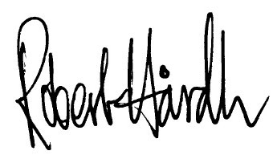
Robert Hårdh
Secretary General

