**BOATSWAIN’S LOCKER ANNOUNCED AS COX POWERTRAIN’S DISTRIBUTOR FOR WESTERN NORTH AMERICA**

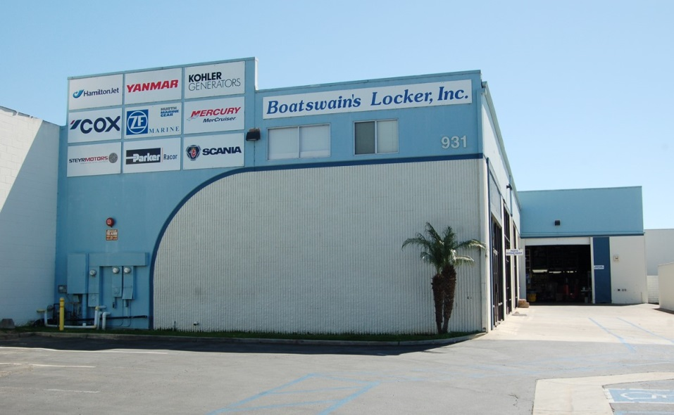

Cox Powertrain has announced an agreement with California based Boatswain’s Locker as its distributor for COX diesel outboards for western North America. Boatswain’s Locker is the latest US distributor to be announced by the British diesel engine specialist as they conclude their line-up of US and European distributor networks ahead of the launch of its first high powered diesel about engine, the CXO300 in 2018.

Boatswain's Locker is a leading wholesale supplier of recreational and commercial marine propulsion engines, generators, and related equipment for the Western US and Canada, Hawaii, Mexico, and the Pacific. Located in Costa Mesa, California the company represents a number of leading brands such as Yanmar, Scania, Steyr, HamiltonJet, Kohler Marine Generators, and ZF Transmissions, as well as leading accessory lines for all related systems. The company serves the recreational marine market through an extensive and well established Dealer network, and serves the commercial and government marine markets both directly and through dealers.

Combining Boatswain’s Locker’s long history of successful marine engine distribution and service with the technical and marketing prowess of COX Powertrain Limited, the strong partnership will make the introduction and future growth of the game-changing CXO300 a big success in western North America.

Commenting on the collaboration, Boatswain’s Locker’s CEO, Dan Gribble said, “Considering the already significant presence of high horsepower gasoline outboards within our territory together with the demand for more power, greater reliability, and superior fuel economy, the opportunity for COX’s diesel outboard is tremendous. While recreational outboard users will jump at the benefits of safety and reliability in a high-power package, the commercial marine market will be an even stronger adopter. That particular customer has long been looking for a high horsepower, sturdy, and reliable work horse that can meet their ever-increasing desire for more power while lowering their overall operating costs. There is no question that the Cox diesel outboard is exactly what the market has been asking for.”

Cox Powertrain’s Sales Director, Joel Reid said of the appointment, “We are delighted to have signed with Boatswain’s Locker as the Cox distributor for the West Coast. Boatswain’s Locker is an established and well-known brand throughout the West Coast, yet Dan, Rob, Lance and the team still have a strong appetite for growth. Their proactivity and commitment to successfully launch the CXO300 next year has been apparent in the conversations we had leading up to the signing of this agreement. We welcome Boatswain’s Locker onto this exciting and disruptive project.”

ENDS

**About Cox Powertrain**

Cox Powertrain is a world-leading British designer and builder of diesel engines developed for worldwide and multi-market applications.

Based on the South Coast of England, Cox Powertrain is backed by the Ministry of Defence and a solid shareholder base of private and institutional investors. As a result, the company has been able to implement a long-term development programme of ground-breaking new products.

Led by ex-Cosworth CEO, Tim Routsis, whose background lies in engine development in global automotive, aerospace and marine markets, the company’s mission is to deliver a completely new concept in diesel engines that has the potential to revolutionise the marine market.

With a strong pedigree in Formula 1 racing and premium automotive design, Cox’s highly skilled team of engineers has decades of experience in combustion engines and understand the many difficulties with which customers are challenged.

Cox’s first ground-breaking diesel outboard engine, the CXO300, is the highest power density diesel outboard engine ever developed. As a low weight, high power, single fuel engine, the CXO300 delivers the same performance and efficiency of an inboard but with the convenience and flexibility of an outboard.

For further information, visit www.coxmarine.com

**Media contacts:**

Reena Bayley, Marketing Manager or Karen Bartlett

Cox Powertrain Limited Saltwater Stone

Tel: +44 (0) 1273 454 424 Tel: +44 (0) 1202 669 244

E: [reena.bayley@coxpwertrain.com](mailto:reena.bayley@coxpwertrain.com) E: [k.bartlett@saltwater-stone.com](mailto:k.bartlett@saltwater-stone.com)