**A London Thing: The latest London gossip**

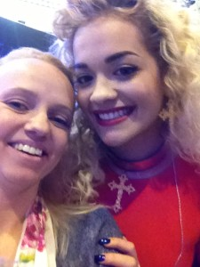She dishes the dirt on celebrities, gives the lowdown on the hottest new bars and interviews the latest names in fashion, beauty and music and has gained a loyal following of readers hooked on her every word.

The London Princess, a.k.a. Natasha Godbold, started the blog A-London-Thing.com in January 2012 and has since gone on to run the site as a full-time business.

Armed with a friendly personality, unquenchable curiosity and an encyclopaedic knowledge of London that could give the city’s cabbies a run for their money, Natasha attends launch parties, catwalk events and exclusive bars and clubs by night and writes about them by day.

Natasha, who is 31, first realized there was an appetite for her tales of life in the capital when meeting overseas clients during her career in the events industry.

*Natasha with Rita Ora*

“Whenever I said I was from London, people were always so lovely,” Natasha explained. “They always told me how much they loved London and asked me about the best bars and restaurants. I’m always out and about and I realized that I had a lot to say and could give lots of recommendations and also point out the places to avoid!”

What sets A London Thing apart from other London lifestyle blogs is it’s no-nonsense, honest approach and coverage of off-the-beaten track places. Natasha makes sure that each blog post is informative and accurate but has the tone of someone chatting to a close friend.

“I’m always having crazy nights out and seem to end up in the most bizarre situations, mingling with celebrities and getting invited to parties where I see things that never make it into the papers! I’m always telling my friends stories from nights out and they all think that I should write a book.

“A lot of authors start out by carving a niche for themselves online and so I thought I’d write a blog,” Natasha said. “I’ love writing and it’s amazing to share my experiences and get positive feedback from readers!”

Since she started the A London Thing, Natasha has been invited to blog for other websites enabling her to earn an income doing what she loves. She has recently teamed up with London restaurant guide Square Meal, and writes reviews as a guest blogger for the site.

“The best thing about it running a blog full-time is getting invited to lots of lovely places and events I wouldn’t normally hear about,” Natasha commented. “I get to meet lots of really cool, interesting people who often have great celeb gossip!”

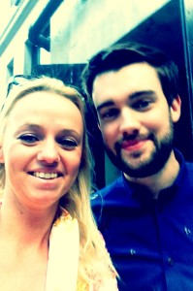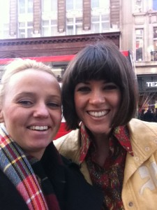

*Natasha with Jack Whitehall, Natasha with Dawn Porter*

**Quick Q & A with Nathasha**

**Most interesting interview:**

“Bernice Robinson. She owns the Mayfair Anti-Ageing Wellness Studio and was the backstage facialist during the X Factor finals last year. She shared lots of interesting gossip about the finalists!”

**Most interesting event:**

“Probably the Notting Hill vintage fair. Lots of famous designers such as Alexander McQueen and Donatella Versace have visited it over the years to get their inspiration.”

**Favourite bar:**

 “At the moment, my favourite bar is Barrio East in Shoreditch. It’s lots of different bars hidden in nooks and they play all sorts of music from Snoop Dogg to Latin music. They even have toilets cubicles with two loo seats so you can pee with your friend!”

**Press enquiries**

**The London Princess is available for:**

* **Interviews and comment**

(Natasha is happy to talk about what it’s like to be a London blogger, how to run a blog as business or any other subject you have in mind!)

* **Guest blogging/columnist opportunities**
* **Restaurant/bar/event/product or treatment reviews**

**Natasha can be contacted directly at alondonthing@hotmail.co.uk**