PRINCE – 1999
REMASTERED AND EXPANDED EDITION
FORMAT & TRACKLISTINGS

SUPER DELUXE EDITION
(5CD+DVD / 10LP+DVD / Digital *)
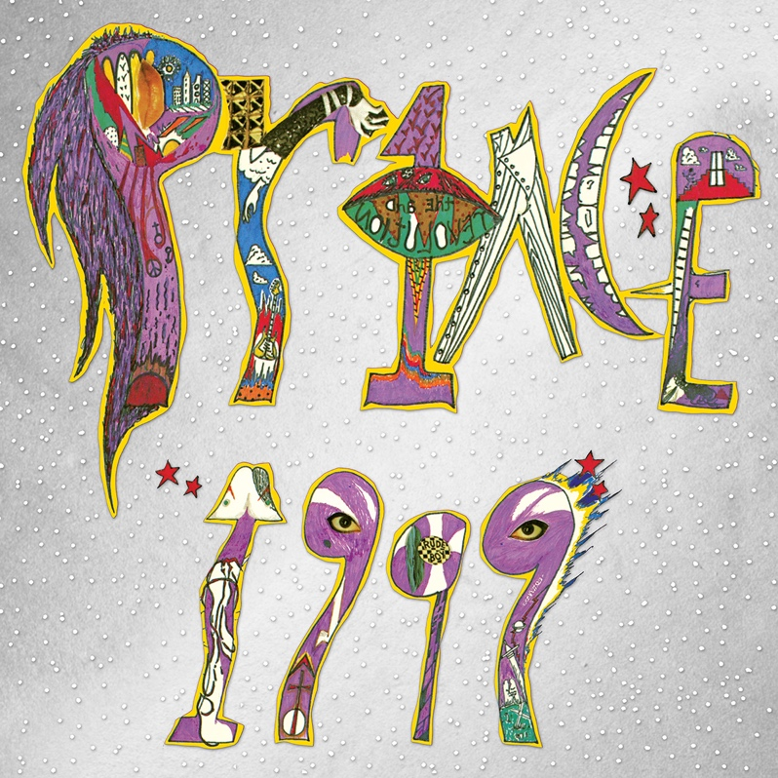

CD1 / LP 1&2: Remastered Album

1 1999
2 Little Red Corvette
3 Delirious
4 Let's Pretend We're Married
5 D.M.S.R.
6 Automatic
7 Something In The Water (Does Not Compute)
8 Free
9 Lady Cab Driver
10 All The Critics Love U In New York
11 International Lover

CD2 / LP 3&4: Promo Mixes & B-Sides

1 1999 (7" stereo edit)
2 1999 (7" mono promo-only edit)
3 Free (promo-only edit)
4 How Come You Don't Call Me Anymore ("1999" b-side)
5 Little Red Corvette (7" edit)
6 All The Critics Love U In New York (7” edit)
7 Lady Cab Driver (7" edit)
8 Little Red Corvette (Dance Remix promo-only edit)
9 Little Red Corvette (Special Dance Mix)
10 Delirious (7" edit)
11 Horny Toad ("Delirious" b-side)
12 Automatic (7" edit)
13 Automatic (video version)
14 Let's Pretend We're Married (7" edit)
15 Let's Pretend We're Married (7" mono promo-only edit)
16 Irresistible Bitch ("Let's Pretend We're Married" b-side)
17 Let's Pretend We're Married (video version)
18 D.M.S.R. (edit)

CD3 / LP 5&6: Vault, Part 1

1 Feel U Up
2 Irresistible Bitch
3 Money Don't Grow On Trees
4 Vagina
5 Rearrange
6 Bold Generation
7 Colleen
8 International Lover (Take 1, live in studio)
9 Turn It Up
10 You're All I Want
11 Something In The Water (Does Not Compute) (Original Version)
12 If It'll Make U Happy
13 How Come U Don't Call Me Anymore? (Take 2, live in studio)

All tracks previously unreleased

CD4 / LP 7&8: Vault, Part 2

1 Possessed (1982 version)
2 Delirious (full length)
3 Purple Music
4 Yah, You Know
5 Moonbeam Levels **
6 No Call U
7 Can’t Stop This Feeling I Got
8 Do Yourself A Favor
9 Don't Let Him Fool Ya
10 Teacher, Teacher
11 Lady Cab Driver / I Wanna Be Your Lover / Head / Little Red Corvette (tour demo)

All tracks previously unreleased except **, released on the 2016 compilation, 4Ever

CD5 / LP 9&10: Live In Detroit – November 30, 1982 (midnight show)

1 Controversy
2 Let's Work
3 Little Red Corvette
4 Do Me, Baby
5 Head
6 Uptown
7 Interlude
8 How Come U Don't Call Me Anymore?
9 Automatic
10 International Lover
11 1999
12 D.M.S.R.

All tracks previously unreleased

DVD: Live In Houston – December 29, 1982 *

1 Controversy
2 Let's Work
3 Do Me, Baby
4 D.M.S.R.
5 Interlude – piano improvisation (contains elements of "With You")
6 How Come U Don't Call Me Anymore?
7 Lady Cab Driver
8 Automatic
9 International Lover
10 1999
11 Head (contains elements of "Sexuality")

All tracks previously unreleased

* N.B. video content is exclusive to the physical DVD and will not appear on digital download or streaming versions of the Super Deluxe Edition set.

DELUXE EDITION
(2CD / 4LP 180g Vinyl / Digital)

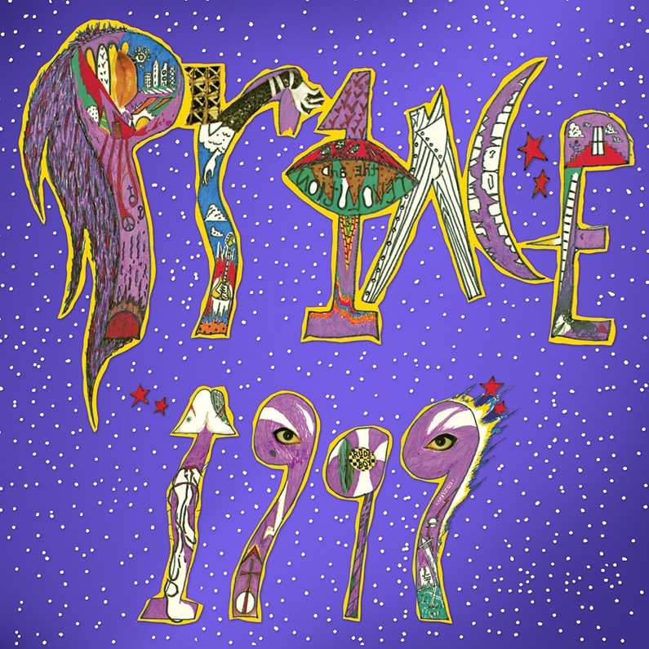

CD1 / LP 1&2: Remastered Album

1 1999
2 Little Red Corvette
3 Delirious
4 Let's Pretend We're Married
5 D.M.S.R.
6 Automatic
7 Something In The Water (Does Not Compute)
8 Free
9 Lady Cab Driver
10 All The Critics Love U In New York
11 International Lover

CD2 / LP 3&4: Promo mixes & B-Sides

1 1999 (7" stereo edit)
2 1999 (7" mono promo-only edit)
3 Free (promo-only edit)
4 How Come You Don't Call Me Anymore ("1999" b-side)
5 Little Red Corvette (7" edit)
6 All The Critics Love U In New York (7” edit)
7 Lady Cab Driver (7" edit)
8 Little Red Corvette (Dance Remix promo-only edit)
9 Little Red Corvette (Special Dance Mix)
10 Delirious (7" edit)
11 Horny Toad ("Delirious" b-side)
12 Automatic (7" edit)
13 Automatic (video version)
14 Let's Pretend We're Married (7" edit)
15 Let's Pretend We're Married (7" mono promo-only edit)
16 Irresistible Bitch ("Let's Pretend We're Married" b-side)
17 Let's Pretend We're Married (video version)
18 D.M.S.R. (edit)

REMASTERED ALBUM
(CD / 2LP 180g Purple Vinyl / Digital)

CD1 / LP1&2: Remastered Album

1 1999
2 Little Red Corvette
3 Delirious
4 Let's Pretend We're Married
5 D.M.S.R.
6 Automatic
7 Something In The Water (Does Not Compute)
8 Free
9 Lady Cab Driver
10 All The Critics Love U In New York
11 International Lover

